Peter Kumar
Email id: peter@gmail.com
Contact no: +91 9876543210

CAREER ASPIRATION  PROFESSIONAL PROFILE    ACHIVEMENTS    CAREER CONTOUR  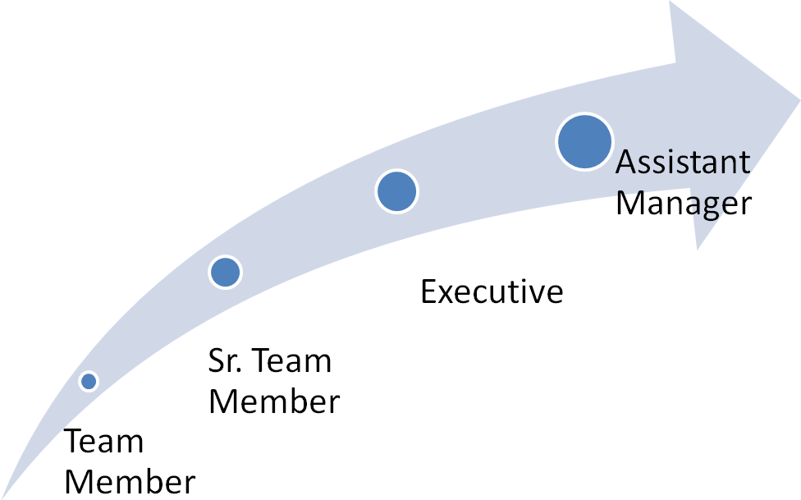 | Seeking challenging and managerial assignments in Training and Transitions F&A Operations/New Business Transition /Client Management / People Management/Customer Service in BPO  - Around 7+ years’ experience in F&A Operations Management.  - Successfully Handled 3 onsite transition and 5 offshore transition  - In depth knowledge of day to day operations in business operations with rich experience in handling operations, training and transition.  - Lead new transitions in Finance & Accounting from training and operation stand point. The role involves analyzing the process readiness, process in scope, skill set, technology readiness, Hiring readiness, documentation (SOP & Training collateral) and sign-off from client.  - Possess excellent interpersonal, communication and organizational skills with proven abilities in analytics, training & development, customer relationship management and planning.  - Excellent skills in using the Microsoft Office products, especially with Excel and PowerPoint.  Significant Highlights:  - Certificate of Pragati: Continuous improvement in work place: Wipro BPO: June 2010 – “Kaizen project on CAPEX report on Fixed Assets”.  - Project support head of WIPRO BPO NEW BUSINESS TRANSITION Finance & Accounts “Domain.  - Deliver training (F&A Domain & Technical)for college students as part of rural BPO concept  - Deliver BU induction & pre-process  - Certificate of Achievement :Operations: (Sep: 2010): Wipro  - Certificate of Excellence: Best Team:(Nov: 2010): Wipro  - Lead SPOC for audits COBC(Certificate of Basic Competence),RCSA(Risk control self assessment)  Feb 2013 – Till date DISYS, Chennai  [Role Handled: Assistant Manager –F&A Operations- till date]  - Handling F&A operations for DISYS (US) – Accounts Payable.  - Accountable for the TAT and SLA.  - Consistently interact with Project Heads in understanding their operational challenges and also Liaise with other business units within the organization to resolve the issues.  - Preparation of Monthly dashboard and present the same to management.  - Pilot batch for account payable operation  - Training (KA) was successfully completed through offshore (WebEx and telephone)  Oct 2009 – Presnet WIPRO , Chennai (3.3 years)  [Role Handled: Executive (KA/KT Specialist)]  Responsibility / KRA New Transition Accounts  - Lead new transitions in Finance & Accounting. The role involves analyzing the process readiness, process in scope, skill set, technology readiness, Hiring readiness, documentation, monitoring transition plan and sign-off from client.  - Identify the pre-process training needs, finalize on the onsite/offshore training plans for the process transition; ensure smooth Knowledge Transfer and certification of resources.  - Ensure that all training milestones are met during due diligence and transition phase for a new account migration  - Ensure that the resources are ready before the KA team reaches onsite location  - Responsible for analyzing and identifying the new transition methodologies based on the complexity of the processes and implementing the same  - Ensure all Training content/Sops are prepared and signed off during transition/before go live.  - Work very closely with the client and identify the client’s training readiness and roll out a gap completion plan  - Complete competency mapping for the process as per the JDs and client feedback.  - Ensure that the onsite training runs smoothly as per the onsite training plan.  - Responsible for certification of all resources before Go Live  - Responsible for standardization of complete training function as per defined norms and SLAs and handover to the steady state manager, once all sub processes go live successfully.  - Gather updates from the operations floor and the feedback from the governance team to make relevant changes to the training content, delivery style or assessment technique  Key process / Transitions handled in Wipro from 2009 to 2013:  Onsite Project: Finance & Accounts - BPMS Bank Accounting – Transition (4 members), China  Duration: Feb ‘10 to Mar’10  Achievements:  - Documentation of Bank Accounting Process for Leading Telecom Company in (Shanghai) China  - Created the SOP(Standard Operating Procedure) for all activities in Bank Accounting Process  - Created Process Maps, SIPOC, FMEA and TM Sheet  - Created the Training Content for KT training delivery  - All documentation created was signed off by the Client within Project timelines
DOMAIN KNOWLEDGE  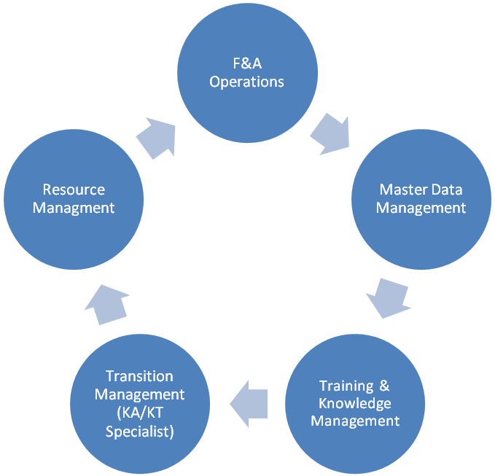  APPLICATIONS USED    TRAININGS DELIVERED   |  | Onsite Project: Finance & Accounts - Fixed Asset – Transition (2 members), US  Duration: May’10 to June’10  Achievements:  - Created the SOP(Standard Operating Procedure) for all activities in Fixed Asset (General Ledger)  - Created Process Maps, SIPOC, FMEA, TM Sheet and Training Content  - Delivered the Knowledge Transfer sessions to all Offshore resources on Process Knowledge & Activities  - Identified the Monthly Metrics for Fixed Asset Metrics to be monitored and reported to the Client & Wipro Management team  - Handled Client/ Customer escalations and also implement Preventive action  Offshore Project: Return Order Management (33 members) – Retail industry, UK  Duration: September’11 to September’11  Achievements:  - Created training plan for a non-existing process  - Software identification & proposal, implemented the ERP system  Offshore Project: Accounts Payable – Inter Unit (3 members) – Leading Telecom company, USA  Duration: November’11 to December’12  Achievements:  - Measure offshore training effectiveness, create & publish weekly & monthly dashboard  - Ensure offshore resource certification  - Delivered induction and pre-process training for offshore resources  Onsite Project: Procurement - Master Data Management (12 members) – Leading chemical manufacturing Client, USA  Duration: April’12 to August’12  Achievements:  - Created the SOP(Standard Operating Procedure) for vendor management & pricing  - Created Process Maps, SIPOC, FMEA and floor policy  - All documentation created was signed off by the Client within Project timelines  - Trained & certified offshore resources, met Go-live timelines  - Governance structure created  May 2006 – Sep 2009 FORD BUSINESS SERVICES CENTER , Chennai (3.4 years)  [Role Handled: Team Member & Sr. Team Member]  Key Responsibility performed  - Process paper Invoices in QAD ERP  - Raising Appropriate Debits and Credits  - Handling E-Mails in Talisma (An advanced E-Mail Management)  - Confirmation / auditing the invoices  - Imports Payment Processing  - Liaison with the Supplier to resolve the issues with regard to problematic invoices  - Checking the correctness of the Entries and passing the adjustment entries wherever required  - Monitoring the Rejected shipments and charging the supplier accordingly  - Reconciling between Imaging system and Payable system in order to find out the outstanding unpaid invoices and open pending line items and rectify the same accordingly  - Payroll entries during month ends & Petty cash reconciliation  - Responsible for disbursing urgent checks / Payment run checks/Wire Transfer Payments (In case of Imports)  - Generate remittance advice details to suppliers  - Banks Charges entry – in case of difference in Bank Reconciliation Statement (BRS).  - TER – Travel Advance Payment / AMEX Card Payments / Travel Cards Settlements  - Monthly BRS Review with Plant  - Identifying and creating provision for the supplier in Debit Balance  - Treasury Disbursement  - Recovering while releasing payment run checks.  - Responsibility of handling Critical Mails / Reconciliation Activity and Managing Payable Operations.  - Matching the Sub-ledger and the General Ledger on monthly basis.  - Reconciliation of Sub ledger & General Ledger on monthly basis.  - Ageing Analysis for all the pending line items(Both Audited & Un-Audited Liability)  - Line Item Reconciliation on a daily monthly basis.  - Intercompany reconciliation and passing the JE for the same on month ends.  - Prepare Daily / weekly and Monthly metrics – Both Recons and Payables.  - Prepare monthly schedules like – Advance, Retention and Stale Accounts.  - Ensure Open items reconciliation Report are being downloaded properly on a daily basis  - Contact Payables for all Customer open line items ageing greater than 60 days  - Ensure the recovery is done for the payment made to the supplier  - Contact Supplier for remittance details for performing recovery  - Monitor & Analyze any disputes that are being reported by the supplier towards payments made  - F&A (Accounts Payables, Disbursement, Reconciliations, Travel & Expenses, Bank Accounting, Fixed Assets)  - Order Management – Return Order Management  - Master Data Management – Vendor & Pricing Management  - Training and knowledge Management  - Transition Management  - MIS Reporting Real Time Scheduling and Management  - Resource Management workflow  - End User to QAD for around 3 Years  - Extensive user of Visio  - Microsoft Excel, Word, PowerPoint  - Up skilled in SAP 4.7 & 6.0 version Finance Module (AP- Disbursement, T&E, FA, Reconciliation, Procurement- Vendor Management & Pricing)  - New Hire Induction  - FAO pre-process training – AP, AR, GL & Procurement  - Technical Training like Basic MS office  - Due diligence training modules and KA/KT methodology for the DD team  - Business etiquette for new hires
PERSONAL DOSSIER

Address : 142/5 N S Road, Mumbai-201 201
E-Mail : peter@gmail.com
Sex : Male
Marital Status : Single
Contact Number : 9876543210
Languages : English/ Tamil
Nationality : Indian
Blood Group : O+
Passport No# : LK12121212 (With Valid United States Business Visa – Valid till 2022)
SCHOLASTICS
Course | Year of Passing | Percentage Score
MBA | June 2006 | 74%
B Com | May 2004 | 64%
Higher Secondary | April 2001 | 69%
Xth | April 1999 | 65%

