|  |
| --- |
| **https://lh6.googleusercontent.com/ruk5sI_ob09S9n8xGXBMzGySj81B8Ywmn6rkfP1mcnig5fmdPPWeInP3Nyy1Iz0oxgKNOdWb5zK5k-iBdKZkxHXz_hYDKXPYnYGXvXEjpJ4s3wlyXXG1tkvSIlA0nxxWcOZJFeCRVENUS WORLD SCHOOLS**  **Year 2021-22**  **SA-I** |
| Std-IV Date - 20 / 09 /21  Subject- Science Time- 2hr  Student name- Marks-50M |

**Q.1) Fill in the blanks with correct option. (5M)**

1. __________ is a method of cooking food. **( Steaming / Freezing)**

2. The nutrients present in large quantity in potatoes are _________.  **(Carbohydrates / minerals)**

3. A sticky yellowish layer of bacteria and food particles formed on the teeth is called__________ . **( dentists / plaque )**

4. Fibres are____________ into threads. **( Knit / spun)**

5. In a sugar solution, sugar is the _________ . **( solute / solvent)**

**Q.2 ) Tick the correct answer. (5M)**

1. State of matter are :

A) solid, liquid, gas. B ) liquid and gas. C) gas and solid

2. This gas is used by plants during photosynthesis.

A) oxygen. B) carbon dioxide. C) water vapour

3. This living things prepared it’s own food.

A) tree. B) tiger. C) butterfly

4. Construction of the house is looked after by:

A) an engineer. B) a fabricator C) a meson

5. It is a synthetic fibre.

A) coir. B) Acrylic. C ) wool

**Q.3) True or false . (5M)**

1. Molecules are do small that they cannot be seen . ______.

2. Gases have a definite shape and size. _______.

3. Sand is soluble in water . _________.

4. Plants and animals depends on each other. _________.

5. We should not take care our teeth. _________.

Q.4)

**Q.4) Match the following. ( 5M)**

**1**. Incisor a)Food pipe

2. Mouth. b). bile

3. Small intestine. c). teeth

4. Oesophagus. d.) saliva

5. Liver. e) long coiled tube.

**Q.5) Name the following . (7M)**

**1. The flat** broad surface of the leaf. _________.

2. The green substance in the leaf. __________.

3. The minute pores on a leaf. _____________.

4. Who makes the plan or design of the house. _______.

5. Who fixes iron and fences for security. _________.

6. Which fibres are collected from the cocoons of silkworms. _____.

7. A plant in which the food is prepared by the stem . _______.

**Q.6) Classify the following. ( 3M)**

( Oil, oxygen , wood , water, water vapour, carbon dioxide.)

|  |  |  |
| --- | --- | --- |
| Solids | Liquids | Gases |
|  |  |  |
|  |  |  |

**Q.7) Answer these questions. (Any5). (10M)**

**1**. What causes tooth decay?

2. What are the advantages of having a thatched roof?

3. Why is glass used as a building materials?

4. What is matter.

5.what is solubility.

6.what is the function of the veins in a leaf.

7. What does a plant require to make food ?

**Q.8) Identify the following figure. 6M.**

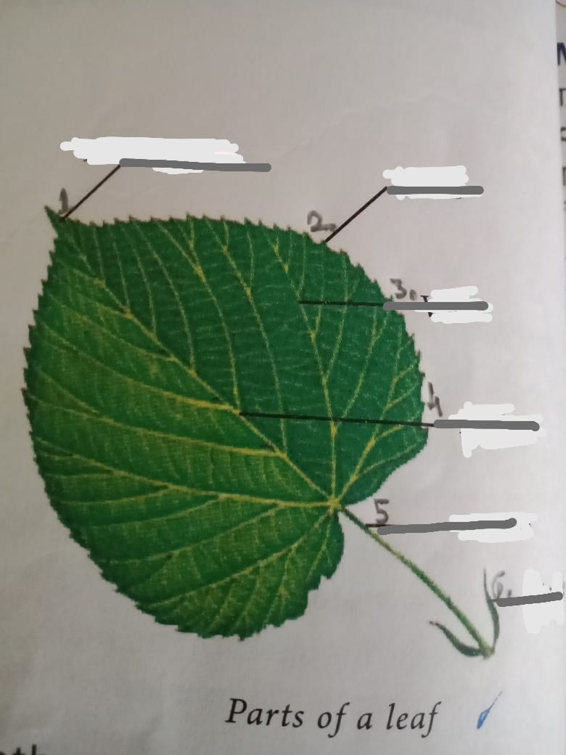

**Q.9) Draw and label a diagrams . (Any 2). (4M)**

1.photosythesis

2.gas exchange between plants and animals.

3. Arrengement of molecules in solids , liquids and gases.