Madni English Medium School
Daily worksheet
Subject: EVS STD: 2nd. Date: 04-06-2020
Teacher Name: Nagma.

1. Write the missing letters:
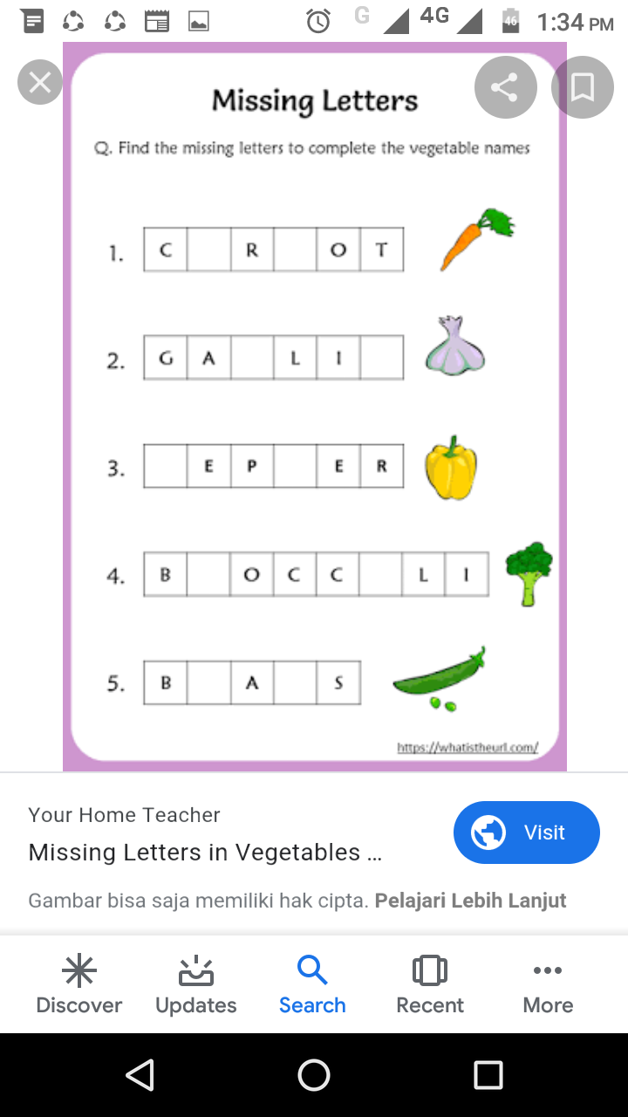

2. Match the following:

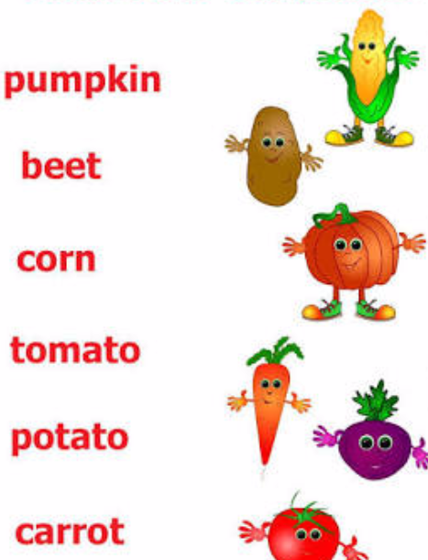

Activity: Make vegetable salad with the help of cucumber and carrot:

