Madni English Medium School
STD: II Date: 10/6/2020
SUB: Kannada In charge Teacher: Ayesha Mulla

- Name the following picture shown in the table:

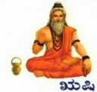

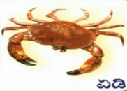


- Write the next letter

C ____
E ____
G ____
J ____
K ____
D ____

- Color the letters given below :-
C D E F

