Madni English Medium School
Daily worksheet - 1
Class: 4th Sub: EVS
Date: 9/06/2020 Teacher: Sabiha Bepari
🌑 Rearrange the jumble words: 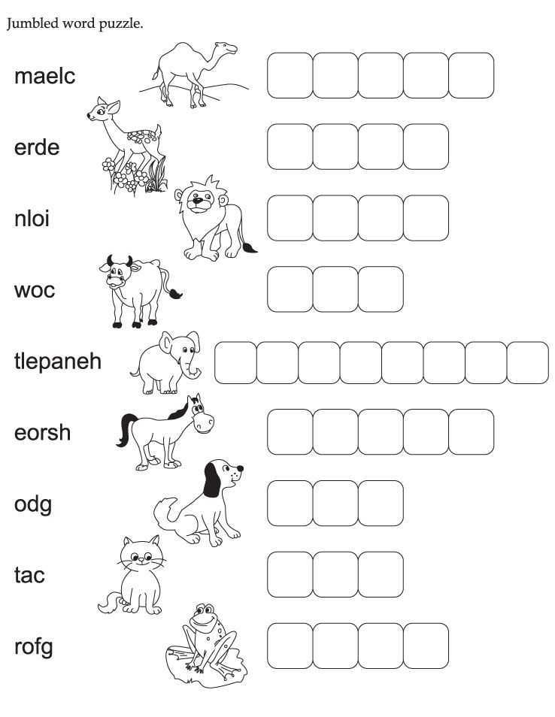
⚫ Look at the pictures and classify the animals in the given boxes:
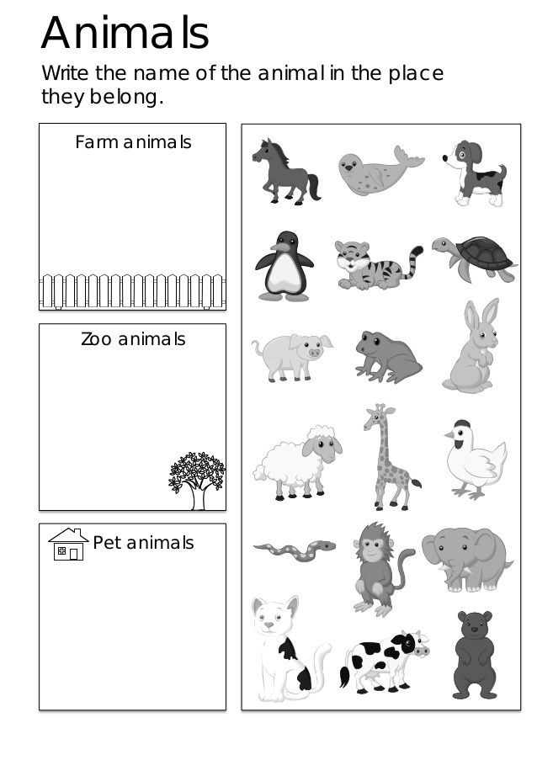

🌑 Activity: Look at the numbers and Colour the following activity:
