MADNI ENGLISH MEDIUM PRIMARY SCHOOL
Std : 3rd Date : 9/6/2020
Sub : Maths Incharge Teacher : Saba Daddi
Daily Worksheet
- Fill the missing numbers of Before , Middle and After numbers
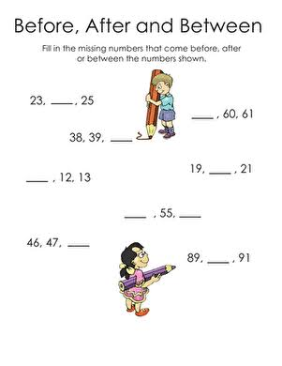

2. Identify the even and odd numbers.
- Colour the flowers of odd numbers with red.
- Colour the flowers of even numbers with orange.

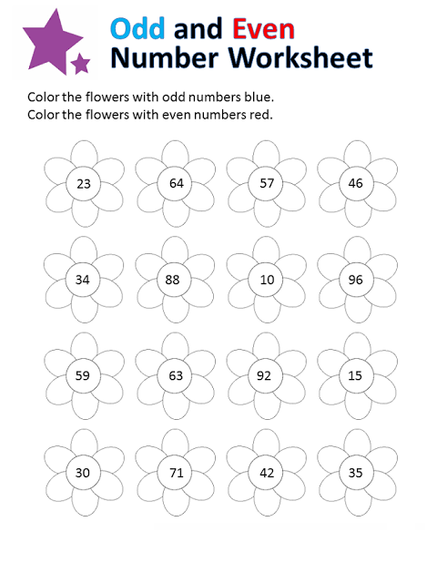

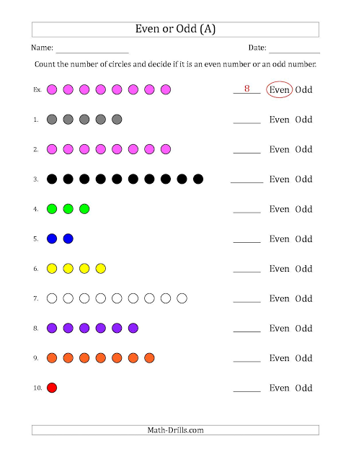
3. Count the number of circles and decide if it is even number or odd number.

- Fill in the blanks:
1. The numbers which starts with 0 is _________
2. 1 is known as __________ number.
3.Natural numbers are know as ___________ numbers.
4. Integers have ________ types.
5. Positive numbers come with ______ symbol.
6. Negative numbers comes with _____ symbol.
7. The Successor of 234 _________
8. The Predecessor of 543 _________

Note :
Please do the above work correctly and neatly.

