**Madni English Medium School**

***Daily worksheet***

**Class:2nd In charge teacher: saleha**

**Subject: Maths Date: 9/6/2020**

***•* Count and write *:***

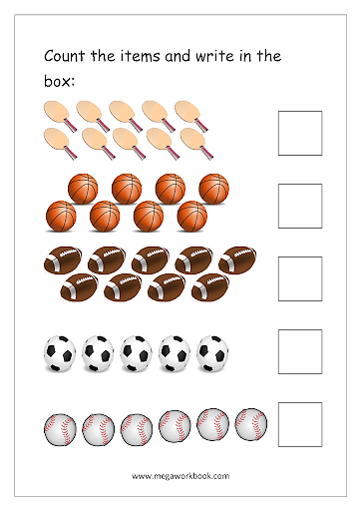

* **Write the numbers in words**

|  |  |
| --- | --- |
| 01 one  20  13  09  15 | 14  12  16  17  11 |

* **Write what come before between and after:**

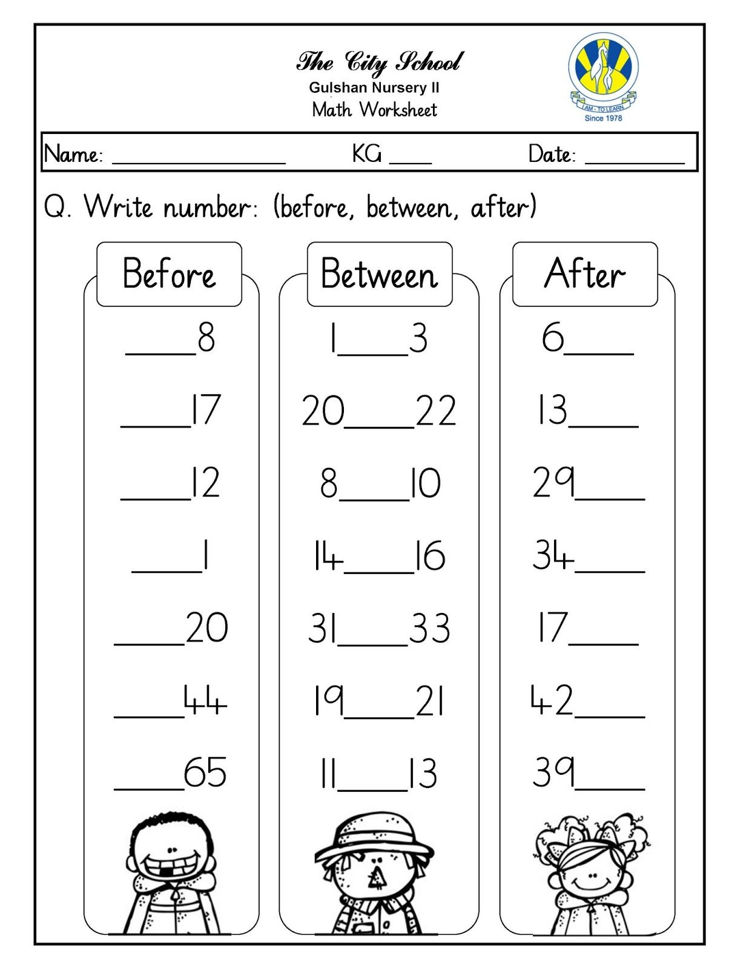

* 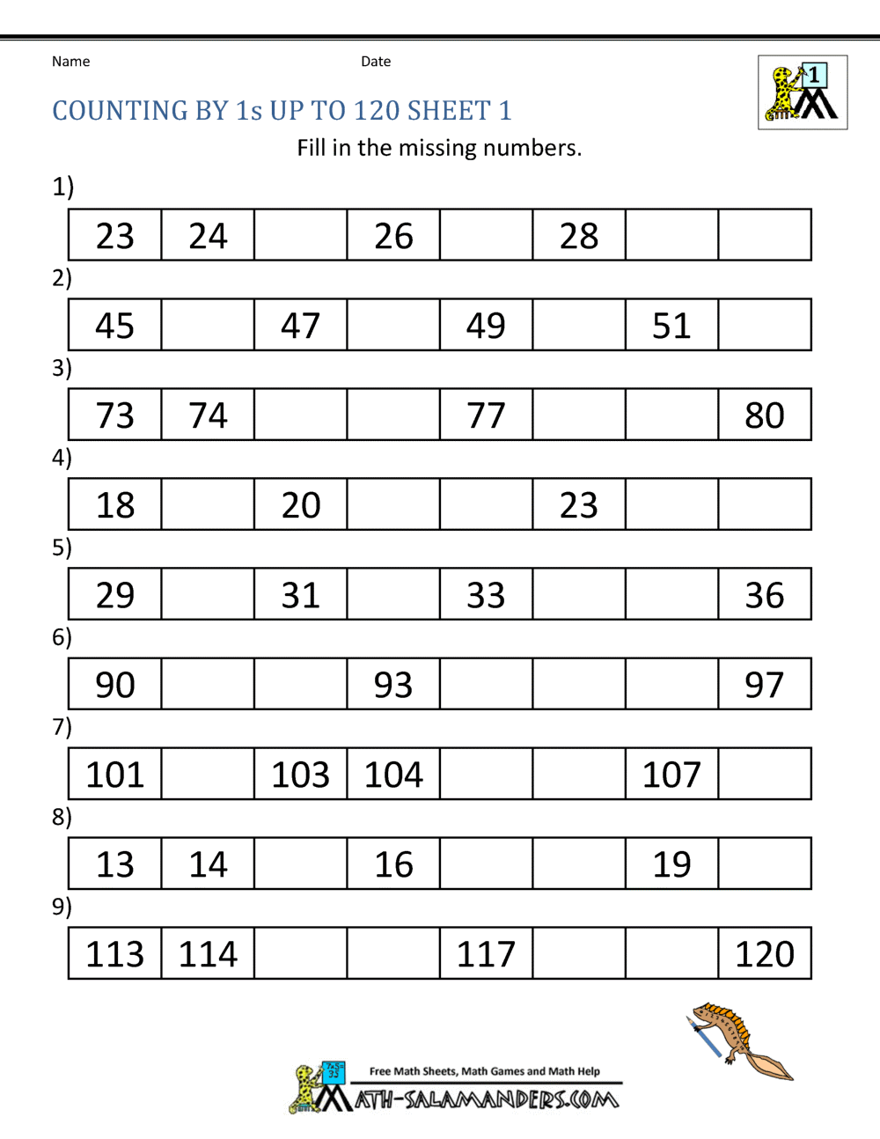**Write the missing numbers.**