Madni English Medium School
Daily Worksheet-2
Class: 3rd Sub: EVS
Tr: Sabiha Bepari
✔ Match the pictures with the right words:
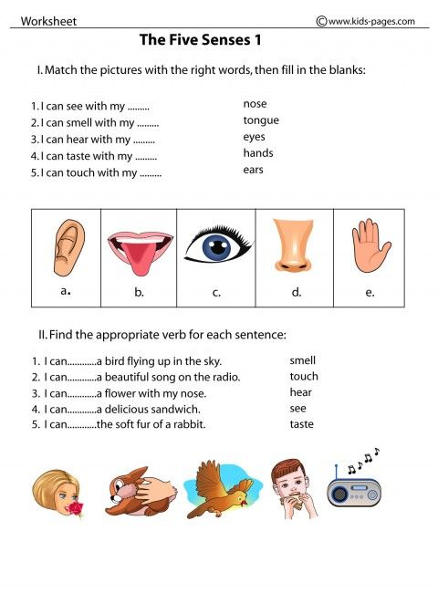

✔ Complete the following Crossword:
