Madni English Medium School
Daily Worksheet-2
Class: 4th Date: 11/6/2020
Sub: EVS Teacher: Sabiha Bepari
Topic: Birds
🌑 Read the words below and write them in alphabetical order:
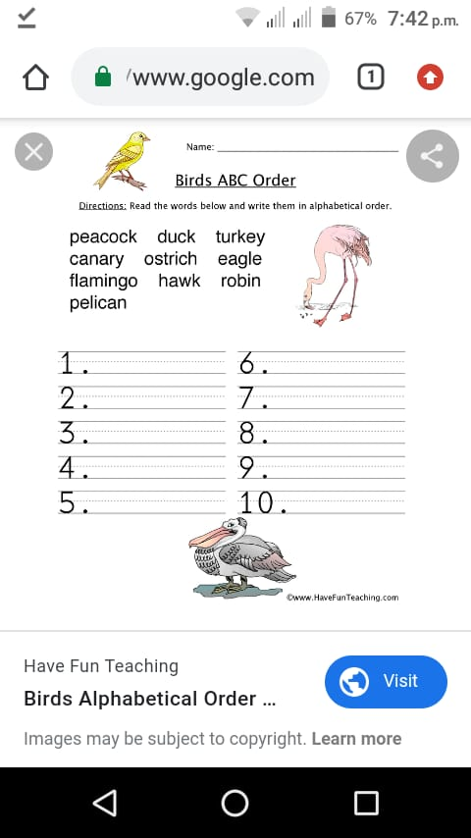

🌑 Colour the bird and write the correct word given below:
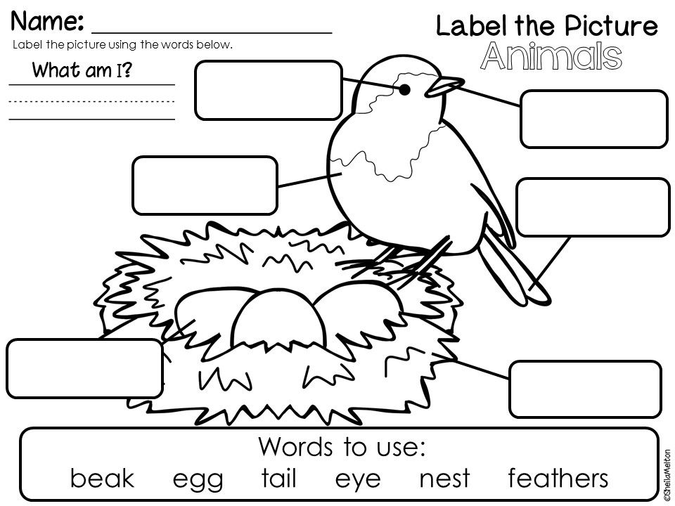

🌑Rearrange the jumble words:
