MADNI ENGLISH MEDIUM SCHOOL.
Daily Worksheet-2
Class: 2nd Sub: EVS Tr: Tabassum Mulla
▪️ Land , Water or Air? Look at the pictures and write the correct answer:
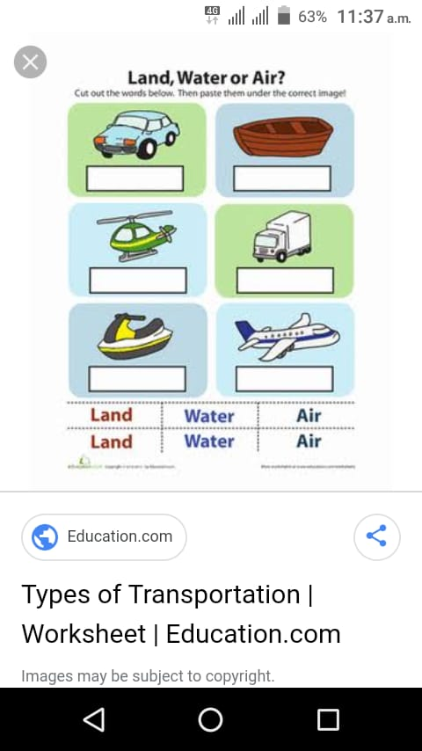
▪️ Make the compound words: Transportation:
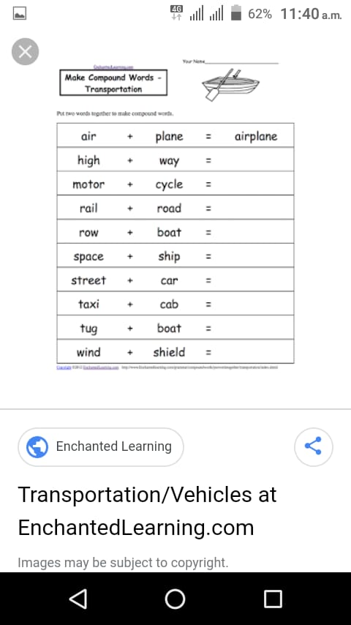

▪️Activity: cut out the shapes and build a Truck with the help of following worksheet:

