MADNI ENGLISH MEDIUM SCHOOL
Daily Homework
Class: I Date: 10/06/20
Sub: English

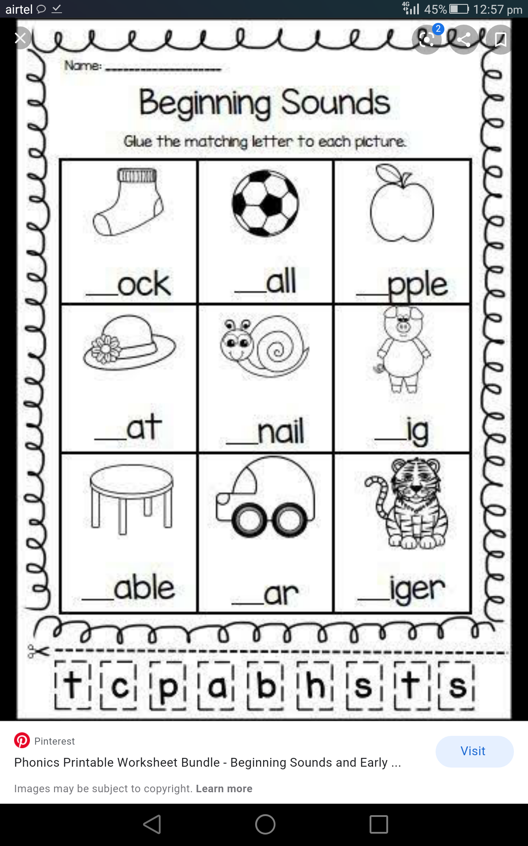
1. Write the initial sound of the given pictures.

2. Say the names of the pictures and circle the letters that matches the sound.

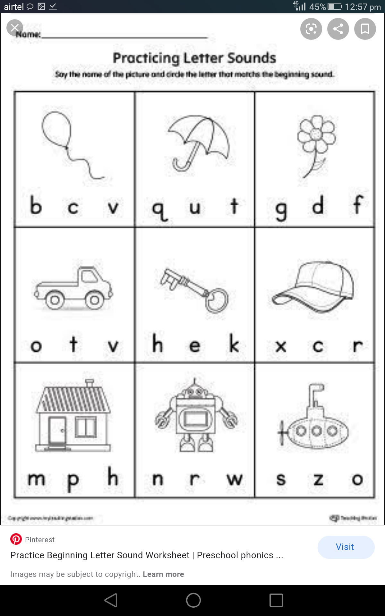

3. Make a card and paste the picture of the sound you have learnt today.

