Madni English Medium School
Homework Sheet
Class: 1st Sub: EVS Teacher: Tabassum Mulla Date: 9/6/20
✔ Fill in the blanks:
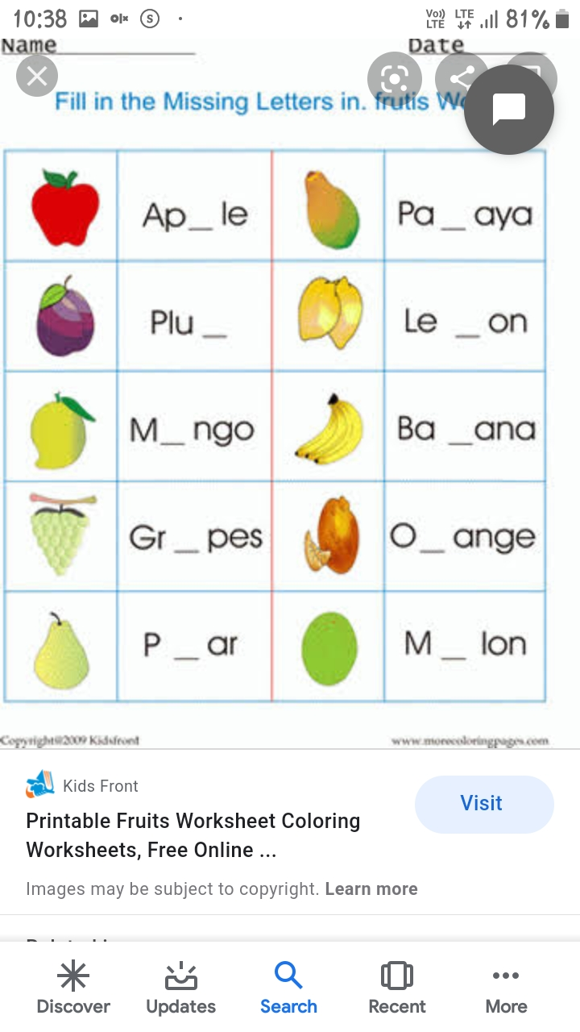

MATCH THE PICTURES WITH THEIR NAMES

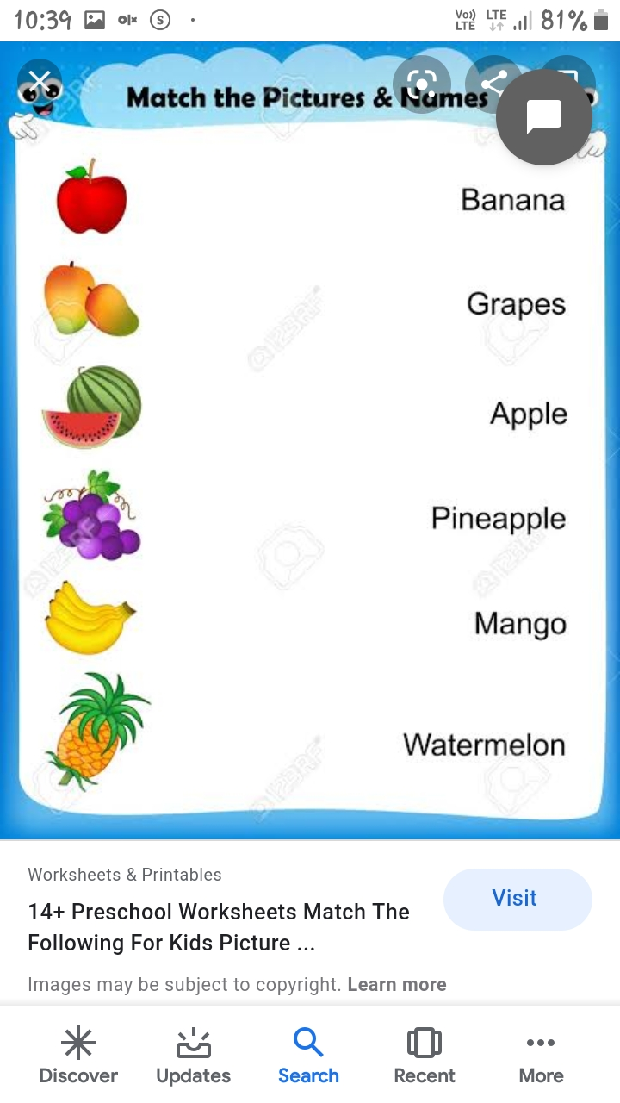

Activity:
✔ Make Fruits salad using different Fruits and send picture

