MADNI ENGLISH MEDIUM SCHOOL
Assignment
Class: II Date: 10/06/20
Sub: English

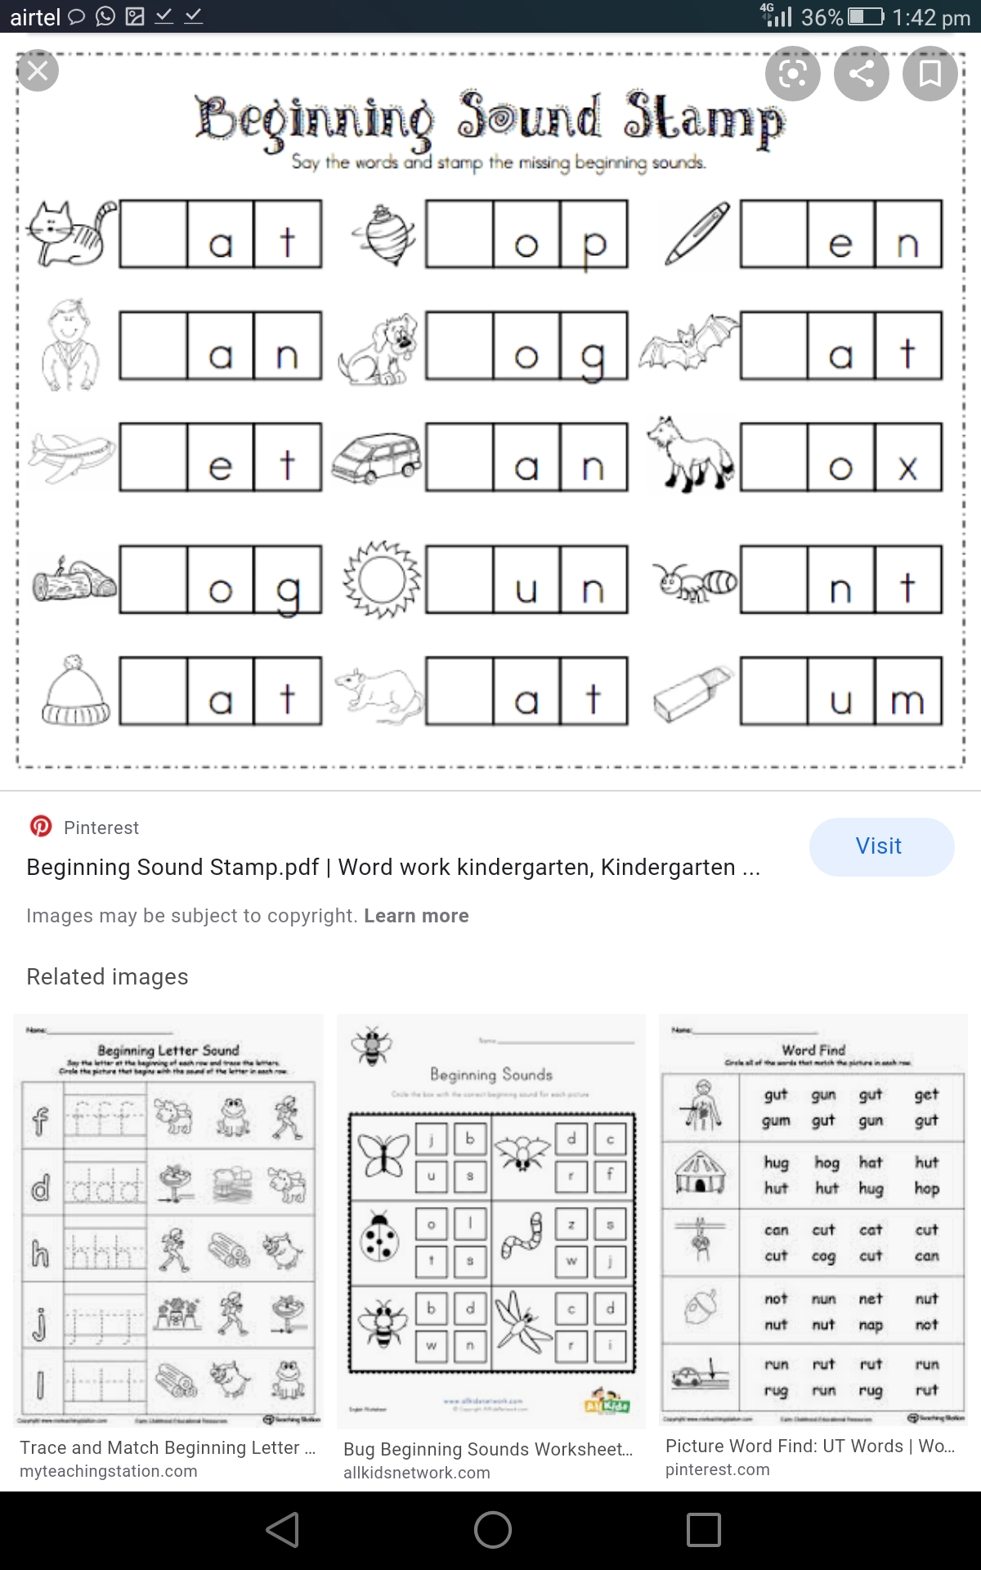
1. Say the word and write the beginning sound.

2. Practice writing cursive letters.

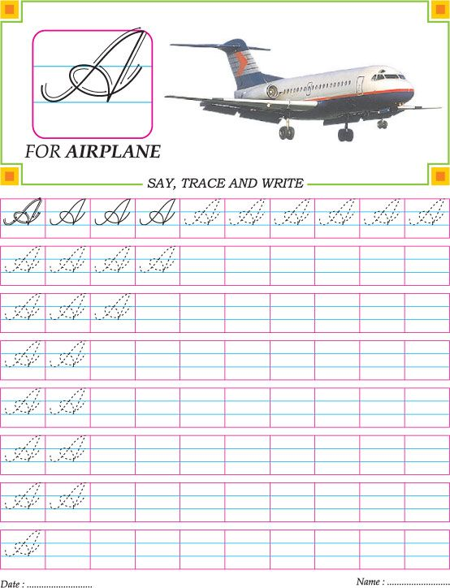

3. Make an attractive card, paste your picture and write about yourself.

4. Match the picture with its initial sound.

