Madni English Medium Primary School

Std : 3rd Date : 11/6/2020

Subject : Kannada Incharge Teacher : AyeshaDarwan

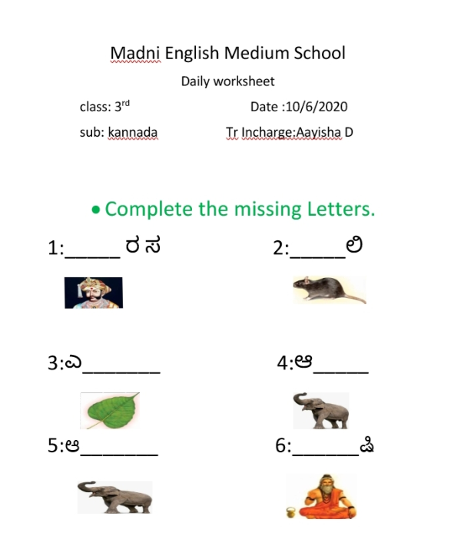Daily Worksheet

