**MADNI ENGLISH MEDIUM SCHOOL  
 Daily Homework  
Class: I Date: 10/06/20  
Sub: English Tr Incharge: T.A.Shaikh**

1.**Fill in blanks with the vowels sounds.**

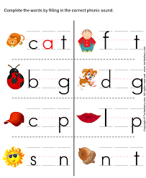

**2.Write 2 words having each of the vowels sounds. One has been done for you.**

**Aa - cat Ee- pen Ii - nip Oo - mop Uu – cub**

**___ ___ ___ ___ ___**

**___ ___ ___ ___ ___**

**3. Colour the clouds with vowels.**

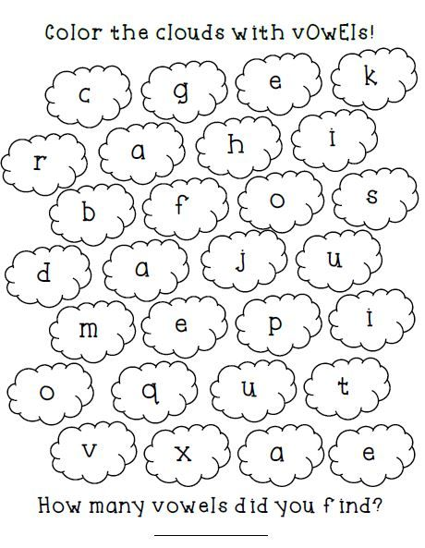

**4. Practice writing the given cursive lines.**

