MADNI ENGLISH MEDIUM SCHOOL
Daily Homework
Class: III Date: /06/20
Sub: English Tr Incharge: T.A.Shaikh

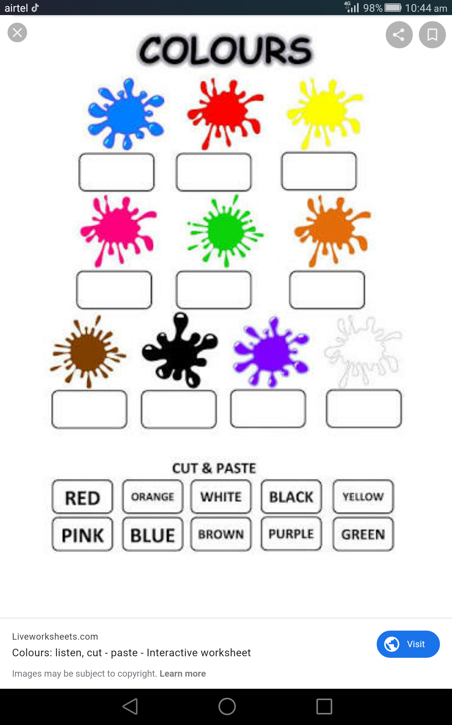
1.Name the given colours.

2. The words below are missing their beginning sounds.write them, match and write again.

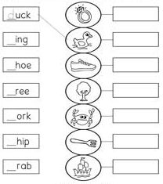

3. Draw and colour rainbow, write the name of rainbow colour in Vibgyor sequence.

4. Draw a house, recall the four letter words and write on it.

