Madni English Medium Primary School

Std : 4th Date : 10/6/2020

Subject : Kannada Incharge Teacher : AyeshaDarwan

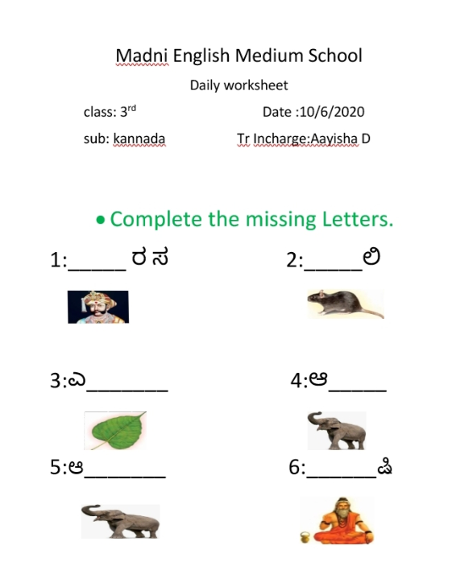Daily Worksheet

