MADNI ENGLISH MEDIUM PRIMARY SCHOOL
Std : 4th Date : 9/6/2020
Sub : Maths Teacher: Saba Daddi
Daily Worksheet

1 . Fill the missing numbers of Before, Middle and After numbers
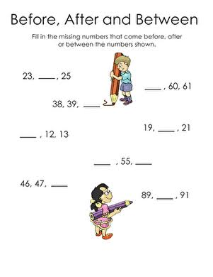

2. Identify the even and odd numbers.
Colour the flowers of odd numbers with red.
Colour the flowers of even numbers with orange.

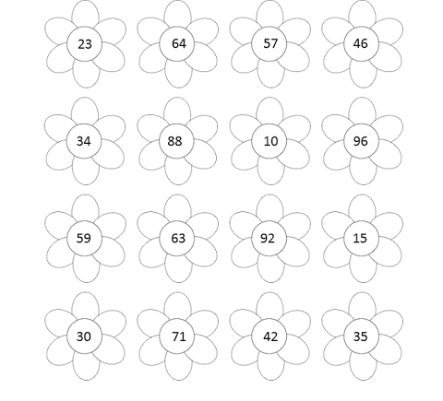

3. Count the number of circles and decide if it is even
number or odd number.
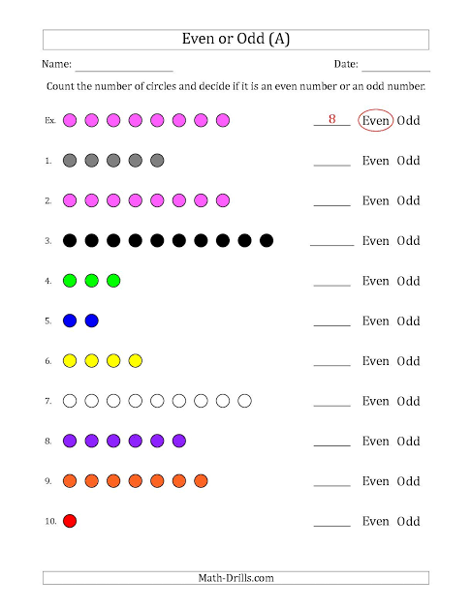

4 . Fill in the blanks .
1. The numbers which start with 0 is _________
2. 1 is known as __________ number.
3.Natural numbers are know as ___________ numbers.
4. Integers have ________ types.
5. Positive numbers come with ______ symbol.
6. Negative numbers comes with _____ symbol.
7. The Successor of 234 _________
8. The Predecessor of 543 _________

Note :
Please do the work correctly and neatly.

