Madni English Medium School
Daily worksheet

Class:2ndIn charge teacher:saleha
Subject: Maths Date: 11/6/2020

• Count and write :


- Write the numbers in words
01 one  20  13  09  15 | 14  12  16  17  11

- Write what come before between and after:
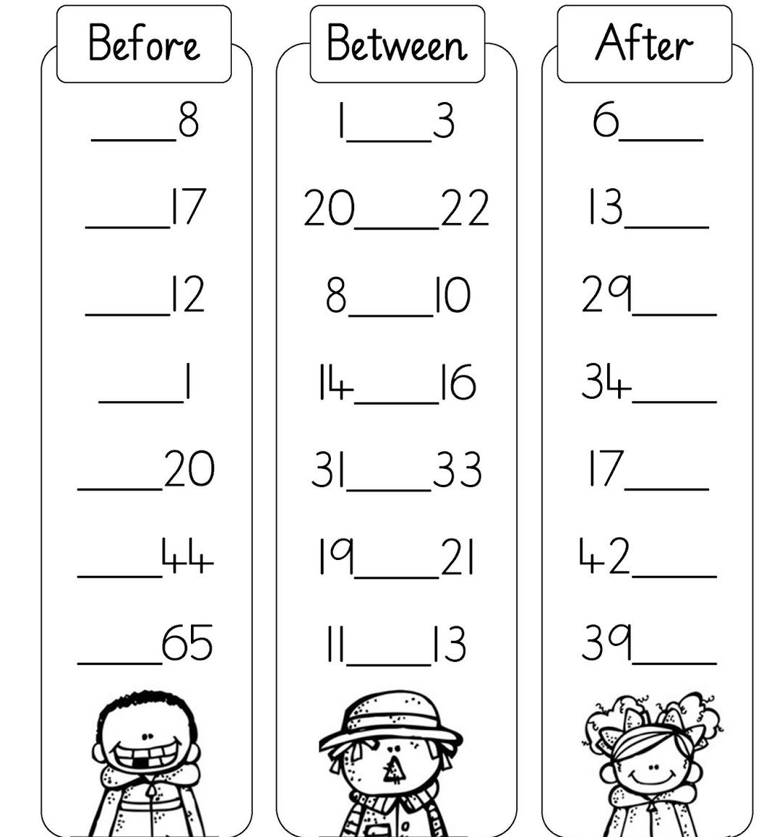

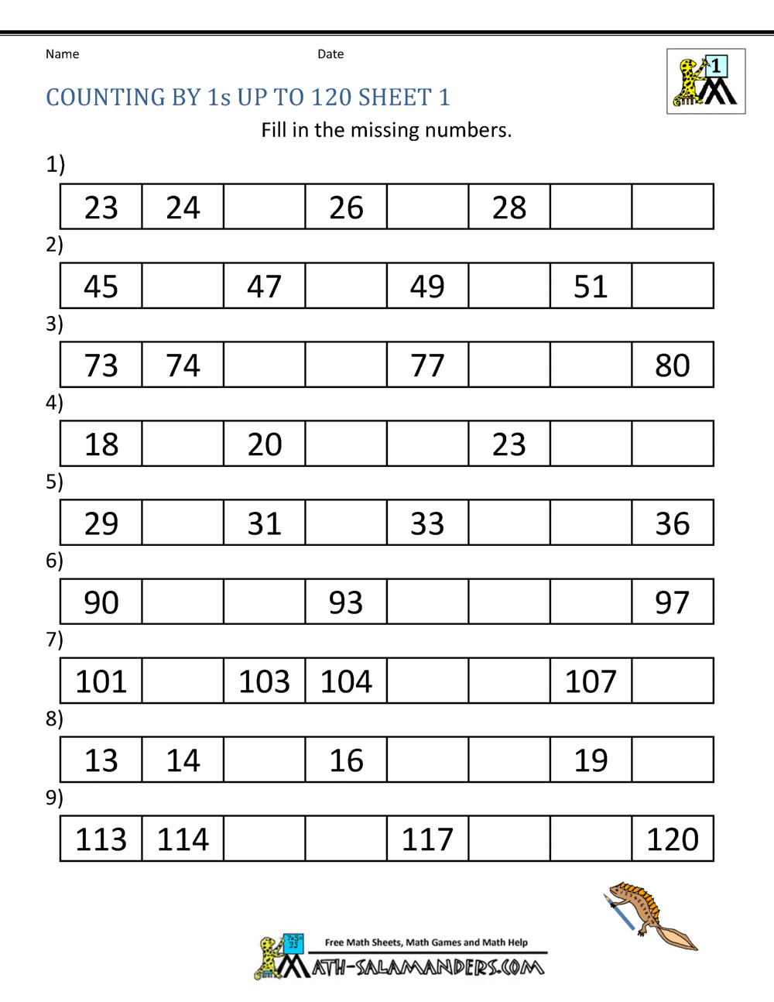
- Write the missing numbers.

