Madni English Medium Primary School

Std : 3rd Date : 10/6/2020

Subject : Kannada Incharge Teacher : Ayesha Darwan

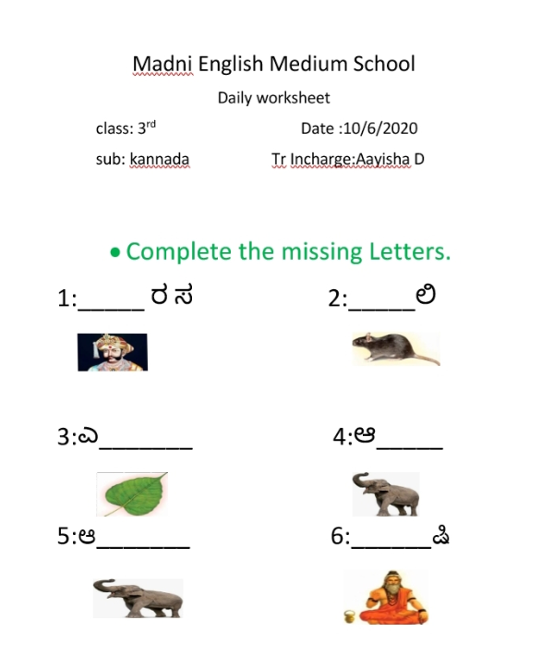Daily Worksheet

