Madni English Medium School
I Homework Sheet - 1
Class: 3rd Subject: EVS
Date: 12/06 /2020 Teacher: Sabiha B
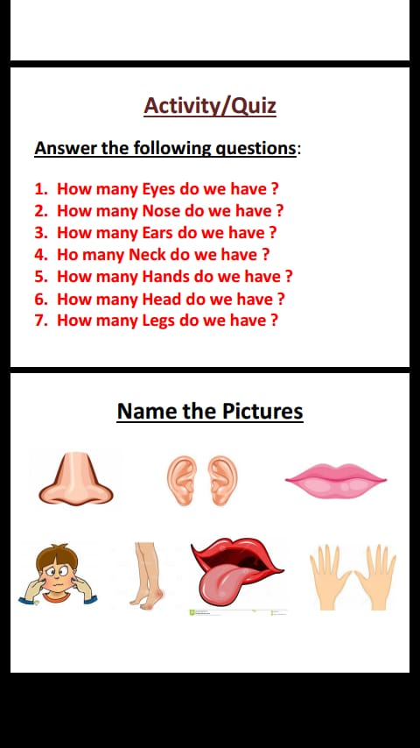

◼ Circle the correct answer: 