MADNI ENGLISH MEDIUM SCHOOL
Daily Assignment
Class: III Date: 15/06/20
Sub: English

1.Each of the following words has a synonym (same meaning) that contains five letters. Choose it from the box and write on the lines.
Write, earth, story, large, hurry,known, thief, right, start, price

1. Big __ __ r __ __
2. Understand __ __ __ __ n
3. Tale __ t __ __ __
4. Correct __ __ __ __ t
5. Begin S __ __ __ __
6. Robber __ __ I __ f
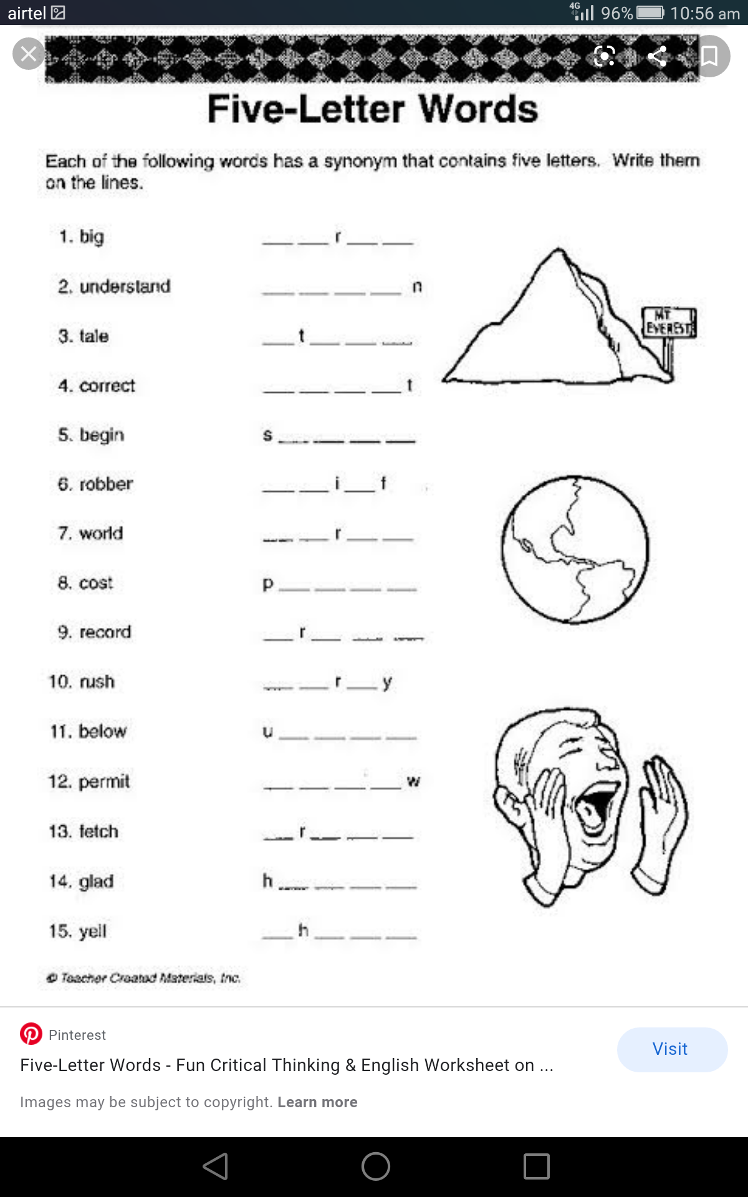
7. World __ a __ __ __
8. Record __ r __ __ __
9. Cost P __ __ __ __
10. Rush __ __ r __ y

2. Write the days of the week

3. Search the given five letter words from the box and colour it with different colours.
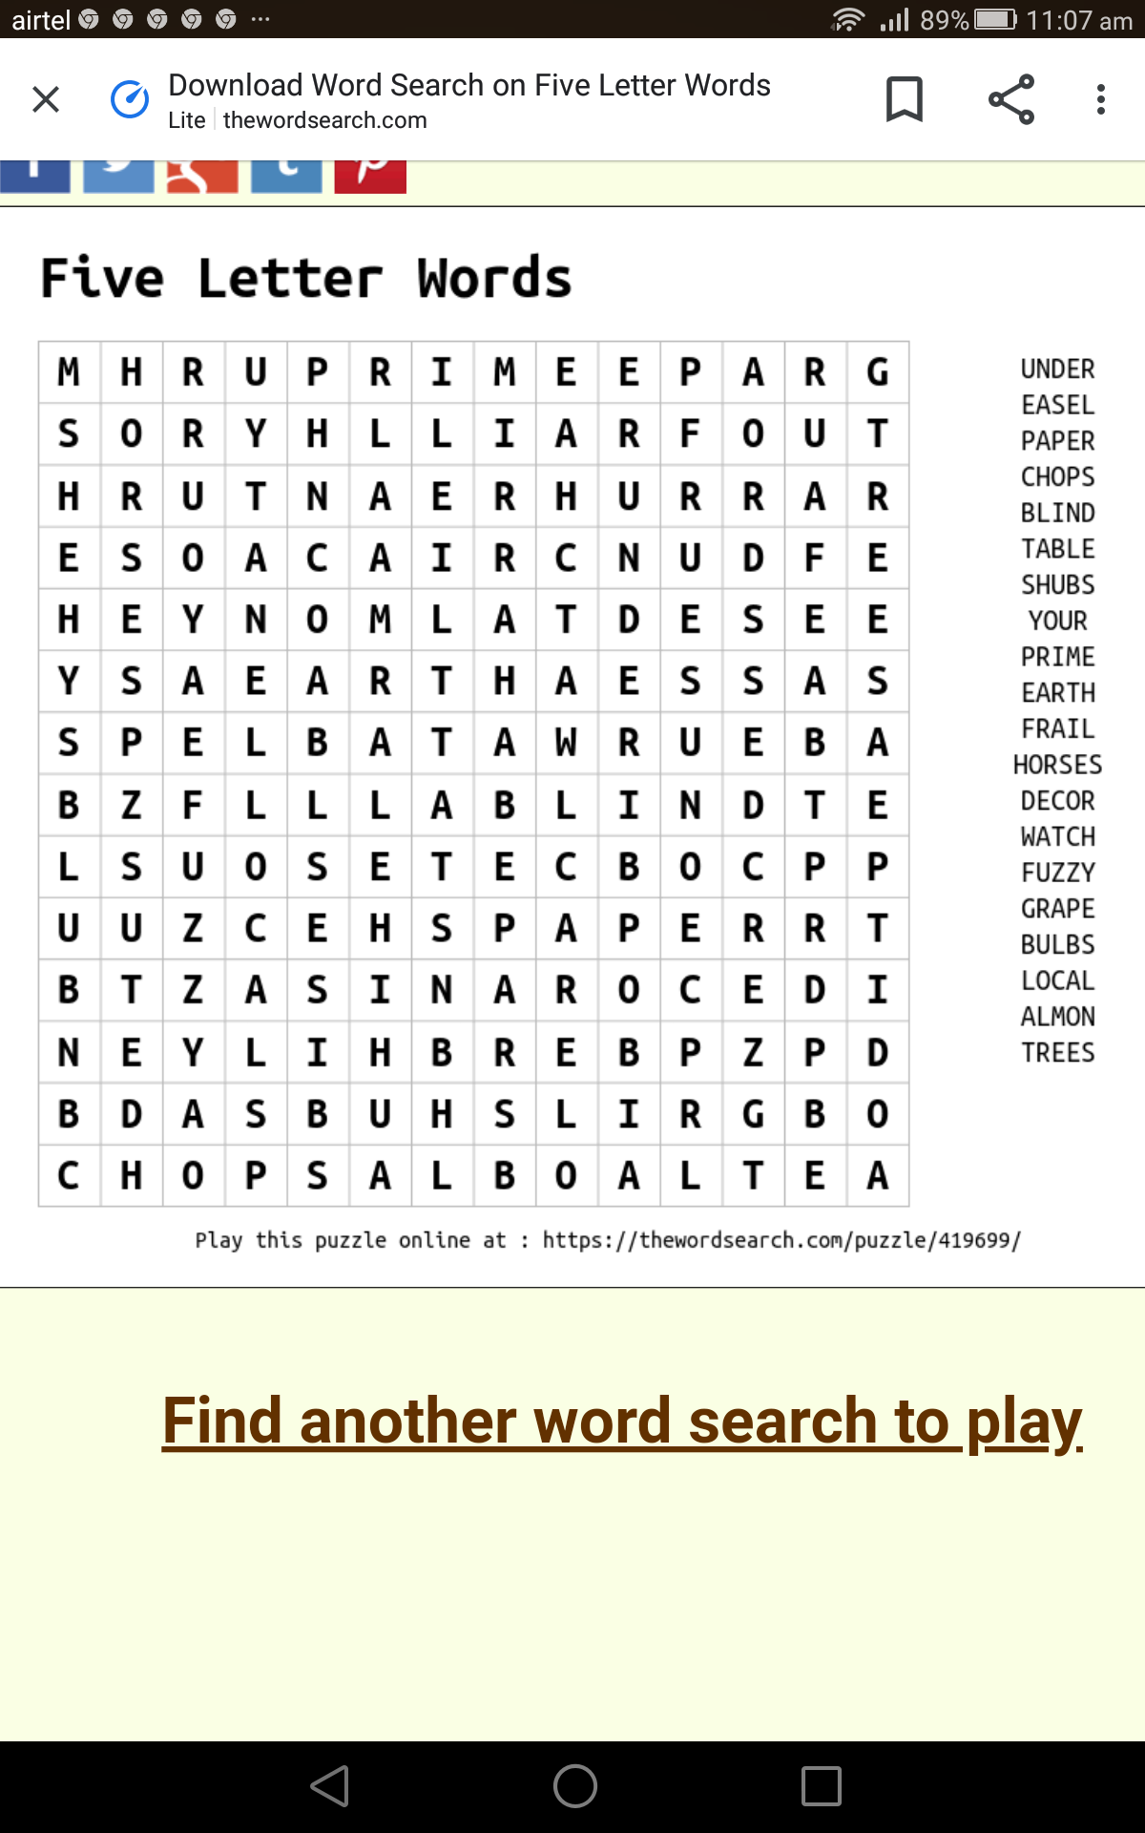

4. Identity the pictures and write their names.


 

