Ln 2, The Overcoat

Extra Meanings

1. Stature – height
2. Wrinkled – having folds
3. Complexion- colour
4. Thrust- push suddenly
5. Customary- usual practice
6. Well bred – well mannered
7. Strewed- scatter
8. Amid- in between
9. Uttered- speak
10. Varied- different
11. Laboured- worked
12. Morrow- tomorrow
13. Foe- enemy
14. Roubles- Russian currency
15. Exhalted- make somebody raise to a higher position
16. Salvation- save from danger
17. Traversing- cross
18. Thawing – show
19. Ridicule- make fun of
20. Pock marks- birth marks on the face
21. Sober- serious
22. Wretched- unhappy
23. Composure- being calm
24. Pursed up his lips –bringing lips tightly in a round shape
25. Utterly- completely
26. Curtail- reduce
27. Dispense- provide
28. Quilting- pattern made in cloth
29. Precisely – exactly
30. Nick of time- last possible moment
31. Threaten – frighten
32. Befits- suits
33. Significant- important
34. Gazed – looked
35. Draped- wear

Grammar

Page 16

1. Binomial Pair: It is a combination of two words usually joined by a conjunction. Options are given you have to join the right pair

For Eg:

1. Neat and tidy
2. Far and wide

**Page 17**

Transitive Verb – A verb which requires an object to complete its sense is called a transitive verb

Intransitive Verb - A verb which does not require an object to complete its sense is called anintransitive verb

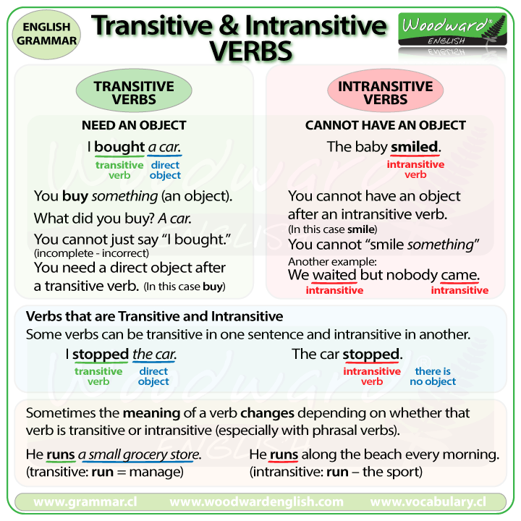

Based on the definition of Transitive & Intransitive verb do the exercise

**Page 18:**

Fill in the blanks with appropriate objects

1. My brother has polished his shoes – Here shoes is the object.

Write the grammar part in your text book. If you don’t have do in your English CW.

*************