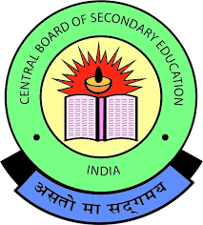S K Education Trust Belagavi’s

SAT SANSKAR INTERNATIONAL SCHOOL

A CBSE Secondary School: Nursery to X

147/6, Near Anandvan Farmhouse; Benakanhalli; Belagavi, 591108 Karnataka

Mobile: 82177 00172, 7975874023, 6362 046 615, mail: [belgaum.tilakwadi@ssrvm.org](mailto:belgaum.tilakwadi@ssrvm.org)

Website**:** [**https://ssisbelagavi.org**](https://ssisbelagavi.org) For Admissions Call: 6362 032 164

School Code: 45892 Affiliation No: 830946

**……………………………………………………………………………………….……………………………………………………………………………………...**

Periodic Test --- I

Name of the student - ________________________________________________ Max Marks: 20

Standard: UKG Subject - EVS Marks obtained - /20

……………………………………………………………………………………………………………………………………………………………....

1. Match the sense picture to correct picture. 1x5=5m

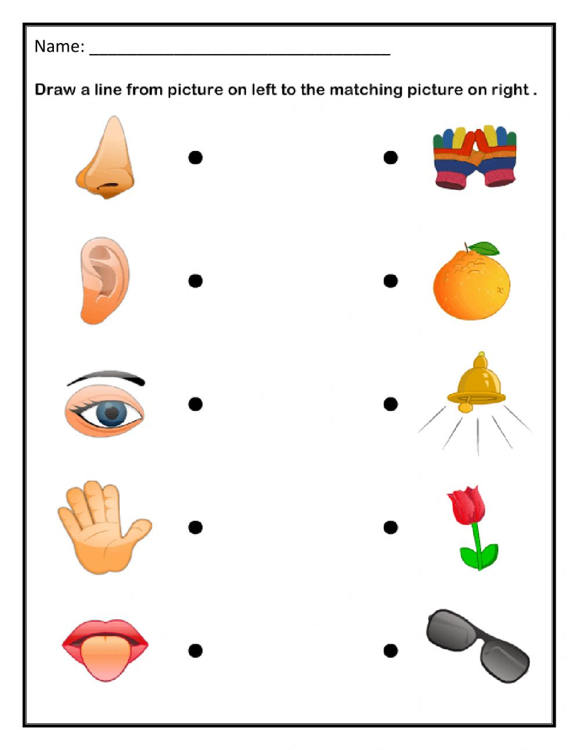

1. Circle the things we need to clean our body parts 1x4=4m

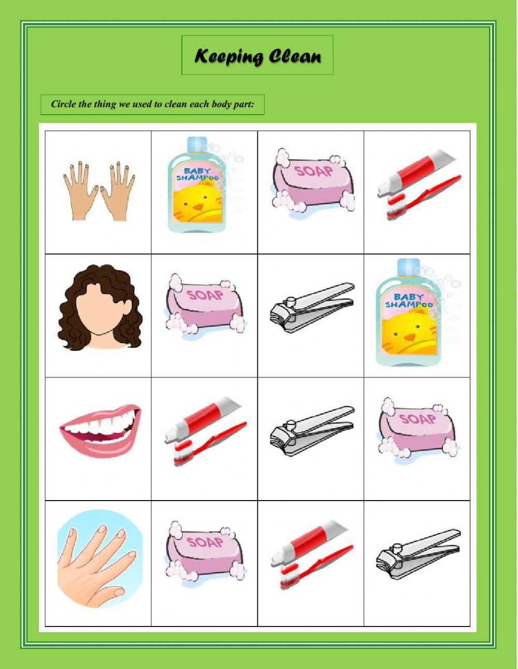

1. Tick the correct word for given picture 1 x4=4m

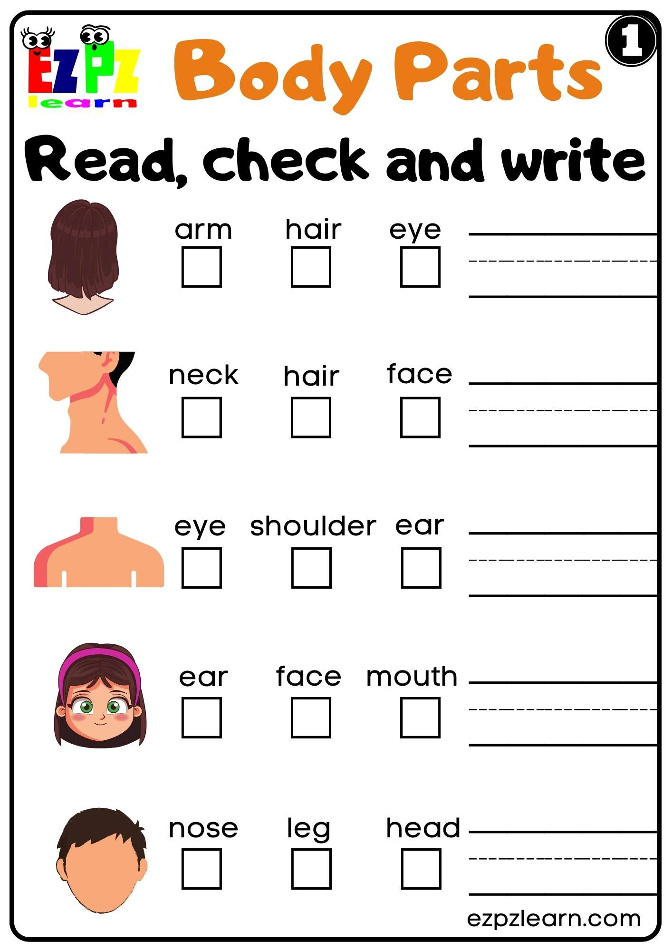

1. Colour the given picture. 1x3 =4m 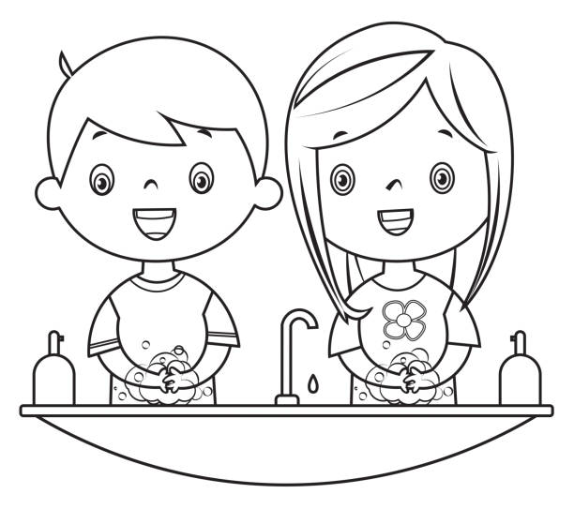

Trace the words for parts of body. 1x4=4m

