**MEASUREMENT AND MOTION**

**II. Answer in brief:**

**1. Define ‘Measurement’.**

Ans) Measurement is the process of comparison of a given physical quantity with a standard unit of that quantity.

**2. Define’ Rest’ and ‘Motion’ .**

Ans) Rest: A body is said to be at rest when it does not change its position with respect to time.

Motion: A body is said to be in motion when it changes its position with respect to time.

**3. Arrange the following in the sequence of their increasing value: 10mm,100m,0.5 km,20cm**

Ans) 10 mm < 20 cm < 100 m < 0.5 km

**4. Convert the following:**

i. i. 22.4 cm = 224 mm

ii. 568 cm = 5.68 m

iii. 18 cm = 0.00018 km

iv. 8300 km = 83,00,000 m

**5. While measuring the length of a pencil, the reading of the scale at one end is 5.5 cm and that at the other end is 17.2 cm. what is the length of the pencil?**

Ans) The length of the pencil is 17.2 – 5.5 = 11.7 cm

**III. Answer in Detail:**

**1. Explain why estimation is necessary in daily life.**

Ans) Estimation is necessary in daily life as :

a) It helps us to gauge the approximate dimension of a given body.

b) It also helps in taking decisions accordingly as every time it is not possible to be precise and accurate.

**2. Discuss why non standard units cannot be used for accurate measurements.**

Ans) Non-standard units cannot be used for accurate measurements as they are not uniform or standard and they cannot be used globally across the world.

**3. Explain with a diagram how parallax error can arise?**

Ans) Parallax error occurs when our eye is not exactly in the line above the reading but it is at an angle.

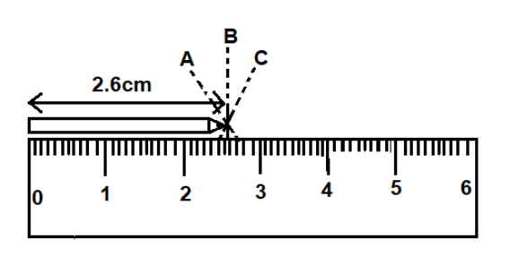

**4. Differentiate between translational motion and rotational motion . Give proper examples.**

|  |  |
| --- | --- |
| Translational motion | Rotational motion |
| Transitional motion is both rectilinear and curvilinear. | Rotational motion is circulatory and about a fixed position. |
| A train moving on a straight track will have rectilinear motion and a ball thrown upwards at an angle will have curvilinear motion. | The motion of a rotating fan. |

**5. What is the difference between periodic and non periodic motion? Give an example for each.**

|  |  |
| --- | --- |
| Periodic Motion | Non periodic motion |
| Periodic motion is regular and repeats after regular intervals of time. | Non-periodic motion is irregular and does not repeat after regular intervals of time. |
| The motion of a pendulum ,the rotation of earth around the sunetc are examples of periodic motion. | The motion of a bee or a fly , children playing in the park etc are examples of non-periodic motion. |

**6. What are the advantages of the SI system?**

Ans) SI system is the international system of units. The advantages of SI system are as follows:

* SI units remain uniform and constant across the globe.
* It becomes easy to exchange scientific data and the results of various experiments among the scientists of different countries.
* They can be used anywhere and everywhere, and the values remain the same if expressed in standard units.

**7. What are the methods used to measure the length of a curved line? Explain with the help of activities.**

**Ans) Method 1-** The length of a curved line can be measured by using a thread

. Aim: Finding the length of a curved line using a thread

Things required: Paper, thread, pencil

Method: • Take thread and place one of its ends at the beginning of the curved line.

• Now, slowly curve the thread along the line.

• Mark the point on the thread that overlaps the other end of the curved line.

• Now straighten the thread and measure it using a ruler.

Conclusion: The length of the curved line is measured.

**Method 2** - You can also use a divider to find out the length of a curve.

Aim: Finding the length of a curved line using the divider

Things required: Divider, pencil, paper

Method: • Draw a curve AB using the pencil on a piece of paper.

• Open the arms of the divider so that there is, say, 2 cm distance between its legs. • Place one leg of the divider on A, and put a mark A1 with another leg on the curve.

• With one leg of the divider resting on A1, put another mark A2 on the curve. Continue like this till the complete curve is divided into equal segments. Measure the part left out separately, because it is less than the distance between the legs of the divider.

Length of the curve = the distance between the legs of the divider × the number of segments of equal lengths + length of the remaining part .

Conclusion: The length of the curve is calculated using the above formula

8. How will you define an error? What are the different types of errors?

Ans) An error is defined as an actual value - measured value.

It can be due to the following reasons:

i. Personal error—an error made by the observer while taking the reading

ii. Instrument error—faulty construction or design of an instrument

iii. Environment error—error due to physical conditions