English- Marks 60

Q.1 write A to Z. Marks 12

Q.2 See the picture and write first letter. Marks 10

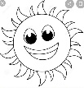

____

Q.3 Match Alphabet. Marks 8

Q H

H Q

Q.4 See the picture and circle the correct letter. Marks5

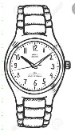

M W N

Q.4 Circle the picture according to alphabet. Marks 5

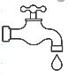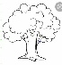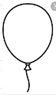

**T -**

**Q.4 Fill in the blanks. Marks 10**

**A _ C _**

**Q.5 circle the odd letter. Marks 5**

**R R P R R**

**Q.6 Tick the common sound picture. Marks 5**

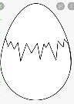 **E -**

**हिंदी- गुण 60**

**प्रश्न 1 . अ से अः तक लिखो । गुण 10**

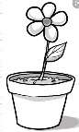**प्रश्न 2. चित्र पहचान कर सही अक्षर लिखो। गुण 5**

**____**

**प्रश्न 3. चित्र को पहला अक्षर से जोडो। गुण 10**

**ध**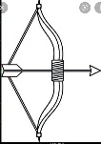

**न**

**प्रश्न 4. खाली स्थान भरो। गुण 10**

**क __ ग ___ ङ**

**प्रश्न 5. अलग अक्षर को गोला लगाओ। गुण 5**

**ज ज ज प ज**

**प्रश्न 6. अगला अक्षर लिखो। गुण 5**

**अ ___**

**प्रश्न 7. अक्षरो को सही क्रम मे रखो। गुण 5**

**क ग ङ ख घ**

**__ __ __ __ __**

**प्रश्न .8**

**Maths - marks 60.**

**Q.1 write Numbers 1 to 20. Marks 10**

**Q.2 write the missing numbers 1 to 20. Marks10**

**1 _ 3 _ 4 _**

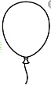**Q.3 Count and write the numbers. Marks 5**

** - _____**

**Q.4 Read the numbers and Draw the object. Marks 5**

**2 triangles - __________________**

**5 Ball - ___________________**

**Q.5 count and circle the corrrect number. Marks 5**

**😊😊😊😊😊😊😊 - 5 7 9**

**❤❤❤❤❤ - 6 8 5**

**Q. 6 concept :- Tick correct the full jug and cross (×) the empty. Marks 2**

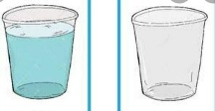 **___ ___**

**Concept:- Look at the picture and write ‘S' for small , ‘M' for medium and ‘L' for large.**

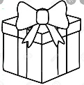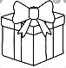 **Marks 5**

**______ _____ _____**

**Concept:- circle the bigger car. Marks 2**

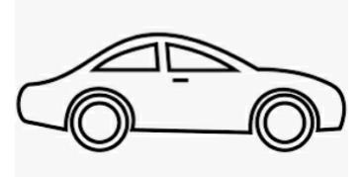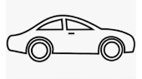

**Q.7 Match the following numbers. Marks 5**

**11 16**

**16 8**

**8 11**

**Q.8 Copy write the given number name 1 to 10. Marks 5**

**ONE – 1 ________**

**TWO – 2 _________**

**Q.9 What comes After numbers. Marks 3**

**9 - __ , 16 - __**

**Q.9 What comes Before numbers. Marks 3**

**___ - 8 , ___ - 12**