**Important topics: 12th April 2021**

**Animal cell:**

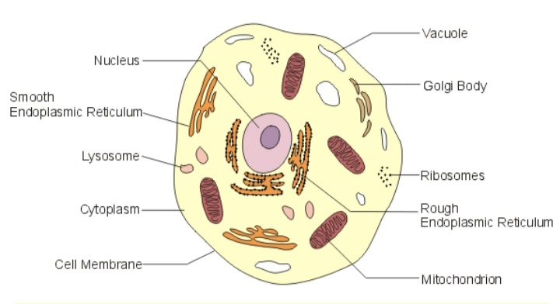

1] The Cell Membrane

The cell membrane packages up the cell and all it’s organelles. Water , energy and nutrients enter the cell and waste material leaves the cell through the cell membrane.

2] The Cytoplasm

The cytoplasm of a cell is not really an organelle –it is the fluid the organelles are bathed in. It contains proteins , sugars and other substances that help the cell function properly.

3] Vacuoles

Vacuoles are storage areas. They are surrounded by membranes and filled with liquid or solid material. Vacuoles are much bigger in plant cells.

4. golgi body

The goli body makes some of the chemicals produced within the cell.It also collects and packages the chemicals for transport to the different parts of the cell.

5. lysosomes:

Lysosomes contain enzymesthat breakdown cell material . when organelle die they are surrounded by the lysosome and broken down by the enzyme.

6. Ribosomes:

Ribosome s are found in the cytoplasm, in mitochondria and they make endoplasmic reticulum rough. Ribosomes make protein.

6. Rough endoplasmic reticulum:

This is made up of a network of membranes folded into a serious sheets or tubes. It is covered in ribosomes giving it a grainy look , proteins are made here.

7. Smooth endoplasmic reticulum:

This has differen functions in different cells

8. Mitochondria:

Respiration occurs in the mitochondria they are called as the ‘power house of the cell’

9. The Nucleus:

It is the klargest organelle within animal cell. Nucleus controls the cell activity. It also contains the cell’s chromosomes

Plant Cell:

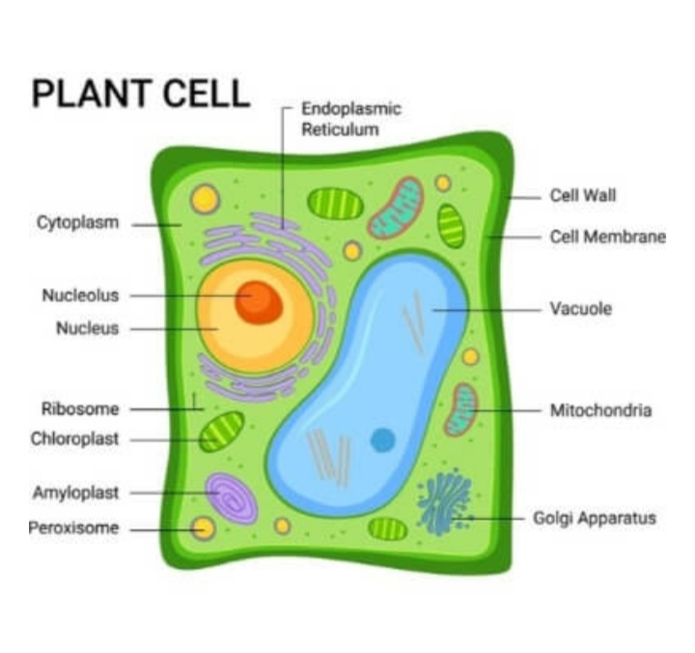

1. Cell wall:

A rigid layer that is composed of cellulose , glycoproteins. It is located outside the cell membrane. It comprises proteins , polysaccharides and cellulose.

The primary function of the cell wall is o protect and provide structural support to the cell. It also filters the molecules passing in and out of the cell.

1. Cell membrane:

It is present withn the cell wall.it is composed of a layer of proteins and fatsIt plays an important role I regulating the entry and exit of specific substances within the cell.

1. Nucleus:

This is an important structure present only I eukaryotic cells. The vital function is to store DNA or hereditary information required for cell division, metabolism and growth.

*Nucleolus: it manufactures protei producing structure and ribosomes

*Nucleopore: allows proteins and nucleic acid to pass through.

4. Plastids:

Hey are organelles that contain their own DNA. They are necessary to store starch to carry out photosynthesis.

1. Central vacuole:

The vital role of central vacuole is to sustain turgid pressure against the cell wall. It consists of call sap. It is a mixture of salts, enzymes and other substance

1. Golgi apparatus:

They are found in eukaryotic cells, which are involved in distributing synthesized macromolecules to various parts of the cell.

1. Ribosomes:

They comprise of RNA and protein. Also known as protein factories of the cell.

1. Mitochondria:

They are found in the cytoplasm of the eukaryotic cello. They provide energy by breaking down carbohydrate and sugar molecules, hence known as power house of the cell

1. Lysosomes:

They hold the digestive enzyme in an enclosed membrane. They perform the function of cellular waste disposal by digesting worn out organelle food particles and foreign body.