**2020 – 21**

**Assignment Term II**

Student Name: Class: 1 Roll no:

--------------------------------------------------------------------------------------

**INDEX**

|  |  |  |  |  |
| --- | --- | --- | --- | --- |
| No | Subject | Topic | Submission | sign |
|  | English | Comprehension |  |  |
|  |  | Story Writing |  |  |
|  | Grammar | Worksheet |  |  |
|  | Maths | semester 1- pg 95, 96, 136- 142 |  |  |
|  | Cherry text bk | semester 2 – pg104, 105, 141 - 144 |  |  |
|  | EVS | Community Helpers |  |  |
|  |  | festivals |  |  |
|  | Hindi | शब्ध |  |  |
|  |  | गिनती |  |  |
|  | Marathi | वर्णमाला |  |  |
|  |  | रंगांचे नाव |  |  |
|  | Play & Learn | Worksheet 1 |  |  |
|  |  | Worksheet 2 |  |  |
|  | GK | Stick pictures- 7 wonders of the world |  |  |
|  |  | Stick picture & write information on S Statue of unity  Taj mahal  Red fort  Qutub minar |  |  |
|  | Computer | 1. Write 5 uses of computer |  |  |

* Assignment file carry 30marks
* Files to be submitted on 12th February 2021 Time: 9am to 10am)
* 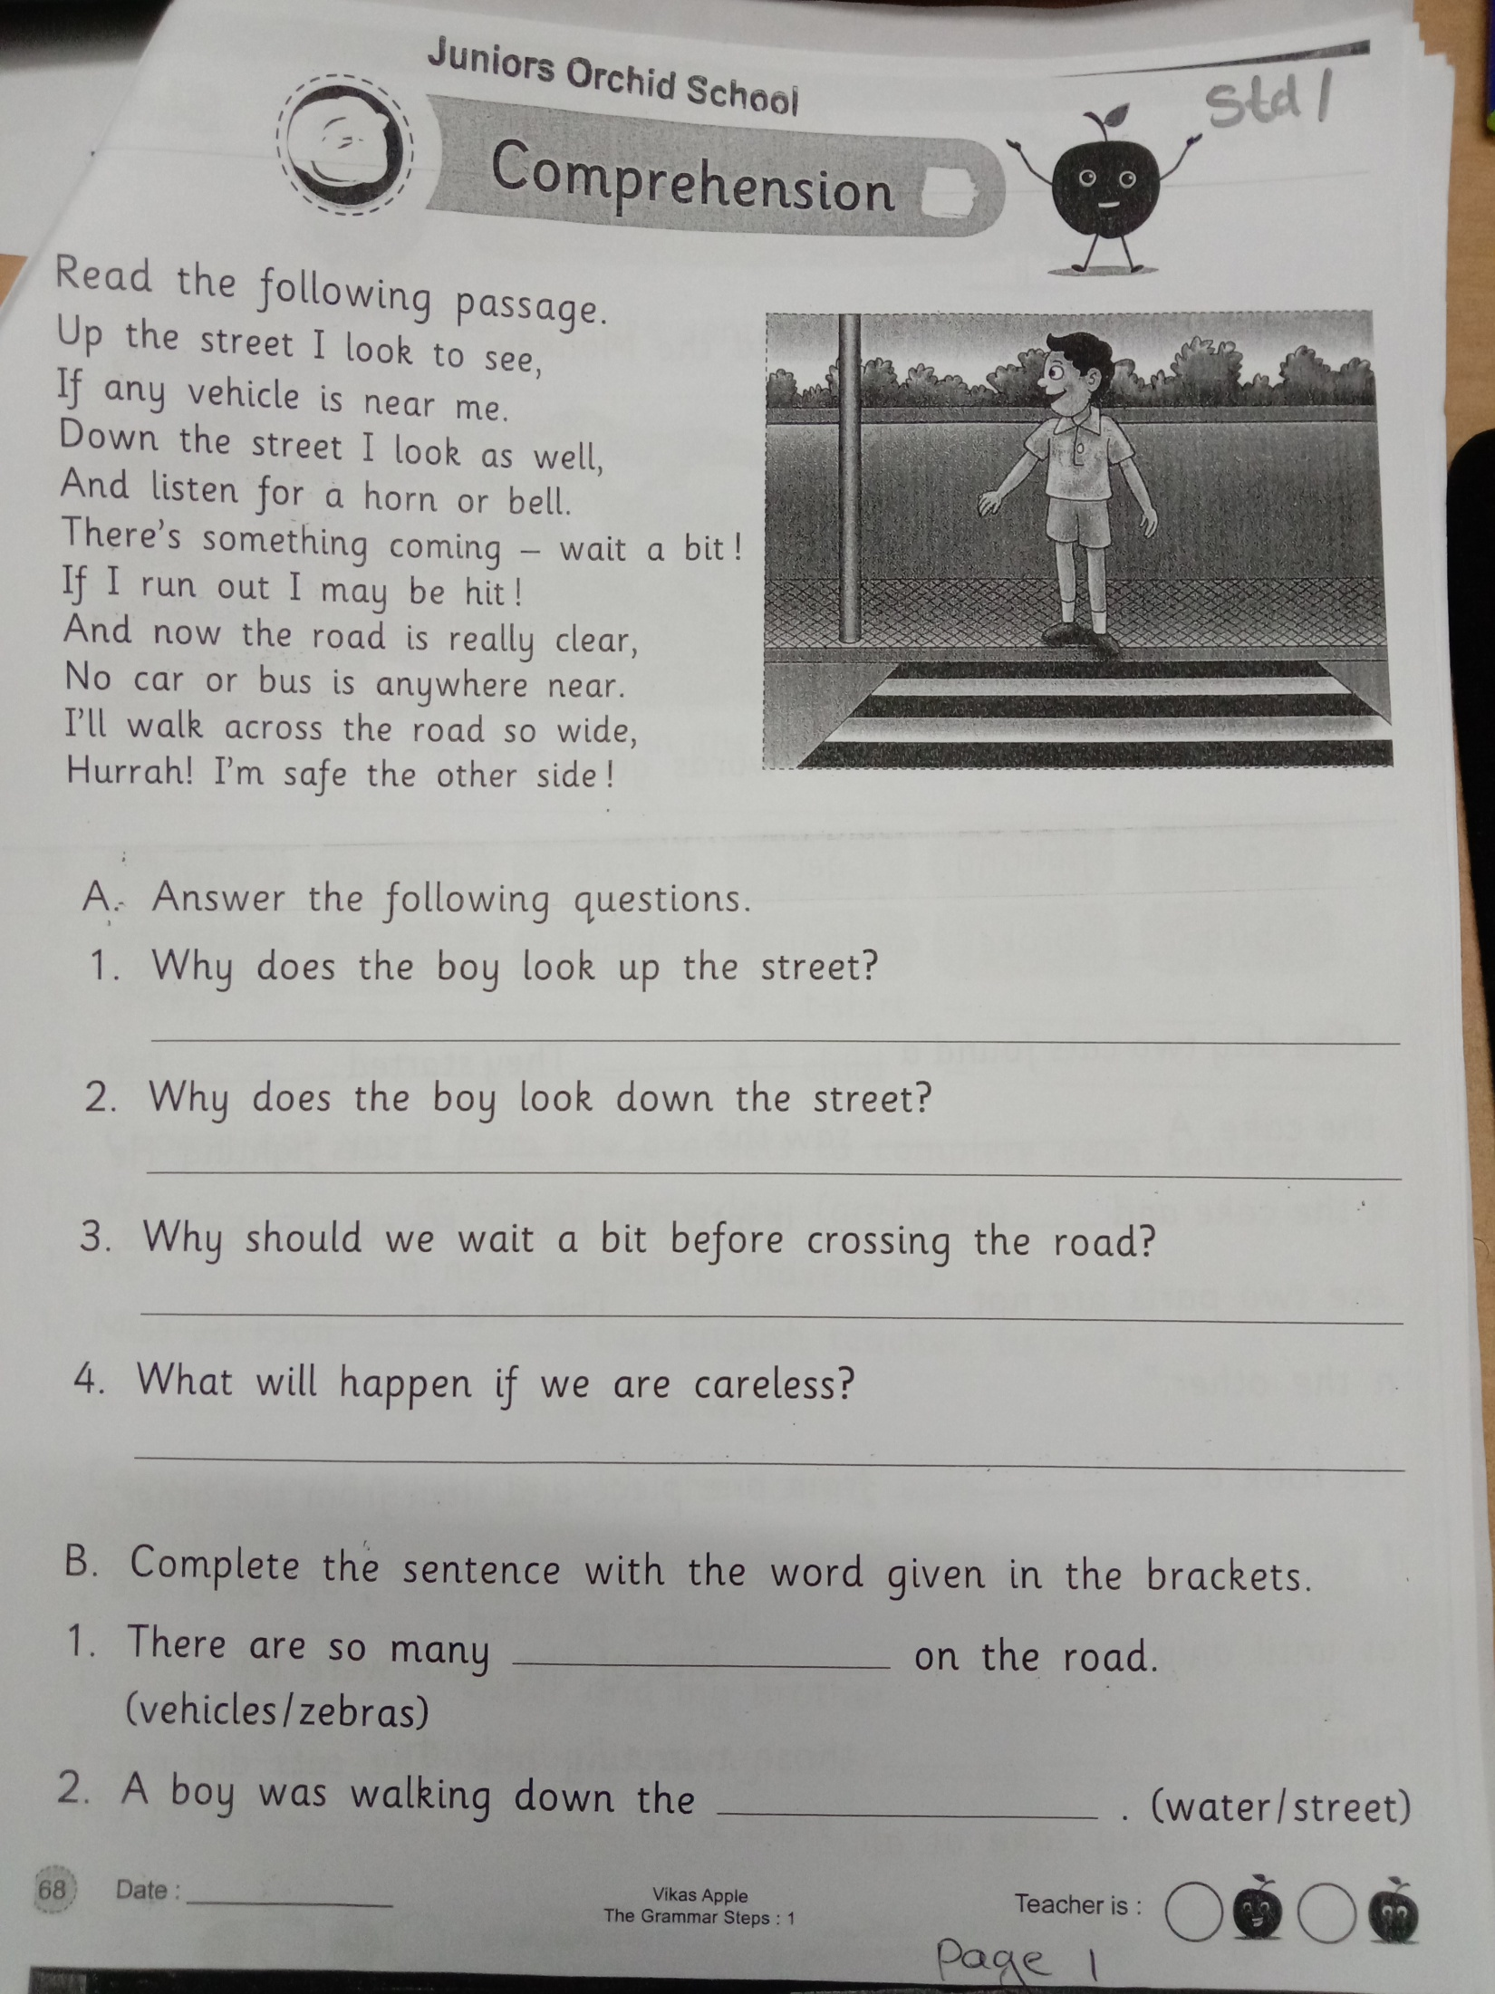

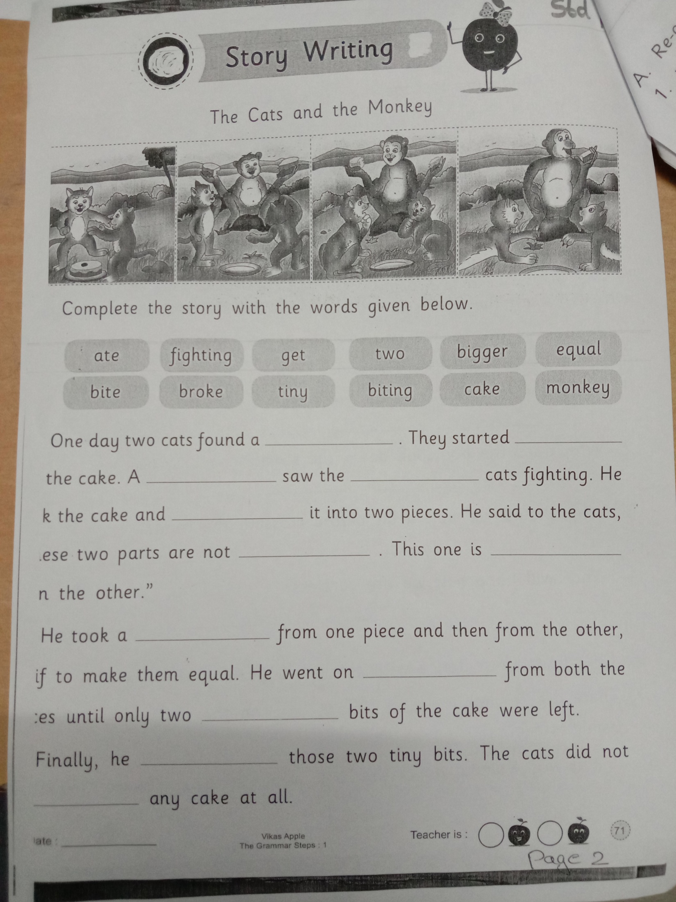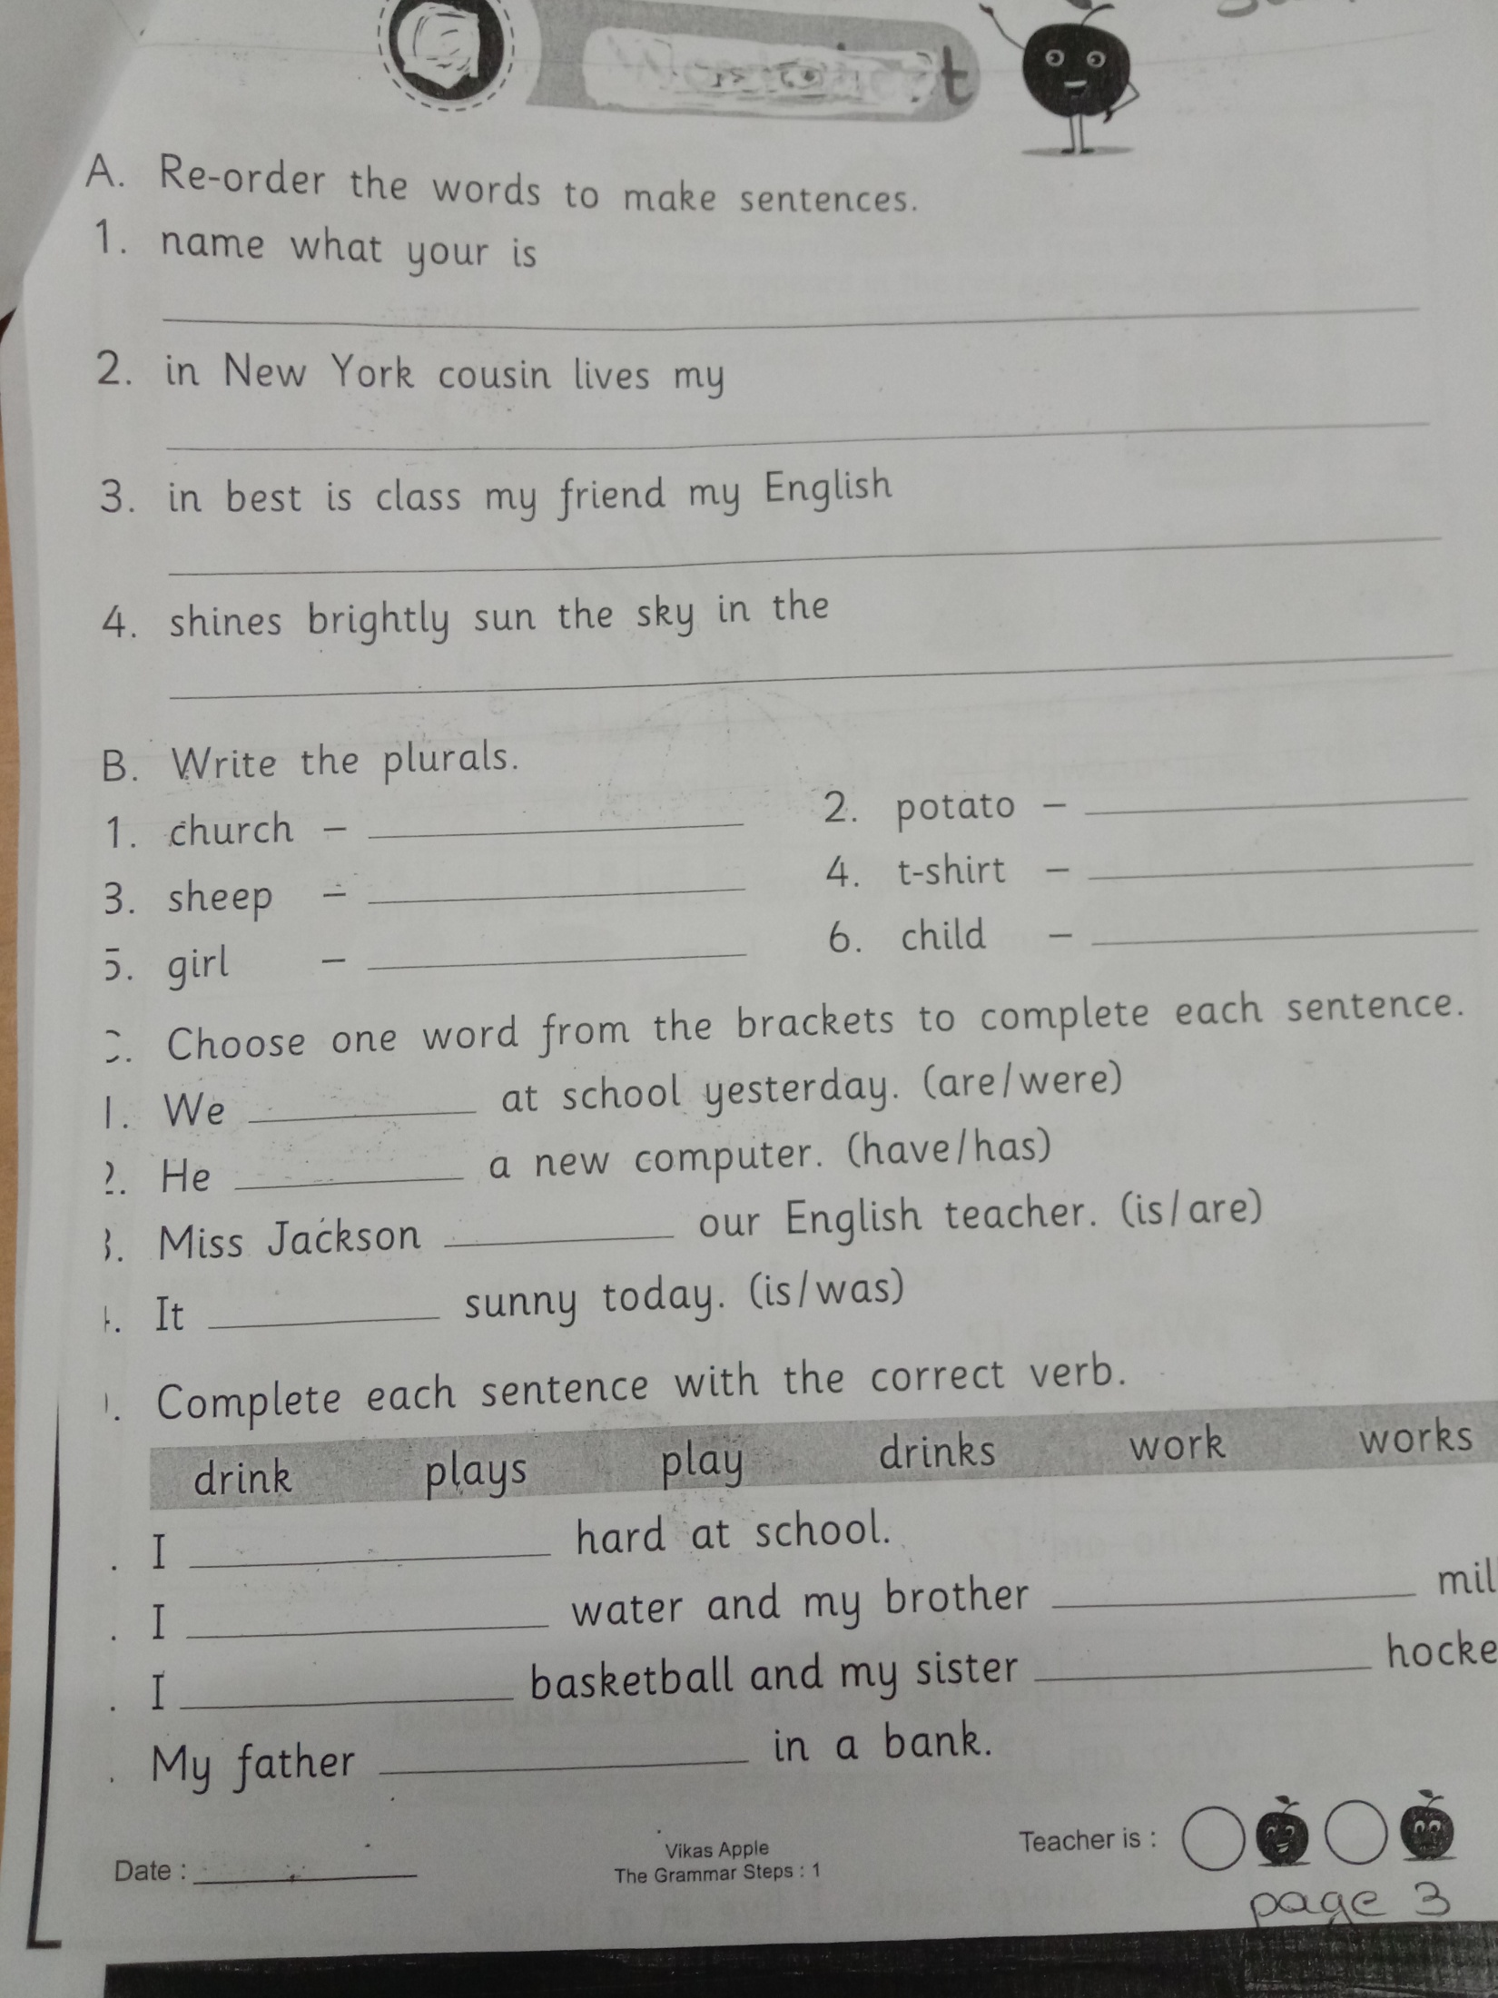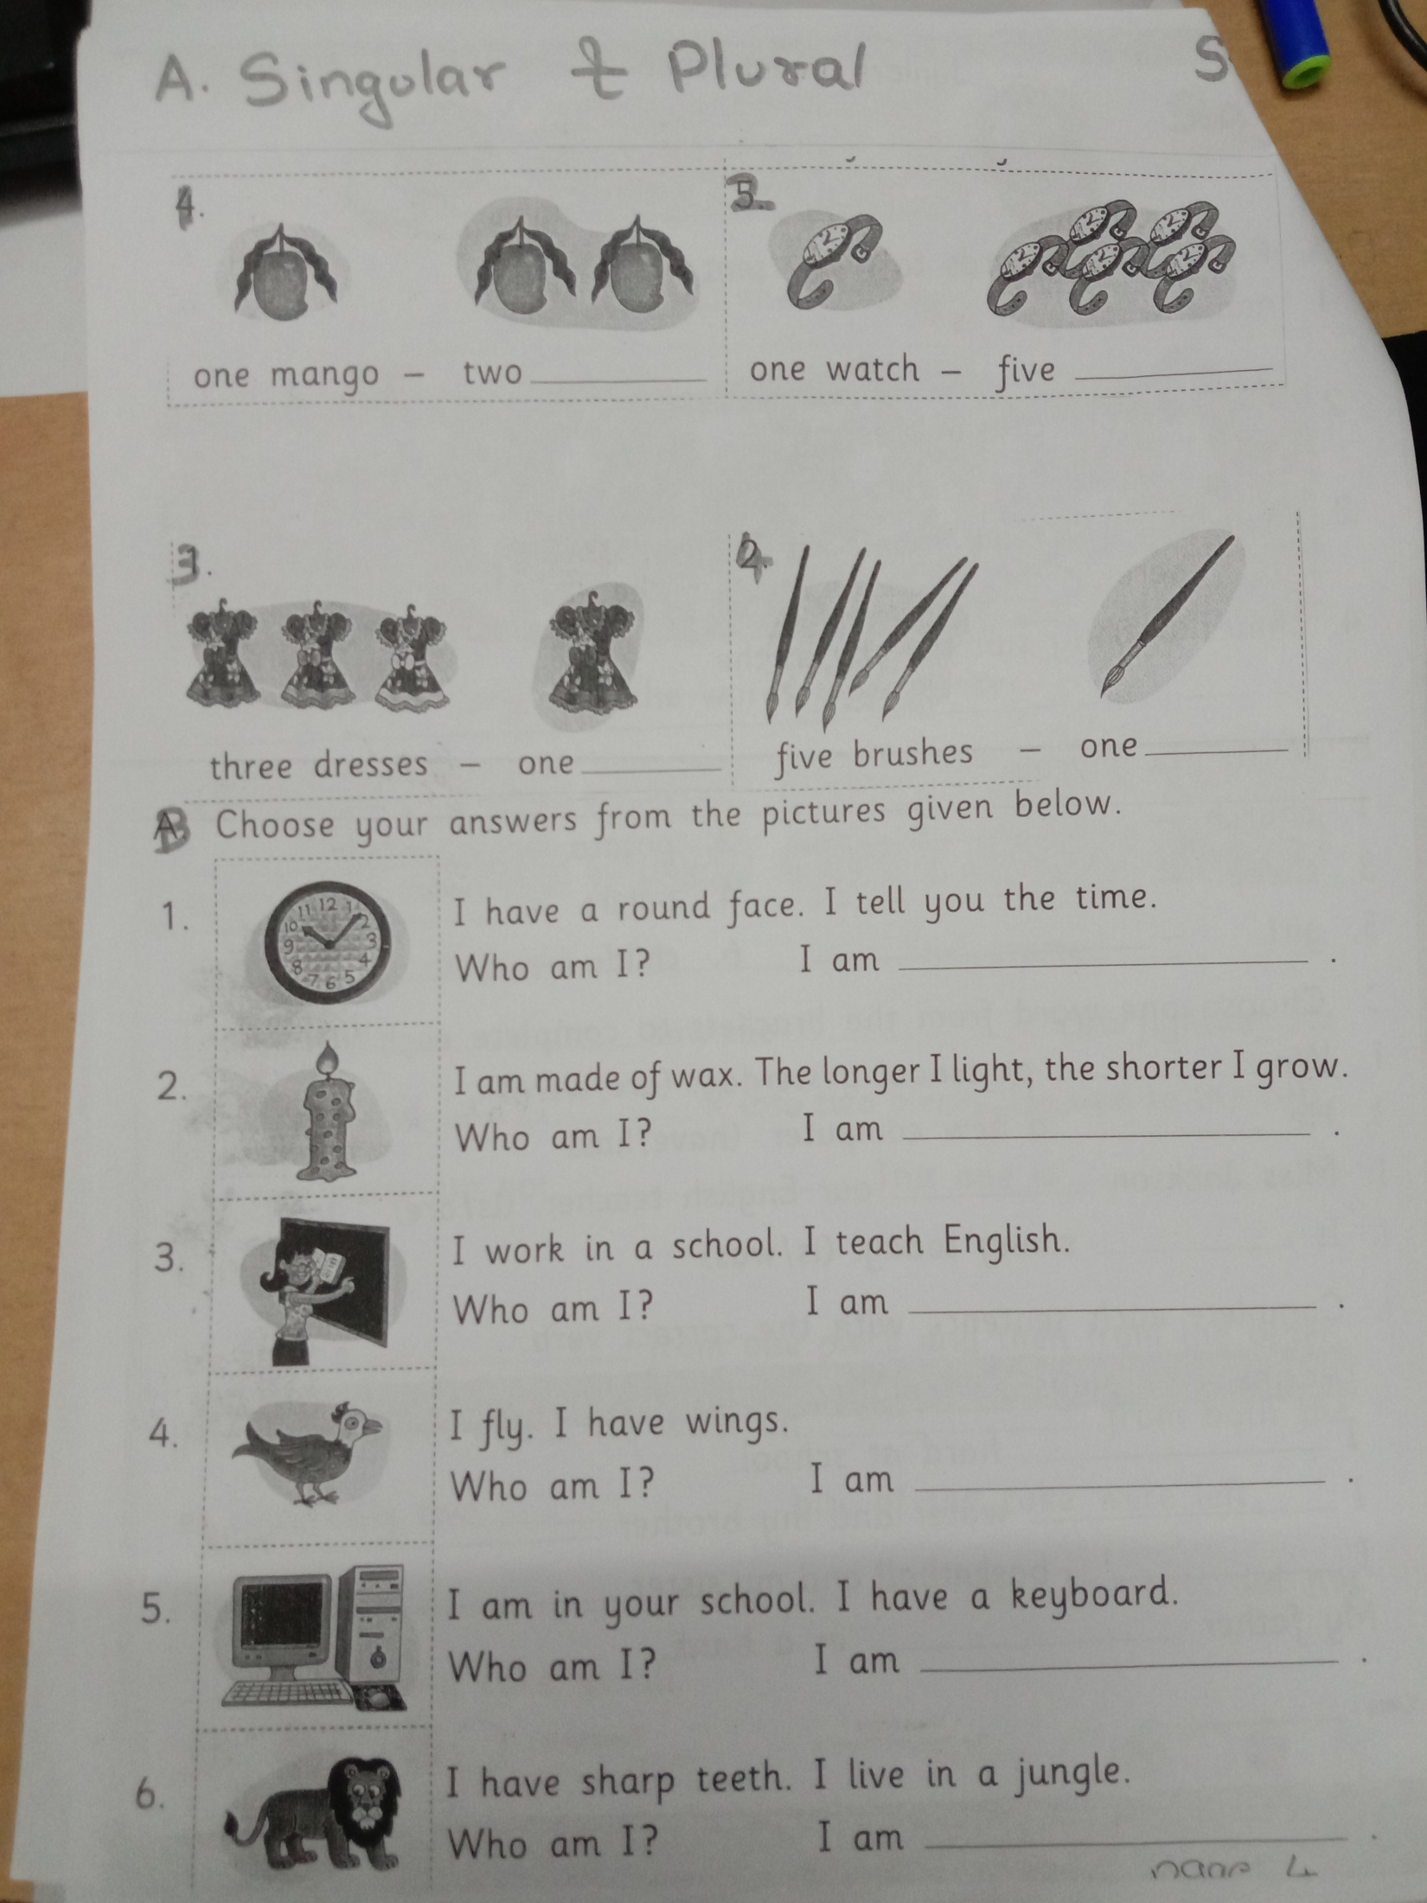

**EVS : Community Helpers std 1**

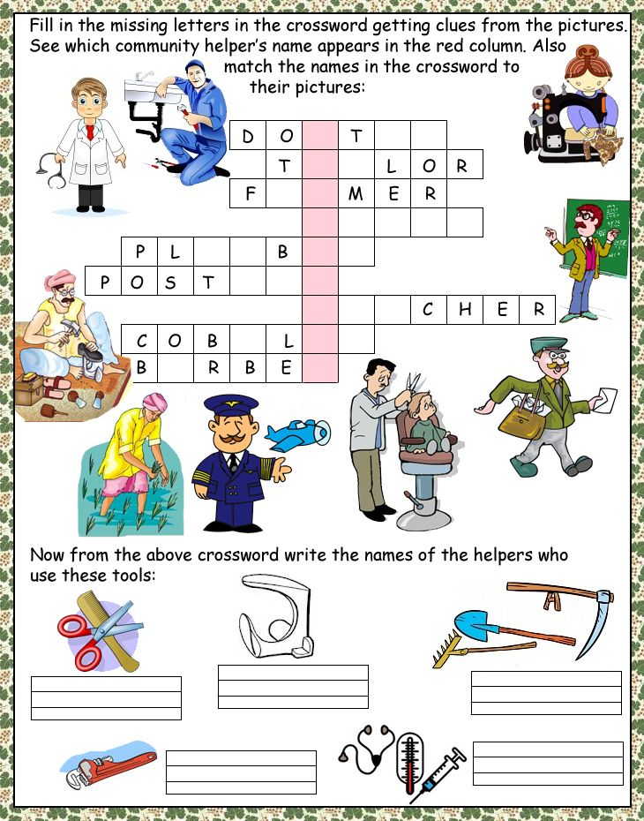

**EVS: festivals std 1**

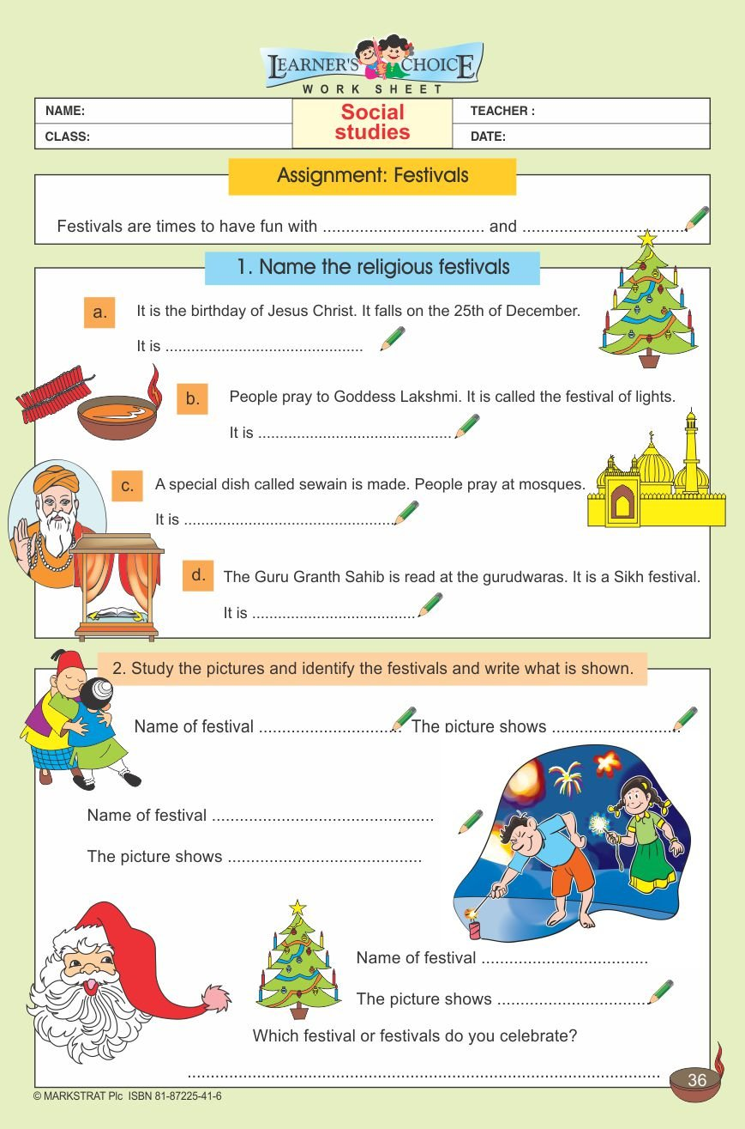

**Hindi – forming words std 1**

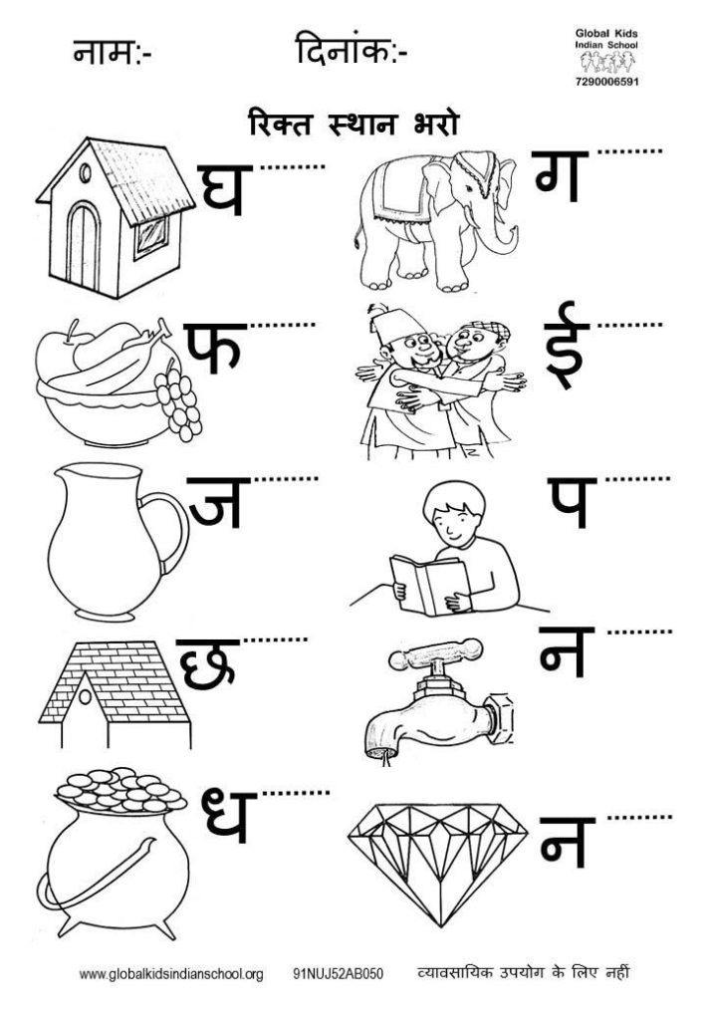

**Hindi : count 1-10 std 1**

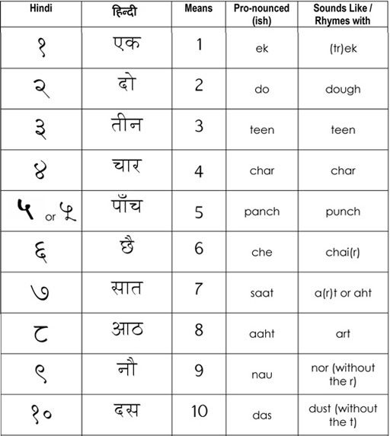

Re-write the given words

Marathi – स्वर

|  |  |  |  |  |  |  |
| --- | --- | --- | --- | --- | --- | --- |
| अ | आ | इ | ई | उ | ऊ | ऋ |
|  |  |  |  |  |  |  |
| ए | ऐ | ओ | औ | अं | अः |  |
|  |  |  |  |  |  |  |

|  |  |  |  |  |
| --- | --- | --- | --- | --- |
| क | ख | ग | घ | ड. |
|  |  |  |  |  |
| च | छ | ज | झ | ञ |
|  |  |  |  |  |
| ट | ठ | ड | ढ | ण |
|  |  |  |  |  |
| त | थ | द | ध | न |
|  |  |  |  |  |
| प | फ | ब | भ | म |
|  |  |  |  |  |
| य | र | ल | व | श |
|  |  |  |  | ज्ञ |
| ष | स | ह | ळ | क्ष |
|  |  |  |  |  |

व्यंजन

मराठी: इंद्र ध्ंनुष्यात रंग भरून रंगांचे नावे लिहा

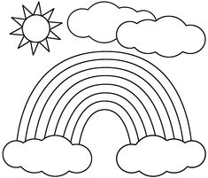

|  |  |
| --- | --- |
| English | मराठी |
| Violet |  |
| Indigo |  |
| Blue |  |
| Green |  |
| Yellow |  |
| Orange |  |
| Red |  |

Play & learn

