**Junior’s Orchid High School & St. Michael’s (Primary Section)**

**Pimple Gurav**

Std :- 1st **Final Exam**  Marks: 20

Subject : Maths Date:

Branch: 60 feet / Kalpataru / sangvi

………………………………………………………………………………………………………………………………………………………………………………………

**Q1. Complete the blanks: 5mks**

1. …………………………………….. is the 10th month of the year.
2. February has ………………… days in a leap year.
3. There are …………………..days in August month.
4. December is the …………… month of the year.
5. There are …………………… months in a year.

**Q2. Look at the clock and write the time: 3mks**

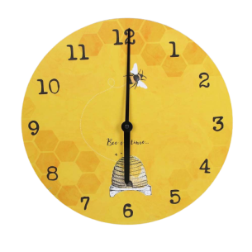 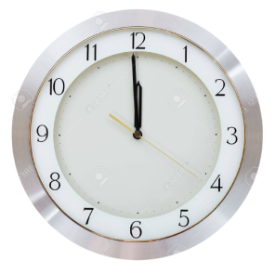 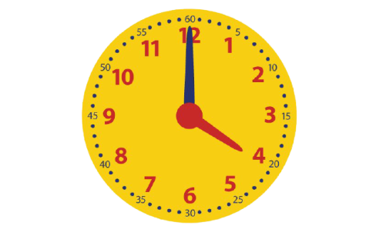 1)…….………………………… 2)…..………………………………… 3)……….…………………………

**Q3. Look at the calendar and answer the questions: 2mks**

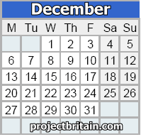

1. Which is the first Monday of the month?

………………………………………………………………………………………………………

1. How many days are there in this month?

………………………………………………………………………………………………………

1. 31st December comes on which day?

………………………………………………………………………………………………………

1. On which day is Christmas celebrated?

…………………………………………………………………………………………………………

**Q4. Solve the following: 4mks**

**1) H T O 2) H T O 3) H T O 4) H T O**

**3 4 8 8 4 2 5 7 9 8 9 3**

**+ 3 2 1 -- 5 3 0 + 4 1 0 -- 7 6 2**

**……………………….. ……………………….. ………………………. ……………………**

**……………………….. ……………………….. ………………………. ……………………**

**Q5. Solve: 3mks**

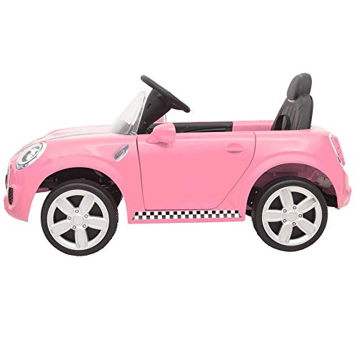  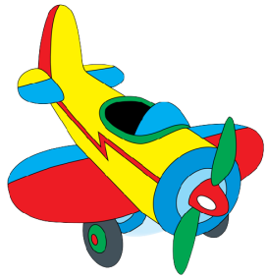

**Rs 15 Rs 10 Rs 32**

1. What is the price of the ball and the toy car together? …………………………………
2. What is the total price of the toys? …………………………………
3. What is the price of the car and the plane together? ………………………………..

**Q6. Word Problems: 3mks**

1. **There are 7 ice creams. If 4 are eaten, how many ice creams are left?**
2. **There are 15 apples in a basket. Raj added 4 more. How many apples are**

**There altogether?**

1. **There are 12 leaves on a branch. 5 leaves fell off. How many leaves**

**Are left?**