**Junior’s Orchid High School & St. Michael’s (Primary Section)**

**Pimple Gurav**

Std :- 1st **Final Exam**  Marks: 20

Subject : English Date:

Branch: 60 feet / Kalpataru / sangvi

………………………………………………………………………………………………………………………………………………………………………………………

**Q1. Complete the blanks with the correct question words: 2mks**

1. ……………………………………….. is the bus going?
2. ………………………………………… are you doing?

**Q2. Re arrange the words to form meaningful sentences: 2 mks**

1. is your What name?

……………………………………………………………………………………………………………………

1. ice cream like I eat to

…………………………………………………………………………………………………………………

**Q3. Give the opposite words for: 2mks**

1. huge x ………… 3. Many x ………… 3. Near x …………… 4. Love x ………….

**Q4. Fill in the blanks: 5mks**

1. Kalia is a …………………………………………………….
2. Mummy is busy in the kitchen baking a ………………………………Strawberry cake.
3. The rabbit was very …………………………………………….
4. The King wanted more money, so he set out to ……………………a country.
5. Varun has ……………........................all his friends and cousins.

**Q5. Make meaningful sentences: 1 mk**

1. Mother - ……………………………………………………………………………………
2. Clever - ……………………………………………………………………………………………………

**Q6. Answer the questions: 2mks**

1. What was the surprise gift? …………………………………………………………………………..

……………………………………………………………………………………………………………………….

1. What does Suraj’s dog do?

……………………………………………………………………………………………………………………….

………………………………………………………………………………………………………………………

**Q7. Look at the picture and write few lines to describe it: 3mks**

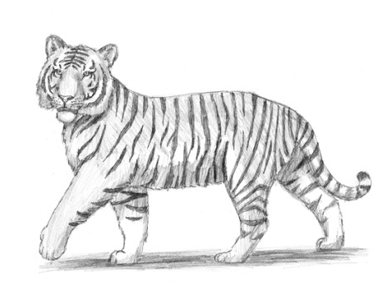…………………………………………………………………………………………

…………………………………………………………………………………………

…………………………………………………………………………………………

………………………………………………………………………………………………………………………………

………………………………………………………………………………………………………………………………

………………………………………………………………………………………………………………………………

………………………………………………………………………………………………………………………………

Q8. Write few lines on ‘My Mother’ 3mks

………………………………………………………………………………………………………………………………

………………………………………………………………………………………………………………………………

………………………………………………………………………………………………………………………………

………………………………………………………………………………………………………………………………

………………………………………………………………………………………………………………………………

………………………………………………………………………………………………………………………………

………………………………………………………………………………………………………………………………

……………………………………………………………………………………………………………………………….

………………………………………………………………………………………………………………………………

………………………………………………………………………………………………………………………………