BIOLOGY

CLASS 10

LESSON WISE QUESTION BANK

LESSON – STRUCTURE OF CHROMOSOMES, CELL CYCLE AND CELL DIVISION

* **Differentiate between the following:**

1. Mitosis and meiosis
2. Chromosome and chromatid
3. G1 phase and G2 phase
4. Centrosome and centromere
5. Aster and spindle fibre
6. DNA and RNA
7. Cytokinesis and Karyokinesis

* **Define the following**:

1. Mitosis
2. Meiosis
3. Cell cycle
4. Chromosomes
5. Chromatin
6. Cell division
7. Genes
8. Nucleosomes

* **Short answer type questions:**

1. (a) what is interphase?

(b) Mention three significant changes that occur in a cell during this phase?

1. With the help of neat sketches, show how cytokinesis differs in a plant cell and an animal cell.
2. Write about the nitrogenous bases found in RNA and DNA.
3. Give the significance of mitosis.
4. Give the significance of meiosis.

* **Long answer questions:**

1. **Given below is a diagram representing a stage during mitotic cell division in an animal cell. Examine it carefully and answer the questions which follow.**

* 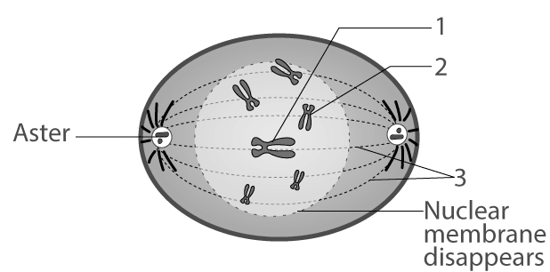

**(a) Identify the stage. Give one reason in support of your answer.**

**(b) Name the cell organelle that forms the ‘aster’.**

**(c) Name the parts labelled 1, 2 and 3.**

**(d) Name the stage that follows the one shown here. How is that stage identified?**

**2. Shown below are four stages (A, B, C, D) (not in sequence) of a certain kind of cell division.**

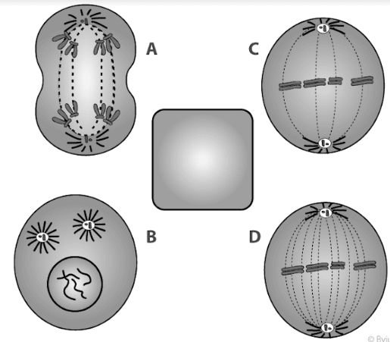

**(a) Is it a plant cell or an animal cell? Give two reasons.**

**(b) Is it undergoing mitosis or meiosis?**

**(c) What should be the correct sequence of these four stages among themselves?**

**(d) Name the stage that should precede the earliest of these stages.**

**3. Given below is a diagram of a double helical structure of DNA:**

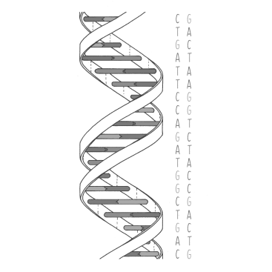

1. **Give the full form of DNA.**
2. **Name the unit of heredity.**
3. **Name the components of a single DNA strand.**

**4. Given below is a schematic diagram of a portion of DNA.**

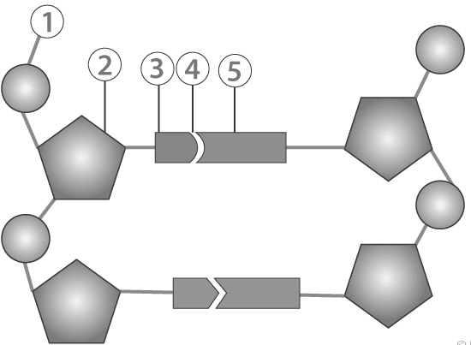

**(a) How many strands are shown in the diagram?**

**(b) How many nucleotides have been shown in each strand?**

**(c) Name the parts numbered 1,2,3,4 and 5 respectively.**

**(d) Name the DNA unit constituted by the parts 1, 2 and 3 collectively.**

**Note:**

1. **Cell cycle and stages of cell cycle with diagram.**

LESSON – GENETICS – SOME BASIC FUNDAMENTALS

* **Define the following terms:**

1. **Genetics**
2. **Mendel’s laws of inheritance**
3. **Heredity**
4. **Variations**
5. **Character**
6. **Traits**
7. **Karyotype**
8. **Alleles**
9. **Heterozygous**
10. **Homozygous**
11. **Dominant allele**
12. **Recessive allele**
13. **Genotype**
14. **Phenotype**
15. **Monohybrid cross**
16. **Dihybrid cross**
17. **Mutation**
18. **Pedigree chart**
19. **Law of segregation**
20. **Law of dominance**
21. **Law of independent assortment**

* **Short answer type questions:**

1. **Why did Mendel select garden pea for his experiments on genetics?**
2. **Does the sex of the child depend on the father? Discuss.**

* **Long answer questions:**

1. **(i) A pure tall plant (TT) is crossed with a pure dwarf plant (tt).**

**Draw Punnett squares to show (a) F1 generation (b) F2 generation**

**(ii) Give the phenotype of the F2 generation.**

**(iii) Give the phenotypic and genotypic ratio of the F1 and F2 generation.**

**(iv) Name any two X-linked disease found in humans.**

**NOTE:**

1. **X-linked inheritance**
2. **Mutation**

LESSON – ABSORPTION BY ROOTS

* **Define the following terms:**

1. **Plant physiology**
2. **Imbibition**
3. **Diffusion**
4. **Osmosis**
5. **Osmotic pressure**
6. **Endosmosis**
7. **Exosmosis**
8. **Isotonic**
9. **Hypotonic**
10. **Hypertonic**
11. **Turgidity**
12. **Flaccidity**
13. **Plasmolysis**
14. **Active transport**
15. **Passive transport**
16. **Turgor pressure**
17. **Wall pressure**
18. **Root pressure**
19. **Bleeding**
20. **Guttation**

* **Give reason:**

1. **Potato cubes when placed in water become firm and increase in size.**
2. **Resins swell up when kept in water.**
3. **Wilted lettuce leaves become firm/crisp when placed in cold water for a while.**
4. **Much salt is added to pickles.**

* **Short answer type questions:**

1. **Give examples of turgor movements in plants.**
2. **Explain two manifestations of root pressure.**
3. **Explain the term plasmolysis. Give one application of this phenomenon in our daily lives.**
4. **List out the uses of turgidity to plants.**

* **Long answer type questions:**

1. **State three ways in which roots are suited for absorbing water.**
2. **Leaves of a sensitive plant wilt and droop down on a slight touch. What mechanism brings about this change?**
3. **Given below are diagrams of plant cells as seen under the microscope after having been placed in two different solutions:**

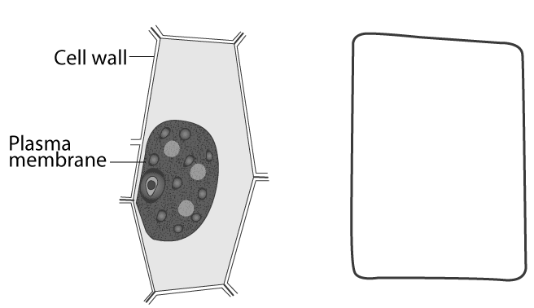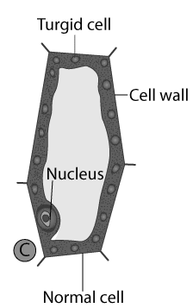

1. **What is the technical term for the condition of?**

**(i) cell A (ii) Cell B**

**(b) From the solutions given in the brackets (water, strong sugar solution, 1% salt solution) name the solution into which:**

**(i) Cell A (ii) Cell B**

**Was placed before being viewed under the microscope.**

1. **The diagram given below represents an experimental set-up to demonstrate a certain process. Study the same and answer the questions that follow:**

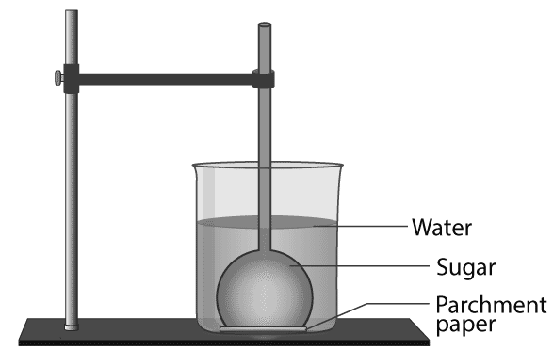

**(a) Name the process.**

**(b) Define the above-named process.**

**(c) What would you observe in the experimental set-up after an hour or so?**

**(d) What control experiment can be set up for comparison?**

**5. . Study the diagram given below and answer the questions that follow:**

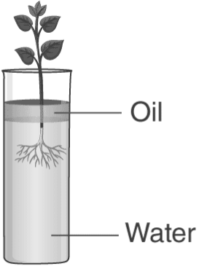

**(a) Name the process being studied in the above experiment.  
(b) Explain the process mentioned above.**

**(c) Why is oil placed over water?  
(d) What do we observe with regard to the level of water when this set up is placed in**

**(1) bright sunlight (2) humid conditions (3) windy day?  
(e) Mention any three adaptations found in plants to foster the process mentioned in (a) above**

6. **A candidate in order to study the process of osmosis has taken 3 potato cubes and put them in 3 different beakers containing 3 different solutions. After 24 hours, in the first beaker the potato cube increased in size, in the second beaker the potato cube decreased in size and in the third beaker, there was no change in the size of the potato cube. The following diagram shows the result of the same experiment.**

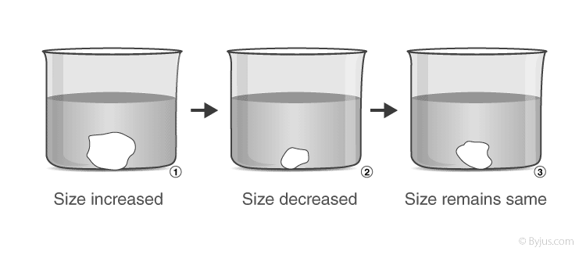

**(a) Give the technical terms of the solutions used in the beakers 1, 2 and 3.**

**(b) In beaker 3, the size of the potato cube remains the same. Explain the reason in brief.**

**(c) Write the specific features of the cell sap of root hair which helps in absorption of water.**

**(d) What is osmosis?**

**(e) How does a cell wall and a cell membrane differ in their permeability?**

LESSON – TRANSPIRATION

* **Define the following:**

1. Transpiration
2. Potometer
3. Lenticels
4. Guttation
5. Bleeding
6. Exudate
7. Exudation
8. Hydathodes
9. Cuticle
10. wilting

* **Differentiate between:**

1. Guttation and bleeding
2. Stomata and lenticels
3. Transpiration and evaporation
4. Stomatal transpiration and lenticular transpiration

* **Write one main function of the following:**

1. Stomata
2. Hydathodes
3. Sunken stomata
4. Lenticels
5. Cuticle

* **Give reasons for the following:**

1. The rate of transpiration increases in hot and dry weather.
2. Water transpired is water absorbed.
3. In some xerophytes leaves are modified into spines.
4. Excessive transpiration results in the wilting of the leaves.
5. More transpiration occurs from the lower surface of the leaves.
6. Forests tend to bring rains.

* **Short answer type questions:**

1. Mention the significance of transpiration.
2. Give the different ways by which a plant transpires.

* **Long answer type questions:**

1. List some adaptations found in desert plants to reduce transpiration.
2. How does the rate of transpiration get affected by ?
3. Wind velocity (b) Intensity of light (c) Humidity
4. **Given below is the diagram of an apparatus used to study a particular phenomenon in plants:**

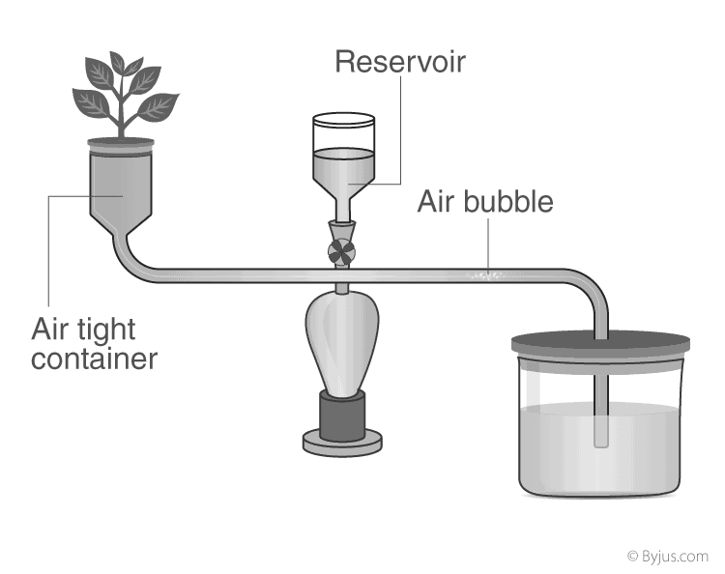

**(a) Name the apparatus.**

**(b) What is it used for?**

**(c) What is the role played by the air-bubble in this experiment?**

**(d) What is the use of the reservoir?**

**(e) What happens to the movement of the air-bubble if the apparatus is kept:**

**(i) In the dark** **(ii) In sunlight** **(iii) In front of a fan**

**4. Given ahead is the diagram of an experimental set up to study the process of transpiration in plants. Study the same and then answer the questions that follow:**

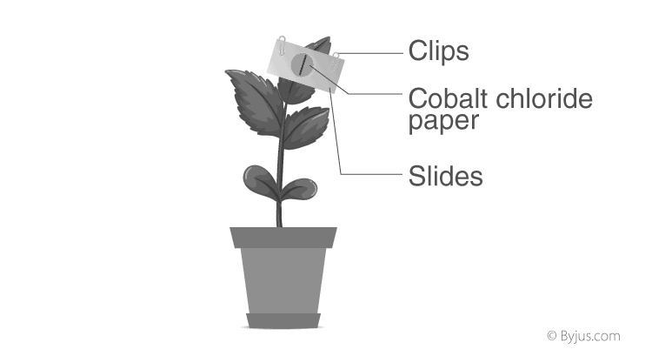

**(a) Name the colour of dry cobalt chloride paper.**

**(b) Is the experimental leaf a monocot or a dicot? Give a reason to support your answer.**

**(c) Why are glass slides placed over the dry cobalt chloride papers?**

**(d) After about half an hour what change, if any, would you expect to find in the cobalt chloride paper placed on the dorsal and ventral sides of the leaf? Give a reason to support your answer.**

**5.  An apparatus as shown below was set up to investigate a physiological process in plants. The setup was kept in sunlight for two hours. Droplets of water were then seen inside the bell jar. Answer the questions that follow:**

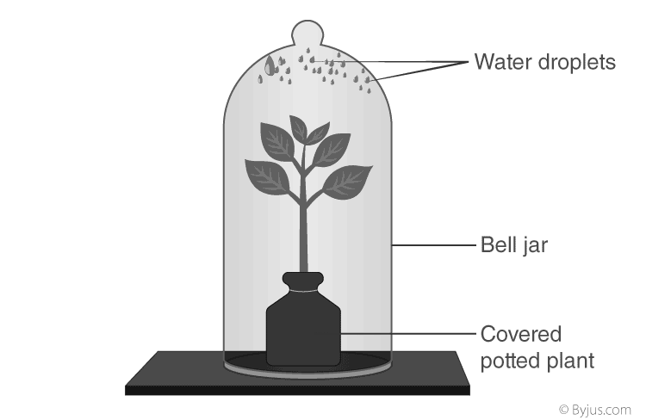

**(a) Name the process being studied.**

**(b) Explain the process named above in (a).**

**(c) Why was the pot covered with a plastic sheet?**

**(d) Suggest a suitable control for this experiment.**

**(e) Mention two ways in which this process is beneficial to plants.**

**(f) List three adaptations in plants to reduce the above mentioned process.**

LESSON – CHEMICAL COORDINATION IN PLANTS

* **Differentiate between the following:**

1. Auxins and gibberelins
2. Ethylene and abscisic acid
3. Hydrotropism and geotropism
4. Phototropism and thigmotropism
5. Chemotropism and heliotropism

* **Define the following:**

1. Phytohormone
2. Parthenocarpy
3. Tropism
4. Tropic movements
5. Clinostat
6. Apical dominance

* **Write the functions of:**

1. Gibberelins
2. ABA
3. Cytokinins
4. Auxins
5. Ethylene

* **Short answer type questions:**

1. Tips of the shoots move towards light. Explain.
2. The leaflets of *Mimosa pudica* droop on being touched by a finger or an object. Give reason.
3. The tendrils of a climber grows around the support. Give reason.
4. Roots move towards soil in the ground. Explain.

* **Long answer type questions:**

1. **What are tropic movements? Briefly explain various types of tropic movements in plants.**
2. **The response of plants to gravity is known as geotropism. How are plant parts sensitive to gravity? Describe with the help of a diagram.**

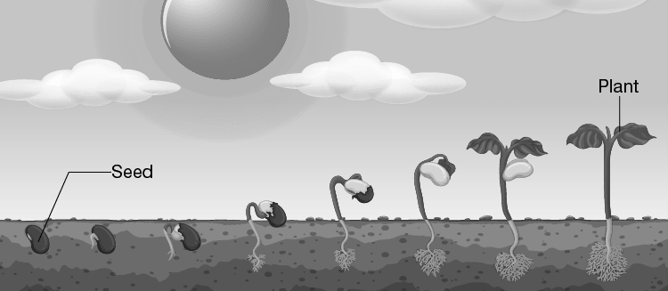

**NOTE:**

1. Functions of the plant hormones
2. Tropic movements in plants (along with activities)

LESSON – POLLUTION

* **Define the following:**

1. Waste
2. Pollution
3. Biodegradable waste
4. Non-biodegradable waste
5. Pollutant
6. Smog
7. Water pollution
8. Air pollution
9. Sewage
10. Effluent
11. Oil spills
12. Soil pollution
13. Sanitary landfills
14. DDT
15. Radiation
16. Noise pollution
17. Acid rain
18. Greenhouse
19. Global warming
20. Thermal pollution

* **Short answer type questions:**

1. Explain the term ‘Bharat Emission Standard’
2. Carbon monoxide is highly dangerous when inhaled. Explain
3. Mention the environmental impacts of oil spills.
4. State the harmful effects of acid rain.
5. State the harmful effects of noise pollution on human health.
6. How are the plants and forests affected by the acid rain.
7. Explain the term greenhouse effect.
8. Suggest the ways of reducing the global warming.
9. Mention the effects of ozone depletion.

* **Long answer type questions:**

1. What are the impacts of greenhouse effect?
2. Discuss the human activities responsible for climate change in recent years.
3. What is Swachh Bharat Abhiyan? Give its main objectives.
4. What are Bharat Stage Vehicular Standards?
5. List the aims and norms of Bharat Stage Vehicular Standards?
6. **The picture below shows a campaign recently started by the Indian Government.**

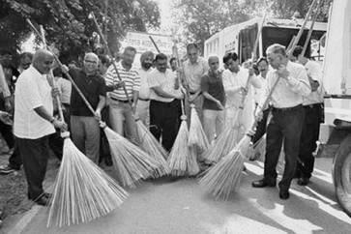

**(i) Who launched this campaign and when?**

**(ii) Mention some chief objectives of this campaign.**