BIOLOGY

CLASS 9

LESSON WISE QUESTION BANK

LESSON – INTRODUCING BIOLOGY

* **Answer the following questions:**

1. Define Biology.
2. Who is known as father of Biology?
3. Who is known as father of Zoology?
4. Who is known as father of Botany?
5. Who is known as father of Medicine?
6. Write a note on special group of organisms.

LESSON – CELL- THE UNIT OF LIFE

* **Differentiate between the following:**

1. Protoplasm and Cytoplasm
2. Nucleolus and Nucleus
3. Centrosome and Chromosome
4. Cell wall and Cell membrane
5. Plant cell and Animal cell
6. Leucoplasts and Chromoplasts

* **State the major functions of the following parts in a cell:**

1. Cell membrane
2. Cell wall
3. Cytoplasm
4. Endoplasmic reticulum
5. Ribosomes
6. Mitochondria
7. Golgi apparatus
8. Lysosomes
9. Plastids
10. Leucoplasts
11. Chromoplasts
12. Chloroplasts
13. Nucleus

* **Short answer type questions:**

1. How many chromosome pairs are found in humans?
2. Why are mitochondria known as the powerhouse of the cell?
3. Why are the cells small sized?
4. What is cell? Who discovered it?

* **Long answer type questions:**

1. Draw neat labeled diagrams of animal cell and plant cell.
2. What is the cell theory? State the three key points of the cell theory.
3. Name the different types of plastids. Give one function of each type.
4. **Given below is a figure of a cell:**

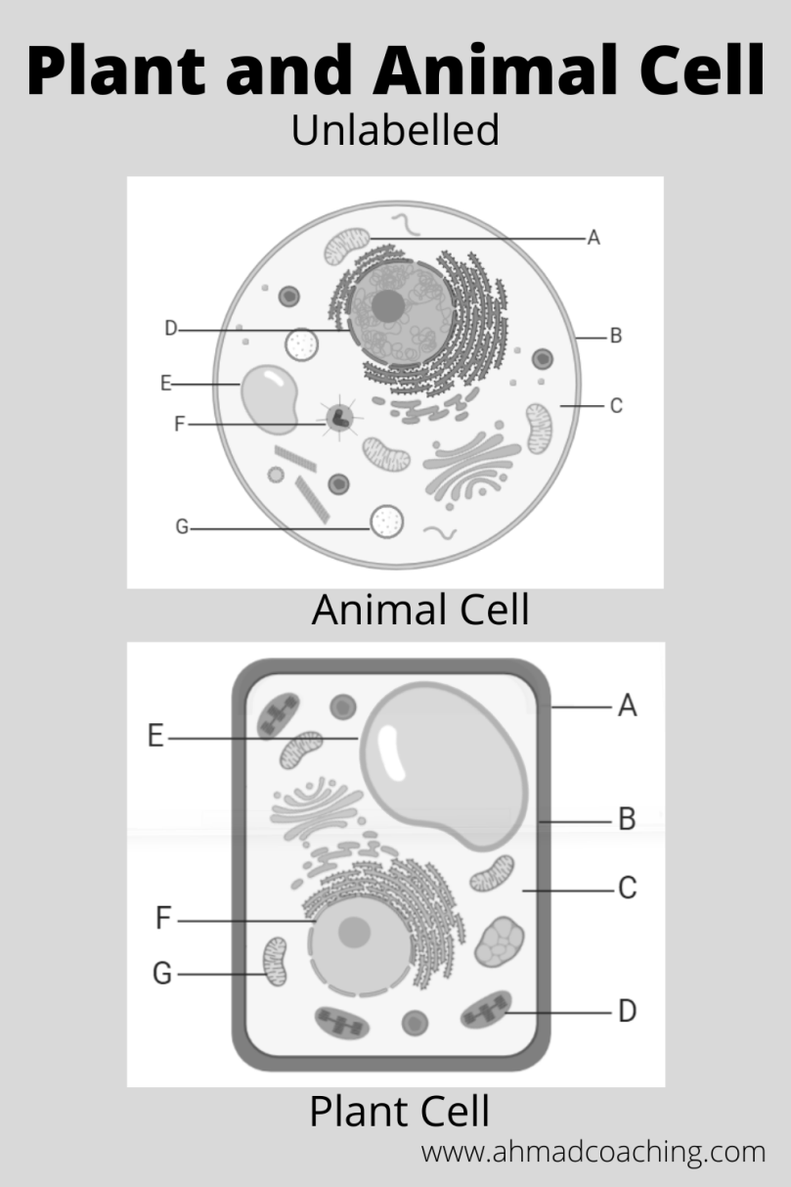

1. Is this a plant cell or an animal cell?
2. Name the parts labeled as A,B,C,D,,F,G.
3. Which of these parts helps in protein synthesis?
4. Which of these parts is also known as the powerhouse of the cell?
5. Write the most important function of a part labeled as B.
6. **Given below is a figure of a cell:**

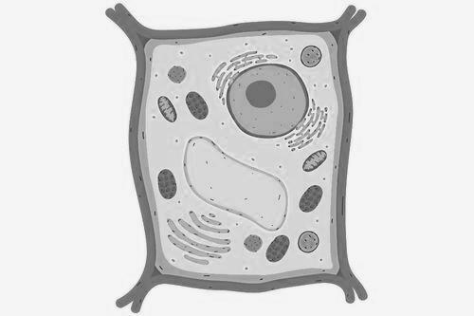

1. Is this a plant cell or an animal cell?
2. Label the following parts in it:
3. Vacuole
4. Cytoplasm
5. Plasma membrane
6. Golgi apparatus
7. Name any two structures which are unique to this type of cell only.
8. Which part helps in exchange of materials in and out of the cell?

* **Name the part of the cell concerned with the following:**

1. Intracellular digestion
2. Liberation of energy
3. Photosynthesis
4. Prevents a plant cell from rupturing
5. Synthesis of protein

* **Name the following:**

1. Powerhouse of the cell
2. Kitchen of the cell
3. Cell organelle responsible for protein synthesis
4. Suicide bag of the cell
5. Control centre of a cell
6. Structural unit of a chromosome

LESSON – TISSUES: PLANT AND ANIMAL CELLS

* **Name the kind of tissue found:**

1. At the tip of plant roots.
2. At the lower surface of leaf
3. In the inner lining of intestine
4. At the joint between two long bones
5. In the walls of the veins of the leaves
6. Tissue that transports water in plant
7. Tissue that stores fat in our body
8. In the heart
9. In the brain
10. In the bone
11. In the skin

* **Give the location of the following tissues in our body:**

1. Meristematic tissue
2. Cartilage
3. Squamous epithelium
4. Sclerenchyma
5. Ciliated epithelium
6. Ligament
7. Tendon
8. Stratified epithelium

* **Differentiate between the following:**

1. Cell and tissue
2. Organ and organism
3. Organelle and organ system
4. Parenchyma and collenchyma
5. Meristematic tissue and permanent tissue
6. Sclerenchyma and parenchyma
7. Involuntary and voluntary muscles
8. Xylem and phloem
9. Blood and lymph
10. Tendons and ligaments

* **Short answer type questions:**

1. Define tissue. What is histology, who coined the term?
2. Why do you think plant cells are different from animal cells?
3. Define striated muscles. Give its three features.
4. What is neuron and what are its functions?

* **Long answer type questions:**

1. Draw a well-labelled diagram of neuron.
2. List out the chief characteristics of meristematic tissue.

LESSON – THE FLOWER

* **Give appropriate words for the following:**

1. Axis bearing a group of flowers
2. Flowers which contain all the four whorls
3. Plants bearing both male and female flowers
4. Filaments of stamens fused with petals
5. The condition when carpels are fused
6. Stamens with united anthers and free filaments

* **Define the following terms:**

1. Inflorescence
2. Incomplete flower
3. Placentation
4. Hermaphrodite flower
5. Monoecious
6. Pistillate flower
7. Epigynous ovary
8. Perianth

* **Differentiate the following:**

1. Gamopetalous and polypetalous
2. Flower and inflorescence
3. Bract and perianth
4. Polyandrous and polyadelphous stamens
5. Unisexual and bisexual flowers
6. Exine and intine layer of a pollen grain

* **Where are the following structures located, and what are their functions?**

1. Anther
2. Ovary
3. Stigma
4. Thalamus
5. Ovules
6. Petaloids

* What are neuter flowers? Give an example
* **Long answer type:**

1. Name the different types of androecium found in flowers.
2. Discuss non-essential parts of a flower and their importance in the sexual reproduction in flowers.
3. The given diagram shows the vertical section of a flower

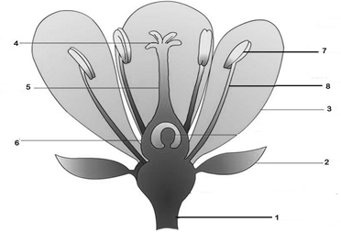

1. Name the parts numbered 1 to 8
2. What are the functions of parts 2 to 4?
3. Which part of the flower forms the fruit?
4. Is the flower shown here unisexual or bisexual?

LESSON – POLLINATION AND FERTILIZATION

* **Explain the following terms:**

1. Pollution
2. Autogamy
3. Geitonogamy
4. Herkogamy
5. Heterostyly
6. Cross pollination
7. Entomophilous
8. Anemophilous
9. Hydrophilous
10. Ornithophily
11. Elephophily

* **What happens to the following after fertilization?**

1. Ovary
2. Ovary wall
3. Ovule
4. Placenta
5. Outer integument
6. Inner integument
7. Secondary nucleus
8. Egg cell
9. Antipodal cells

* **State the name of chief pollinating agent in the following plants:**

1. Maize
2. Bougainvillea
3. Sugarcane
4. Vallisneria
5. Bombax
6. Sunflower

* **Long answer type:**

1. What is self pollination? List its advantages and disadvantages.
2. List the advantages and disadvantages of cross-pollination in plants.
3. Given below is a diagrammatic representation of the process of fertilization. Study the same and then answer the questions that follow:

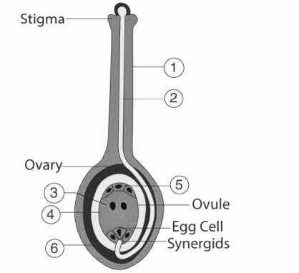

1. Name the parts labelled 1,2,3,4,5,6
2. What is the function of the pollen tube?
3. What is the function of the synergids?
4. What role does the stigma play in the process of fertilization?

LESSON – SEEDS- STRUCTURE AND GERMINATION

* **Define the following terms:**

1. Seed
2. Micropyle
3. Vivipary
4. Hilum
5. Cotyledons

* **Differentiate the following:**

1. Dicotyledonous and Monocotyledonous seeds
2. Albuminous and Exalbuminous seeds
3. Embryo and seed
4. Coleoptile and Coleorhiza
5. Radicle and Plumule

* **What are the functions of the following in a seed?**

1. Seed coat
2. Cotyledons
3. Micropyle
4. Plumule
5. Radicle

* **Answer the following:**

1. Why do we call maize, a grain, and not a fruit or a seed?
2. Draw and label structure of Bean seed.
3. Draw and label structure of Maize grain.

LESSON – NUTRITION

* **Name the mineral element that is needed for the following respectively:**

1. Strong teeth
2. Proper working of thyroid
3. Synthesis of haemoglobin
4. Development of red blood cells
5. Synthesis of enzymes
6. Clotting of blood
7. Water balance
8. Production of melanin

* **Name the deficiency disease caused by the following:**

1. Vitamin A
2. Vitamin B1
3. Vitamin B2
4. Vitamin B3
5. Vitamin B5
6. Vitamin B6
7. Vitamin B9
8. Vitamin B12
9. Vitamin C
10. Vitamin D
11. Vitamin E
12. Vitamin K

* **Give one word for each of the following:**

1. It helps in getting rid of undigested food
2. Nutrients needed in very small quantities, but are essential for immunity
3. A sugar made up of one molecule each of glucose and galactose
4. A polysaccharide that acts as an anticoagulant
5. A long chain of amino acids
6. Protein and energy deficiency in the body

* **Answer the following:**

1. Name the various essential components of food.
2. What is balanced diet?
3. Write three uses of carbohydrates in our body.
4. Why is water an important component of our food?
5. Study the following picture and answer the following questions:

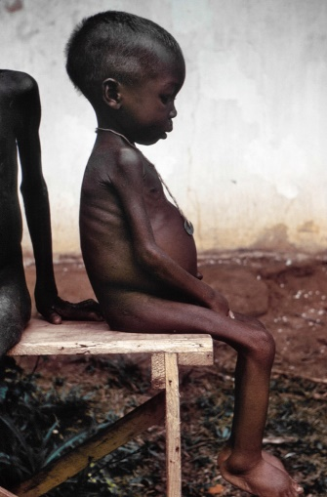

1. Identify the deficiency disease.
2. Mention three symptoms observed in the above picture.
3. How this disease can be cured?
4. Study the following picture and answer the following questions:

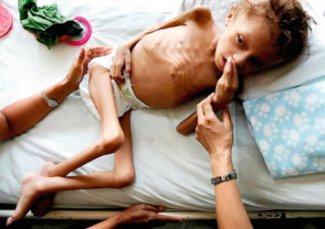

1. Identify the deficiency disease.
2. Mention three symptoms observed in the above picture.
3. How this disease can be cured?

LESSON – HYGIENE- A KEY TO HEALTHY LIFE

* **Name the following:**

1. The condition of the body of a person who depicts physical, mental, social and emotional fitness
2. The science of maintaining good health
3. The organisms that cause disease
4. Natural scavenger
5. Public enemy no.1
6. Domestic pests

* **Name the diseases caused by the following vectors:**

1. Flies
2. Anopheles
3. Culex
4. Aedes
5. Rats
6. Vibrio cholera
7. Shigella
8. Entamoeba histolytica

* **Answer the following questions:**

1. Mention the symptoms of the disease Hepatitis.
2. Mention the prevention of the disease Hepatitis.
3. Suggest methods of controlling flies.
4. Suggest methods of controlling mosquitoes.
5. Suggest methods of controlling cockroaches.
6. Suggest methods of controlling rats.
7. List out the symptoms of the disease cholera.

LESSON – HEALTH ORGANISATIONS

* **What do the following abbreviations stand for:**

1. WHO 2. UNO 3. NICD

* **Answer the following questions:**

1. State the main functions of WHO.
2. State the main functions of the Red cross.
3. Write a note on WHO.

(Note: full form of WHO, established in the year, regional offices, headquarters.)

LESSON – WASTE GENERATION AND MANAGEMENT

* **Short answer type questions:**

1. What is domestic waste? Give examples.
2. What is municipal waste?
3. What is an incinerator?
4. Why is e-waste harmful to the environment?
5. What is agricultural waste?

* **Differentiate between the following:**

1. Biodegradable and non-biodegradable waste
2. Solid, liquid and gaseous waste
3. E-waste and Biomedical waste

* **Give reasons for the following:**

1. We should segregate waste before disposal.
2. We should minimize the use of plastic
3. Biomedical wastes should be disposed of very carefully.
4. Agricultural wastes pollutes water bodies

* **Answer the following questions:**

1. Describe the method of preparing compost.
2. Name the two types of devices commonly used for removing the particulate air pollutants.
3. Describe the usefulness of incineration of wastes and also mention the precautions required for it.