**Blooming Buds School**

AFFILIATED TO CISCE, NEW DELHI – KA366 (ICSE SYLLABUS)

TERM –II REVISION WORKSHEET 1 2022-23

Class – I Subject – Mathematics

Name: ________________________________ Roll No. ________

**I Tick ($√)$ the correct answer -**

1)How much is 90+10?

a)10 b)100 c)18

2) How much is 40-10?

a)30 b)40 c)50

3)Manu has 67 marbles.She lost 17 of them. How many marbles does she have now ?

a)70 b)60 c)50

4) 2 times 5 is

a)10 b)11 c)7

5)The day that comes before Sunday is

a)Tuesday b)Saturday c)Thursday

.**II.Add or subtract-**

|  |  |
| --- | --- |
| 5 | 5 |
| 2 | 4 |
|  |  |

|  |  |
| --- | --- |
| 6 | 9 |
| 2 | 4 |
|  |  |

|  |  |
| --- | --- |
| 3 | 4 |
| 4 | 4 |
|  |  |

1) 2) 3)

|  |  |
| --- | --- |
| 5 | 5 |
| 2 | 2 |
|  |  |

5)

**IIISolve and write the correct answer from the brackets -**

1. 25+ 34 = (69,59,49) 2)31 + 44 = (75,76,54)

3)75 _ 30 = (40,55,45) 4) 89 _ 62 = (27,37,29)

**IV Draw and colour the next three shapes to repeat the pattern -**

1) __ _________________________

2) __ _________________________

**VMultiply and write the answer _**

1. 3 X 3 = 2) 5 X 2 =

3) 4 X 5 = 4) 4 X 3 =

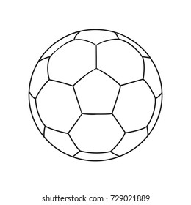**VI Tick( $√)$ the lighter object and cross out (x)the heavier one.**

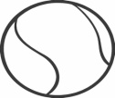 1)

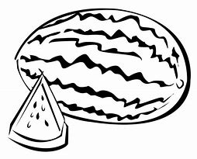

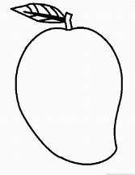2)

**VII Draw the hands on the clock to show the given time**

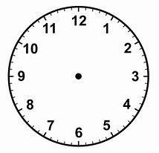

1. 9 0’clock 2) 6 o’ clock

**VIII Write as repeated addition .**

1) 2 X 5 =______ + ______. 3) 4 X 2 = _____ + ______.

2) 3 X 3 = ______ + ______. 4) 3 X 7 = _____ + ______+______

**IX Circle the coins that add up to the price of each thing .**

Indian Rupee Symbol (₹): Facts about the official Currency of India1) Balloon 15

|  |
| --- |
| Lesson Zone AU - indiaLesson Zone AU - India, ₹10 Coin B&WLesson Zone AU - India, ₹5 Coin B&WBalloon Outline Images – Browse 83,133 Stock Photos, Vectors, and Video |  Adobe Stock |

Indian Rupee Symbol (₹): Facts about the official Currency of India

1. 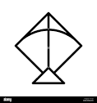Kite 17

|  |
| --- |
| Lesson Zone AU - India, ₹5 Coin B&WLesson Zone AU - indiaLesson Zone AU - India, ₹10 Coin B&WLesson Zone AU - india |

**X Write the given tables .**

1)

|  |  |  |  |  |
| --- | --- | --- | --- | --- |
| **4** | **x** | **1** | **=** | **4** |
|  |  |  |  |  |
|  |  |  |  |  |
|  |  |  |  |  |
|  |  |  |  |  |
|  |  |  |  |  |
|  |  |  |  |  |
|  |  |  |  |  |
|  |  |  |  |  |
|  |  |  |  |  |

**XI Solve the given number strip.**

1. 4 x 2 = ______

|  |  |  |  |  |  |  |  |  |  |  |  |  |
| --- | --- | --- | --- | --- | --- | --- | --- | --- | --- | --- | --- | --- |
| 0 | 1 | 2 | 3 | 4 | 5 | 6 | 7 | 8 | 9 | 10 | 11 | 12 |

Jumps of steps each.

1. 2 x 6 =_______

|  |  |  |  |  |  |  |  |  |  |  |  |  |
| --- | --- | --- | --- | --- | --- | --- | --- | --- | --- | --- | --- | --- |
| 0 | 1 | 2 | 3 | 4 | 5 | 6 | 7 | 8 | 9 | 10 | 11 | 12 |

Jumps of steps each.

**XII Look at the given table . Answer the questions that follow.**

|  |  |
| --- | --- |
| **Name** | **Toys** |
| Mary | Aeroplane, outline, transport icon - Download on Iconfinder ...Kite outline icon Black and White Stock Photos & Images - AlamyCricket bat and ball vector Black and White Stock Photos ...Spinning Top Outline Icon 9241293 Vector Art at VecteezyCar outline Black and White Stock Photos & Images - AlamyToys Clip Art Outline Stock Illustrations – 297 Toys Clip ...Outline Ball - ClipArt Best |
| Raja | Spinning Top Outline Icon 9241293 Vector Art at VecteezyCricket bat and ball vector Black and White Stock Photos ...Outline Ball - ClipArt BestCar outline Black and White Stock Photos & Images - Alamy |
| Salma | Kite outline icon Black and White Stock Photos & Images - AlamyToys Clip Art Outline Stock Illustrations – 297 Toys Clip ...Aeroplane, outline, transport icon - Download on Iconfinder ... |

1) Who has more toys – Raja or Mary ? ____________________.

2) Who has least toys ? ____________________.

3) How many toys Raja is having? ____________________.