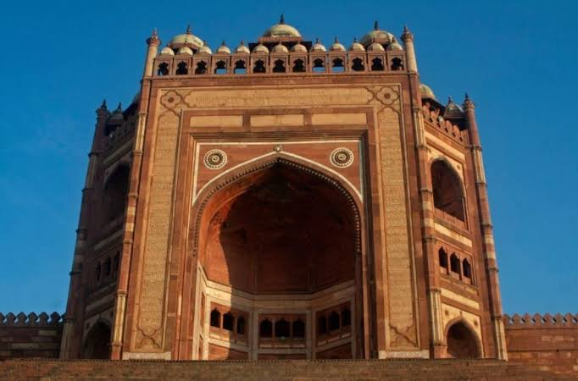

**Picture study**

1. Name this building.

Ans. Buland Darwaza

1. Where it is located?

Ans. Fatehpur Sikri

1. Why and when was it built?

Ans. The buland Darwaza was built to commemorate Akbars conquest of Gujarat.

1. Name the Emperor Who built it.

Ans. Akbar built buland Darwaza

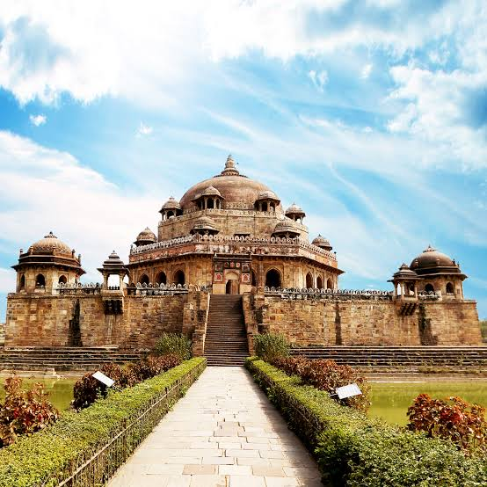2. **Picture study**

**Q1.** Identify the picture

Ans. Tomb of sher Shah Suri

Q2. Where it is located?

Ans. Sasaram bihar

Q3. Who built it?

Ans. Sher Shah Suri himself.

**Geography**

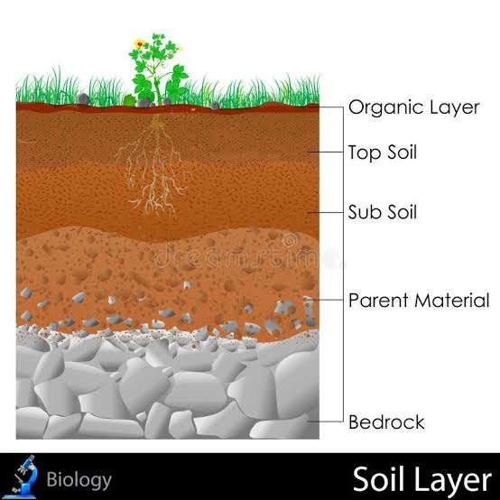**Soil profile**