**RESPIRATION IN PLANTS**

**Very Short Answer Type**

**Question 1**

Fill in the blanks:

1. ............... are the openings found on older stems.
2. Glycolysis occurs in the ............... of the cells.
3. ............... is a respiratory substance.
4. Rate of ............... is more than the rate of ............... in the daytime in the case of green plants.
5. ............... is a chemical substance which absorbs oxygen of the air.
6. ............... is used to create vacuum to show anaerobic respiration.

***Answer***

1. ***Lenticels*** are the openings found on older stems.
2. Glycolysis occurs in the ***cytoplasm*** of the cells.
3. ***Glucose*** is a respiratory substance.
4. Rate of ***Photosynthesis*** is more than the rate of ***Respiration*** in the daytime in the case of green plants.
5. ***Pyrogallate of potash*** is a chemical substance which absorbs oxygen of the air.
6. ***Caustic potash (KOH)*** is used to create vacuum to show anaerobic respiration.

**Question 2**

Name the following:

1. Energy currency of cell.
2. Oxidative breakdown of carbohydrates to release energy.
3. An organism which respires throughout life anaerobically.
4. A common phase in both aerobic and anaerobic respiration.
5. A chemical which removes CO2 from the air.

***Answer***

1. ATP (Adenosine triphosphate)
2. Respiration
3. Fungus
4. Glycolysis
5. Soda lime

**Question 3**

Do the plants respire all day and all night or only at night?

***Answer***

Respiration is an essential life process for all living organisms. Therefore, plants also respire all day and all night.

**Question 4**

Mention if the following statements are true or false. If false, rewrite them correctly.

1. Aerobic respiration of one mole of glucose yields 138 ATP.
2. Anaerobic respiration in plants yields lactic acid.
3. Carbon dioxide readily dissolves in lime water.
4. All leaves of a green plant normally respire anaerobically at night.

***Answer***

1. False  
   **Corrected Statement** — Aerobic respiration of one mole of glucose yields ***38 ATP***.
2. False  
   **Corrected Statement** — Anaerobic respiration in plants yields ***ethanol***.
3. True
4. False  
   **Corrected Statement** — All leaves of a green plant normally respire ***aerobically*** at night.

**Short Answer Type**

**Question 1**

Define

(a) Respiration

(b) Combustion

(c) ATP

***Answer***

(a) **Respiration** — Respiration is a catabolic process of releasing energy from glucose for carrying out life processes.

(b) **Combustion** — Combustion or burning is defined as a physio-chemical process in which energy is liberated in the form of heat and light.

(c) **ATP** — ATP is defined as energy currency of the cell as it acts as the immediate source of energy for different life processes.

**Question 2**

Name:

(a) Two raw materials of respiration.

(b) Two end products of aerobic respiration.

(c) Two microbes which normally respire anaerobically

***Answer***

(a) Glucose and Oxygen

(b) Carbon dioxide and water

(c) Bacteria and Fungi

**Question 3**

Write the full form of ATP and ADP.

***Answer***

Full form of ATP — **Adenosine triphosphate**

Full form of ADP — **Adenosine diphosphate**

**Question 4**

What happens to the energy liberated in respiration?

***Answer***

The energy liberated in respiration is stored in the form of ATP inside the cells. Some part of it is lost as heat to the surroundings.

**Question 5**

How is the tilling of the soil useful for the crops growing in it?

***Answer***

Tilling makes the soil porous and airy. The parts of the plant present below the ground receive adequate oxygen supply to respire. This way tilling facilitates faster crop growth.

**Question 6**

Why is it usually difficult to demonstrate respiration in green plants?

***Answer***

During day time, both photosynthesis and respiration takes place in green plants. Evolution of carbon dioxide is an indicator to demonstrate respiration in living organisms. Carbon dioxide produced during respiration in plants gets utilized during photosynthesis and thus, there is no evolution of carbon dioxide. Consequently, it becomes difficult to demonstrate respiration in green plants as there in no evolution of carbon dioxide during day time.

**Question 7**

Can cell respiration occur in any organism at a temperature of about 65°C? Give reason.

***Answer***

Cell respiration cannot occur in any organism at a temperature of about 65°C because the enzymes involved in respiration become inactivated at high temperatures.

**Long Answer Type**

**Question 1**

Distinguish between the following pairs:

(a) Aerobic and anaerobic respiration

(b) Respiration and combustion

(c) Stomata and lenticels

(d) Photosynthesis and respiration

(e) Anaerobic respiration in plants and animals

***Answer***

(a) Difference between Aerobic and anaerobic respiration:

| **Aerobic respiration** | **Anaerobic respiration** |
| --- | --- |
| Proceeds in the presence of oxygen. | Proceeds without using oxygen. |
| Complete breakdown of glucose. | Incomplete breakdown of glucose. |
| End products are carbon dioxide and water. | End-products are ethyl alcohol and carbon dioxide. |
| Energy liberated in large quantity (38 ATP) from one mole of glucose. | Energy liberated in small quantity (2 ATP) from one mole of glucose. |
| Occurs normally throughout life. | Occurs temporarily for short periods. |

(b) Difference between Respiration and combustion:

| **Respiration** | **Combustion** |
| --- | --- |
| Cellular process | Non-cellular process |
| Occurs at body temperature | Occurs at high temperature (at ignition point) |
| Occurs in a series of chemical steps | Occurs in a single step |
| Carried out by enzymes | Carried out by heat |
| Biochemical process | Physico-chemical process |
| Energy released as ATP and heat | Energy released as heat and light |
| Light energy is not produced | Light energy is produced |

(c) Difference between Stomata and lenticels:

| **Stomata** | **Lenticel** |
| --- | --- |
| Stomata are present in leaves and green stems. | Lenticels are present in mature stems, roots and fruits. |
| Stomata are active only during day time. | Lenticels are active both during day and night. |
| Stomata have guard cells and they can be opened and closed. | Lenticels do not have guard cells, they are always open. |

(d) Difference between Photosynthesis and respiration:

| **Photosynthesis** | **Respiration** |
| --- | --- |
| Occurs only in the presence of chlorophyll. | Occurs in all living cells. |
| Occurs only in presence of light. | Occurs at all times. |
| Uses carbon dioxide and water. | Uses oxygen and glucose. |
| Oxygen is released as an end product. | End product is carbon dioxide. |
| Light energy is converted into chemical energy. | Chemical energy is converted into useful energy (ATP) and heat. |
| Results in gain in weight. | Results in loss in weight. |
| Anabolic process. | Catabolic process. |

(e) Difference between Anaerobic respiration in plants and animals:

| **Anaerobic respiration in plants** | **Anaerobic respiration in animals** |
| --- | --- |
| It leads to formation of ethanol | It leads to formation of lactic acid |
| Little heat is released | More heat is released |

**Question 2**

How do the following structures help in respiration in plants?

(a) Lenticels

(b) Stomata

(c) Root hairs

***Answer***

Given below are the ways in which the following structures help in plant respiration:

(a) Lenticel — These help the stem to participate in respiration.

(b) Stomata — These help the leaves to participate in respiration.

(c) Root hairs — These help the roots to participate in respiration.

**Question 3**

How are aerobic and anaerobic respirations different in plants?

***Answer***

The differences between aerobic and anaerobic respiration in plants are as follows:

| **Aerobic Respiration in Plants** | **Anaerobic Respiration in Plants** |
| --- | --- |
| Also called oxybiotic respiration | Also called anoxybiotic respiration |
| Proceeds in the presence of oxygen | Proceeds in the absence of oxygen |
| Occurs in mitochondria | Occurs in cytoplasm |
| Complete breakdown of glucose | Incomplete breakdown of glucose |
| End-products are Carbon dioxide and Water | End products are Ethyl Alcohol and Carbon dioxide |
| Large quantity of energy is liberated (38 ATP) from one mole of glucose | Small quantity of energy is liberated (2 ATP) from one mole of glucose |
| Occurs normally throughout the life | Occurs temporarily for short periods |

**Question 4**

Explain why respiration is said to be the reverse of photosynthesis.

***Answer***

Respiration is said to be the reverse of photosynthesis due to the following reasons :

1. In respiration, the organic food is disintegrated into its inorganic compounds, namely –  
   Carbon dioxide and Water. In photosynthesis, the organic food is manufactured from its inorganic components, namely - Carbon dioxide and Water.
2. In respiration, Carbon dioxide is released whereas in Photosynthesis Carbon dioxide is consumed.
3. Oxygen is consumed during respiration while Oxygen is evolved in photosynthesis
4. Energy is liberated in Respiration while in Photosynthesis, energy is absorbed.

**Question 5**

What is respiration? How are respiration and burning similar and how are they different?

***Answer***

Oxidation of organic food particularly carbohydrates in living cells to release energy is called respiration.

Similarities between burning and respiration are —

1. Oxygen is required by both.
2. Energy is released by both.
3. The outcome of both is water and carbon dioxide.

Differences between burning and respiration:

| **Respiration** | **Burning** |
| --- | --- |
| Cellular process | Non-cellular process |
| Occurs at body temperature | Occurs at high temperature (at ignition point) |
| Occurs in a series of chemical steps | Occurs in a single step |
| Carried out by enzymes | Carried out by heat |
| Biochemical process | Physico-chemical process |
| Energy released as ATP and heat | Energy released as heat and light |
| Light energy is not produced | Light energy is produced |

**Question 6**

Describe one experiment each you would perform to demonstrate the following phenomena: The germinating seeds

1. Produce heat,
2. Give out Carbon dioxide,
3. Can respire even in total absence of air.

***Answer***

1. Aim — Experiment demonstrating the fact that germinating seeds produce heat.

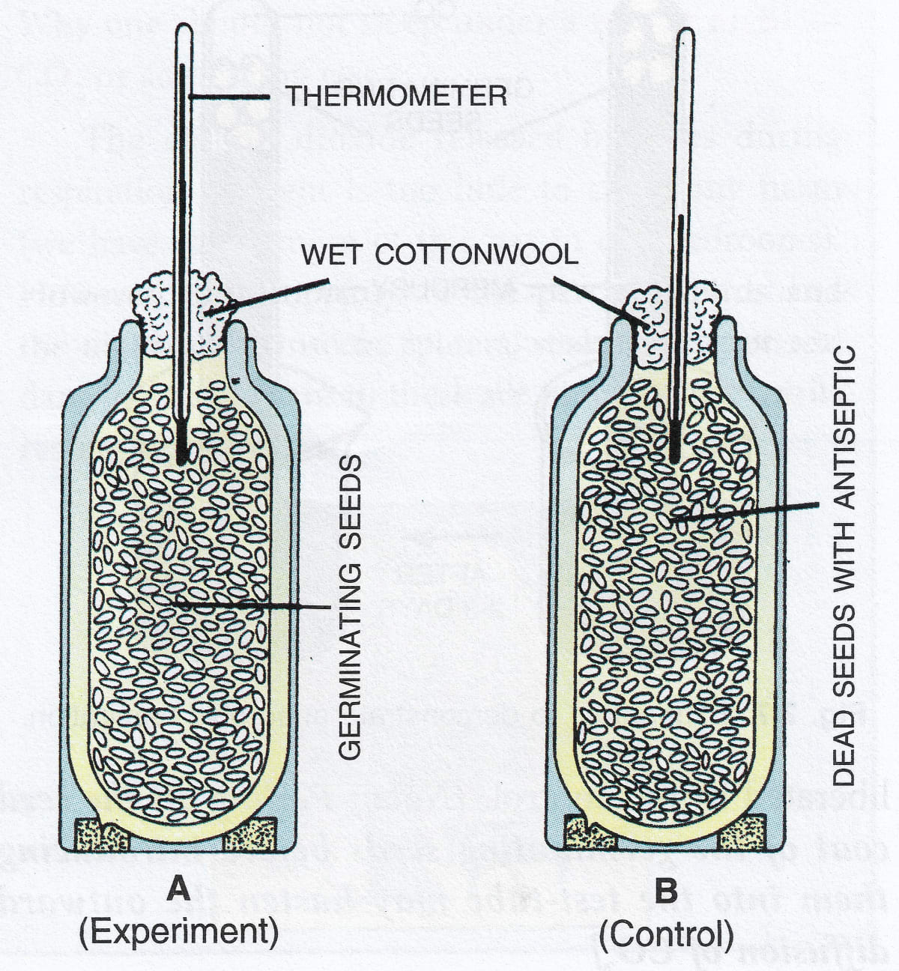

Procedure —

1. Name two thermo flasks as 'A' and 'B', keep them aside
2. Approximately 200 pea seeds or beans would be used in the experiment. Soak them in water for more than 24 hours.
3. Split the seeds into two equal groups approximately
4. One group of seeds are killed by boiling them and washing them with dilute formaline in order to restrict bacterial decay
5. The live germinating seeds need to be placed in flask A and the boiled/killed seeds in flask B.
6. Introduce a thermometer into each of the flasks and seal their mouths with cotton wool.
7. Take note of the initial reading observed in the thermometer.

Inference —

1. A few hours later, thermometer in the flask A shows a higher reading depicting that the seeds that germinate generate heat.
2. Flask B shows no rise in the temperature.
3. Aim — Experiment demonstrating the fact that germinating seeds produce Carbon dioxide.

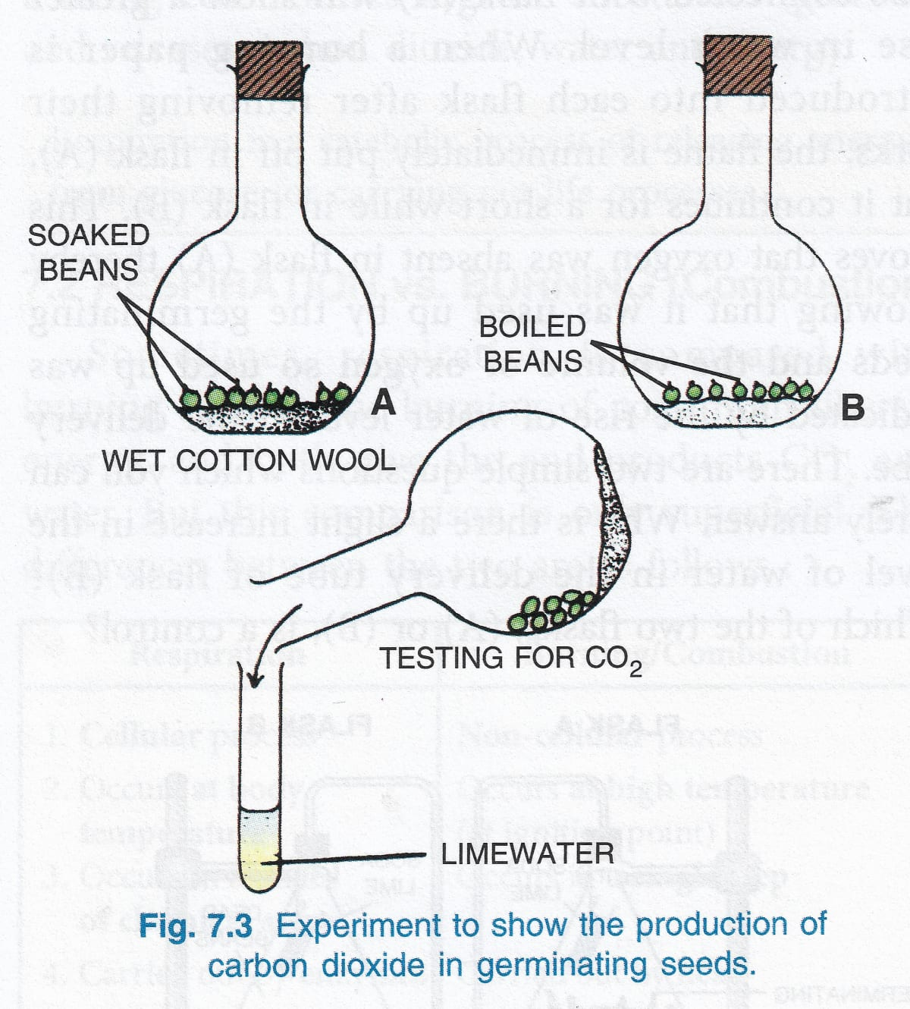

Procedure —

1. Name two thermo flasks as ‘A’ and ‘B’, keep them aside.
2. At the base of both the flasks, place wet cotton wool.
3. In flask A, take a few soaked seeds of pea, simultaneously take equal quantity of boiled seeds in flask B.
4. To flask B, add some carbolic acid so as to inhibit bacterial growth on the dead seeds.
5. Seal the flasks with a cork, leave them undisturbed for a couple of days.
6. Observe the changes.

Inference —

1. Post few days, germination of seeds in flask A is observed.
2. Flask B shows no signs of seed germination.
3. Cork is removed to test the gases in each of the flasks. The flask is toppled over a test tube which carries limewater. The test tube is then shaken up.
4. Indication of carbon dioxide as expected in flask A is observed when lime water turns milky, thereby depicting that germinating seeds produce carbon dioxide.
5. The gas in the flask B shows no effect upon coming in contact with limewater, indicating absence of carbon dioxide.
6. Aim — Experiment demonstrating the fact that seed germination undergoes respiration even in complete absence of air

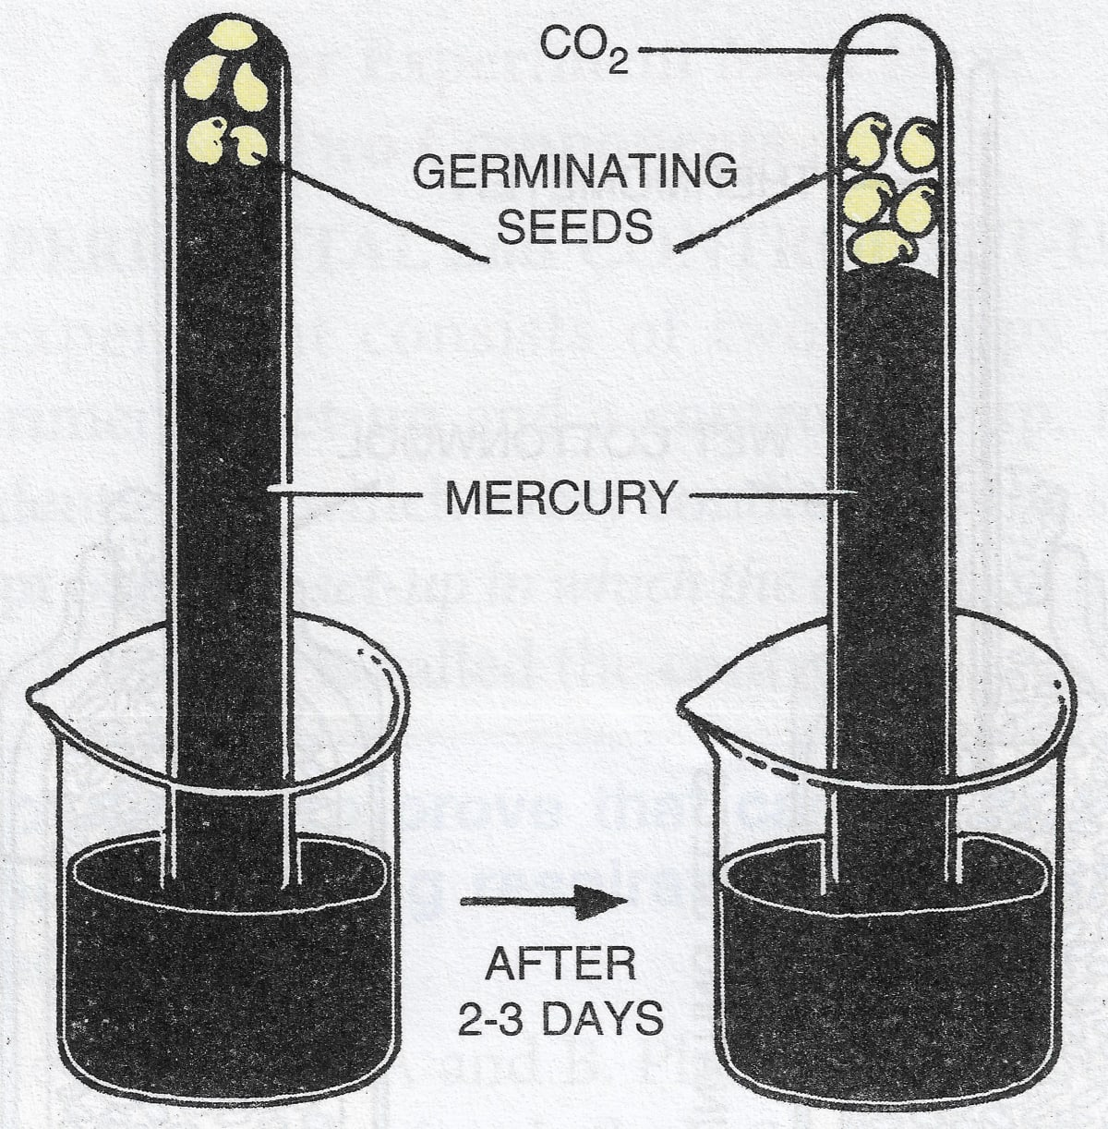

Procedure and Inference —

1. Fill a test tube with mercury that is inverted into a beaker of mercury.
2. Into this tube, push some soaked and peeled off pea seeds before inverting into the mercury beaker.
3. You will observe that seeds will float up and are entirely girdled by mercury.
4. A few days later, few changes are observed. Mercury level drops, presence of some gases are detected in the tube.
5. Pour in some KOH into the tube.
6. Gas in the tube is absorbed, mercury level rises again, depicting that the gas was carbon dioxide
7. Consequently it is proved that the germinating seeds undergo respiration even in the total absence of air.

**Question 7**

Draw a neat and labelled, diagram showing the experimental set up (initial and final stages) to demonstrate anaerobic respiration in germinating seeds.

***Answer***

Below diagram shows the experimental set up (initial and final stages) to demonstrate anaerobic respiration in germinating seeds:

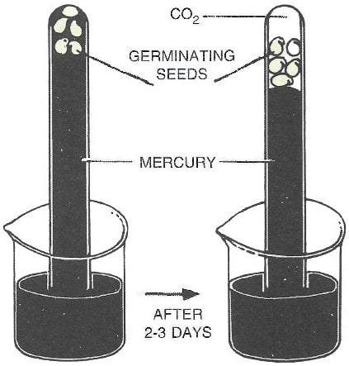

**Structured / Application / Skill Type**

**Question 1**

The following two chemical reactions are supposed to indicate a certain process occurring in the green plants under two different conditions:

(a) C6H12O6 + 6O2 → 6CO2 + ...... + 38ATP

(b) C6H12O6 → ...... + 2CO2 + 2ATP

1. Fill in the blanks of each reaction
2. Name the process represented by the two chemical equations
3. What are the conditions under which the two reactions (a) and (b) are occurring?

***Answer***

1. (a) 6H2O  
   (b) 2C2H5OH
2. (a) The process observed in this chemical reaction here is aerobic respiration  
   (b) The process observed in this chemical reaction is anaerobic respiration
3. The reaction occurring in (a) can take place only in the presence of oxygen as it is aerobic respiration. The reaction occurring in (b) can take place even in the absence of oxygen as it is anaerobic respiration.

**Question 2**

Given below is a set of six experimental set-ups (A-F), kept in this state for about 24 hours.

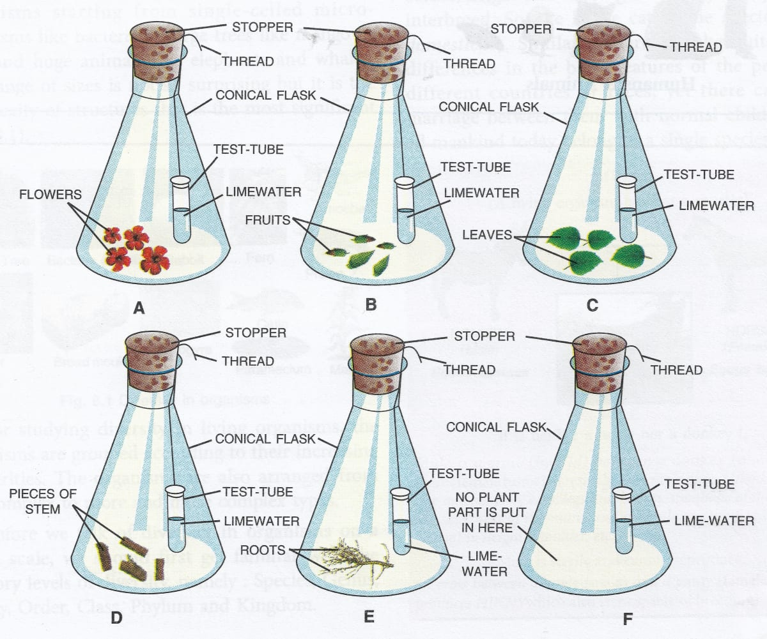

(a) In how many flasks, the different plant parts have been kept under observation?

(b) What is the purpose of keeping a test-tube containing limewater in each flask?

(c) In which tube/tubes the limewater will turn milky?

(d) What is the purpose of the set-up F?

(e) What conclusion can you draw from this experiment?

***Answer***

(a) The different plant parts for observation have been placed in five flasks right from A-E flasks as observed in the diagram.

(b) It is the property of limewater to absorb Carbon dioxide. Hence it is placed in the flask, so as to absorb Carbon dioxide and turn milky in the presence of any Carbon dioxide.

(c) Limewater turns milky in the presence of Carbon dioxide. All five flasks from A to E have plant parts hence respiration takes place in all five parts causing the limewater to turn milky. In flask F, respiration does not take place as there is no plant part, hence no change is observed

(d) In the experiment, the setup F depicts the experiment control, wherein all conditions are maintained in the same way except for the plant part that is absent in flask F.

(e) The experiment clearly shows that Carbon dioxide is produced during the process of respiration.

**Question 3**

The following diagram refers to an apparatus which is used to demonstrate a physiological process:

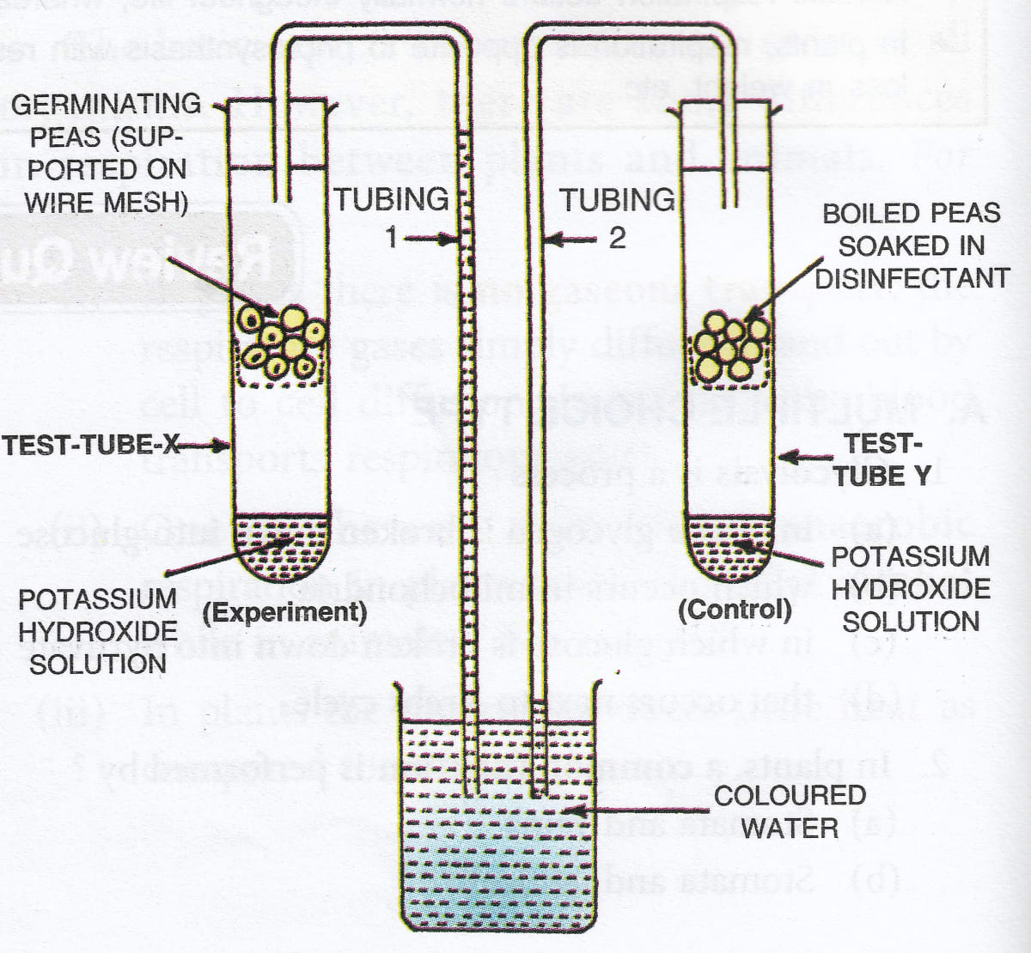

(a) What is the purpose of keeping potassium hydroxide solution in the test tubes X and Y?

(b) Why has the coloured water risen in tubing 1?

(c) What is the purpose of keeping boiled peas soaked in a disinfectant in test tube Y?

(d) Name the biological process which causes the above rise.

(e) Define the biological process shown in the experiment

***Answer***

(a) To check the presence of Carbon dioxide, potassium hydroxide is placed in the test tubes X and Y. Potassium hydroxide has a special property of absorbing Carbon dioxide if produced.

(b) In the test tube X, when the process of respiration takes place, the oxygen is consumed that is present in the test tube. Due to respiration, Carbon dioxide that is produced is absorbed by the KOH in the test tube. Due to consumption of Oxygen, a space is developed causing the colored water to rise in the tubing 1.

(c) It is because the seeds die once they are boiled and hence cannot undergo respiration. This is why respiration does not take place in test tube Y.

(d) The biological process that causes a rise is respiration.

(e) It is respiration. It is a catabolic process wherein energy is liberated from simple sugars to be able to carry out life processes.

**Question 4**

In order to study and prove a particular physiological process in plants, the following experiment was set up. Study the same and then answer the questions that follow:

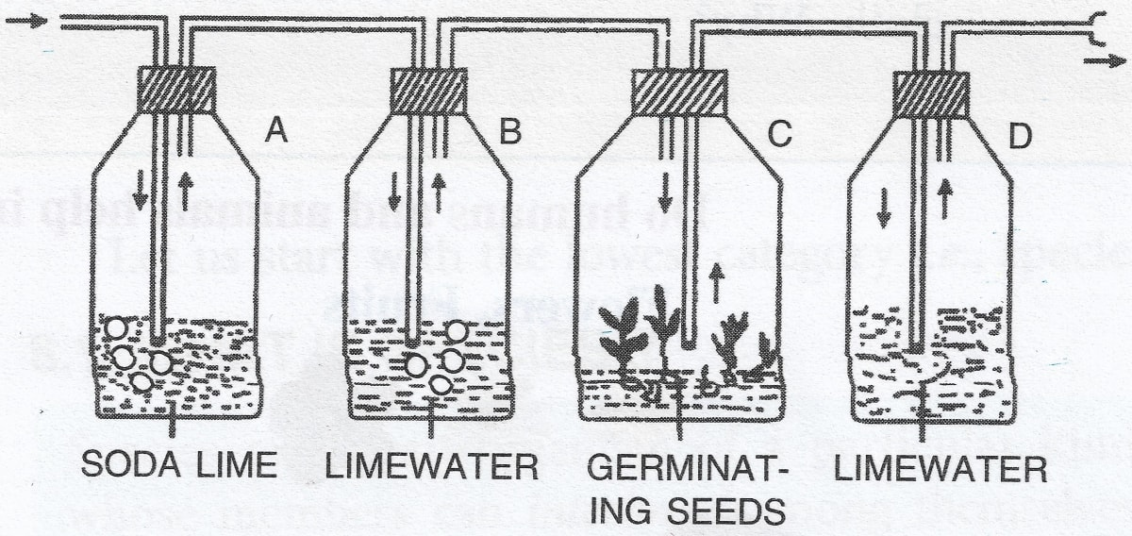

(a) Name the physiological process being studied.

(b) What is the function of soda lime in the bottle 'A' and why is limewater placed in bottle 'B'?

(c) What change would you expect to observe in bottle 'D'?

(d) Represent the physiological process named in (a) above in the form of a chemical equation.

(e) In order to obtain accurate results, the bottle ‘C’ should be covered with a piece of black cloth. Why?

(f) If bottle 'C' was fitted with a 3-holed rubber stopper and a thermometer were introduced in such a way that its bulb reaches close to the germinating seeds, what would you observe? Why?

***Answer***

(a) The experiment demonstrates that carbon dioxide is produced during the process of respiration in germinating seeds.

(b) Soda lime is placed in bottle ‘A’ as it indicates the passage/presence of Carbon dioxide in bottle A. Another property of soda lime is that is absorbs Carbon dioxide that is present in the air. The clear limewater in bottle B indicates that the air that enters the flask C is free from Carbon dioxide.

(c) The bottle D holding limewater should indicate that carbon dioxide is produced as a result of respiration occurring in bottle ‘C’ possessing the germinating seeds. As carbon dioxide is produced in the bottle C, limewater turns milky that enters the bottle 'D'.

(d) The chemical reaction is as written below:  
C6H12O6 + 6O2 → 6CO2 + 6H2O + 38ATP (energy)

(e) The bottle 'C' is covered with a black cloth in order to restrict any chance of photosynthesis so as to make sure the process of respiration only is carried out and observed.

(f) A thermometer is inserted in bottle C to observe the changes in temperature. Respiration causes the temperature to rise, if there is no respiration, the temperature will not rise.