CLASS 10th - Chapter 6 Refraction of Light

Question 1:Fill in the blanks
a. Refractive index depends on the wavelength of light.
b. The change in direction of light rays while going from one medium to another is called refraction.

Question 2:Prove the following statements.
a. If the angle of incidence and angle of emergence of a light ray falling on a glass slab are i and e respectively, prove that, i = e.

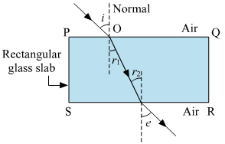
Leave 6-7 lines

b. A rainbow is the combined effect of the refraction, dispersion, and total internal reflection of light.
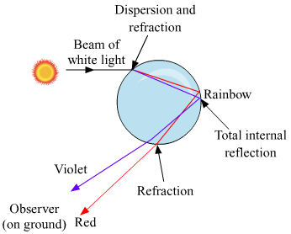After rainfall, the tiny droplets of water present in the atmosphere act as a prism for the rays coming from the Sun. Thus, the sunlight after striking the surface of the droplets gets refracted and dispersed into its seven components .After this, the light rays are subjected to total internal reflection. Then the rays are again refracted when they come out of the water droplet. Hence, rainbow formation is the combined effect of the refraction, dispersion, and total internal reflection of light.

Question 3.Mark the correct answer in the following questions :
A. What is the reason for the twinkling of stars?
(i) Explosions occurring in stars from time to time
(ii) Absorption of light in the earth’s atmosphere
(iii) Motion of stars
(iv) Changing refractive index of the atmospheric gases
Answer: Changing refractive index of the atmospheric gases.

B. We can see the Sun even when it is little below the horizon because of
(i) reflection of light
(ii) refraction of light
(iii) dispersion of light
(iv) absorption of light
Answer: refraction of light
C. If the refractive index of glass with respect to air is 3/2, what is the refractive index of air with respect to glass?
(i) 12
(ii) 3
(iii) 13
(iv) 23
Answer:
(iv) 2/3

Question 4.
Solve the following examples:
- If the speed of light in a medium is 1.5 × 108 m/s, what is the absolute refractive index of the medium?
Solution:
V₁ = 1.5 × 108 m/s,
V₂= 3 × 108 m/s, n = ?
n = V_{2/} / V₁= 3×108m/s / 1.5×108m/s = 2
This is the absolute refractive index of the medium.

b. If the absolute refractive indices of glass and water are 3/2 and 4/3 respectively, what is the refractive index of glass with respect to water?

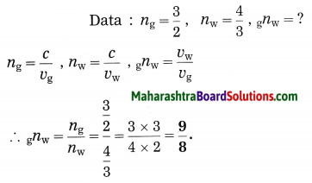
Extra
Q. What is meant by refraction of light? Draw the diagram of a ray of light passing through glass slab
Answer: The change in the direction of light when it passes from one transparent medium to another is called refraction of light.
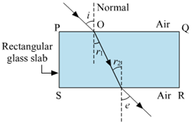

Q. State the laws of refraction of light.
Answer:
Laws of refraction of light:
(1) The incident ray and the refracted ray are on the opposite sides of the normal to the surface at the point of incidence and all the three, i.e., the incident ray, the refracted ray and the normal are in the same plane.

(2) For a given pair of media, the ratio of the sine of the angle of incidence to the sine of the angle of refraction is constant (Snell’s law). This constant is called the refractive index of the second medium with respect to the first medium.
[Note: Here, a ray means a ray of light.]

