NATIONAL PROGREESIVE EDUCATION TRUST’S ENGLISH MEDIUM SCHOOL BELGAUM

**HOLIDAYS HOME WORK**

**Subject: SCIENCE**

**Class:VIII**

**PHYSICS:**

**ASSIGNMENT 1:**

1.Find out any ten different definitions from the chapter force and pressure ,chemical effect and write them in the holiday homework copy.

2.Explain different types of contact forces and non contact forces.

**ASSIGNMENT 2:**

1.Make a tester and check the conductivity of some liquids available at your home. And explain your observations.

2.Write 10 examples of conductors and insulators.

3. Why distilled water does not conducts electricity but tap water does? Explain.

**CHEMISTRY**

1.Study the concept of green chemistry and write few sentences on our own.

2.Observe and study the periodic table chart

 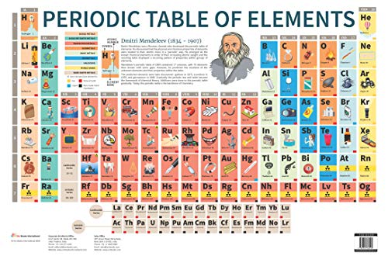

**BIOLOGY**

1.Observe and Study about human and animal cell



2.Stuyd about Nerve cell and write few sentences on your own.