NATIONAL PROGREESIVE EDUCATION TRUST’S ENGLISH MEDIUM SCHOOL BELGAUM

**HOLIDAY HOMEWORK**

**Subject:Science**

**CHEMISTRY**

**1.** Study about transferring of electrons to make a stable compound (NaCl) and write few more examples on your own

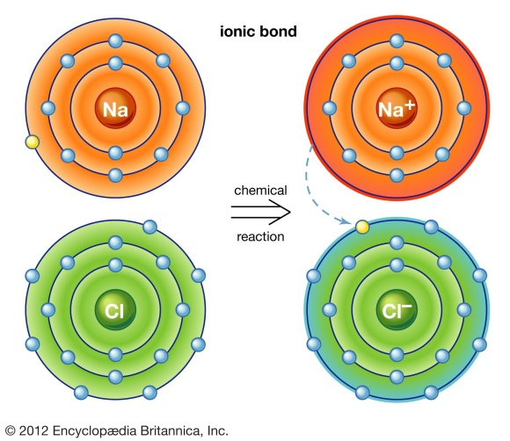

*2*.Read and write 30 elements of periodic table and observe the periodic table of elements.

**BIOLOGY**

**1.**Observe the 3D animated neuron function and write few sentences on your own.

2.Draw and study about human heart ( emphasize on double circulation)