**0. By splitting the following figures into rectangles, find their areas (The measures are given in centimetres).**

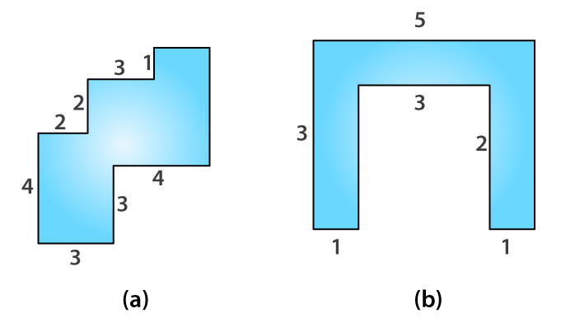

**Solutions:**

**(a)**

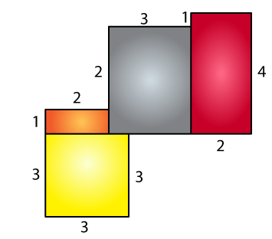

Area of yellow region = 3 × 3

= 9 cm2

Area of orange region = 1 × 2

= 2 cm2

Area of grey region = 3 × 3

= 9 cm2

Area of brown region = 2 × 4

= 8 cm2

Total area = 9 + 2 + 9 + 8

= 28 cm2

∴ The total area is 28 cm2.

(b)

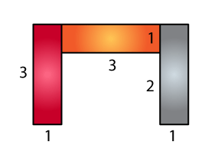

Area of brown region = 3 × 1

= 3 cm2

Area of orange region = 3 × 1

= 3 cm2

Area of grey region = 3 × 1

= 3 cm2

Total area = 3 + 3 + 3

= 9 cm2

∴ The total area is 9 cm2.

**11. Split the following shapes into rectangles and find their areas. (The measures are given in centimetres)**

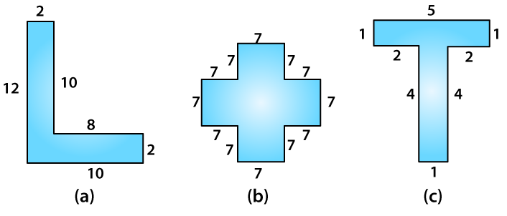

**Solutions:**

(a)

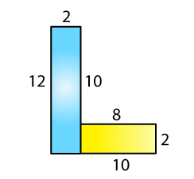

Total area of the figure = 12 × 2 + 8 × 2

= 40 cm2

(b)

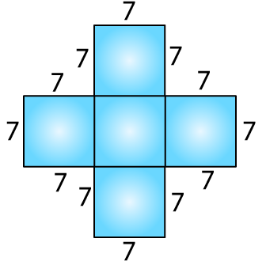

There are 5 squares, and each side is 7 cm.

Area of 5 squares = 5 × 72

= 245 cm2

(c)

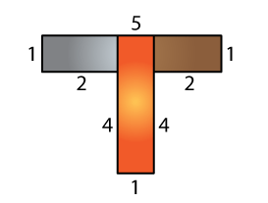

Area of grey rectangle = 2 × 1

= 2 cm2

Area of brown rectangle = 2 × 1

= 2 cm2

Area of orange rectangle = 5 × 1

= 5 cm2

Total area = 2 + 2 + 5

= 9 cm2

**12. How many tiles whose length and breadth are 12 cm and 5 cm, respectively, will be needed to fit in a rectangular region whose length and breadth are respectively,**

**(a) 100 cm and 144 cm?**

**(b) 70 cm and 36 cm?**

**Solutions:**

(a) Area of rectangle = 100 × 144

= 14400 cm

Area of one tile = 5 × 12

= 60 cm2

Number of tiles = (Area of rectangle) / (Area of one tile)

= 14400 / 60

= 240

Hence, 240 tiles are needed.

(b) Area of rectangle = 70 × 36

= 2520 cm2

Area of one tile = 5 × 12

= 60 cm2

Number of tiles = (Area of rectangle) / (Area of one tile)

= 2520 / 60

= 42

Hence, 42 tiles are needed.