Suresh Angadi Education Foundation’s

Angadi International School

(Affiliated CBSE, New Delhi)

**GRADE 2 WORKSHEET**



Suresh Angadi Education Foundation’s

Angadi International School

(Affiliated CBSE, New Delhi)

**ANNUAL EXAMINATION (2023-24)**



#### Tick (✓) the correct option.

* + 1. If we need to add two or more numbers, we need to put sign.

1. – **b.** × **c.** +
   * 1. What remains the same even if we add numbers in any order?
2. Answer **b.** Product **c.** Quotient
   * 1. 66+ 4 is equal to
3. 90. **b.** 70. **C .**80.
   * 1. When 0 is added to a number, the sum is the number
4. itself. **b.** before. **c.** after.
   * 1. 12+ 14 + 20 is same as
5. 14+20+12. **b.** 14+20. **c.** 12+14+22.

#### Solve these sums.

* + 1. There are 45 birds on a tree. 36 more birds join them. How many birds are there on the tree now?
    2. Anil collected 28 pebbles on Saturday and 26 pebbles on Sunday. How many pebbles did she collect altogether?

D) Add the following sums

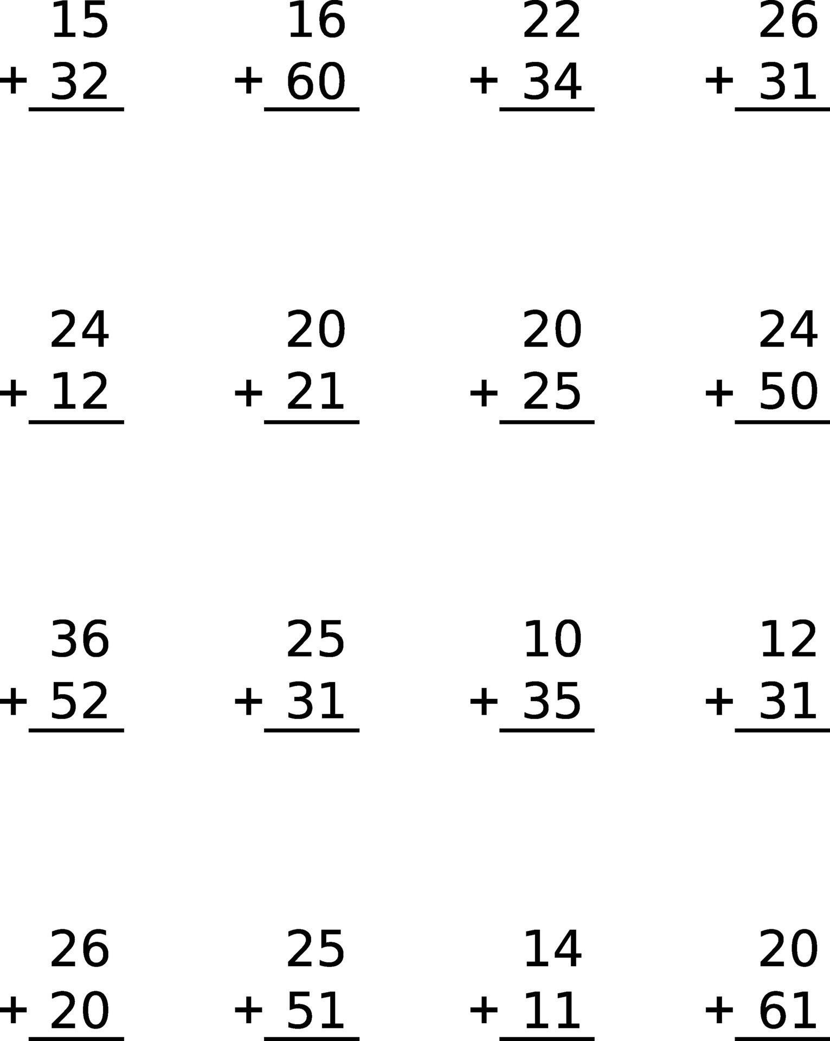

**E) subtract**

