Suresh Angadi Education Foundation’s

Angadi International School

Opp. AITM College, Savagaon Road, Belagavi – 590009

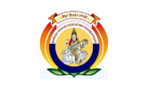

**Grade: II Subject: English**

**Student name ______________________________**

**Q I. Underline the Pronoun and circle the common noun.**

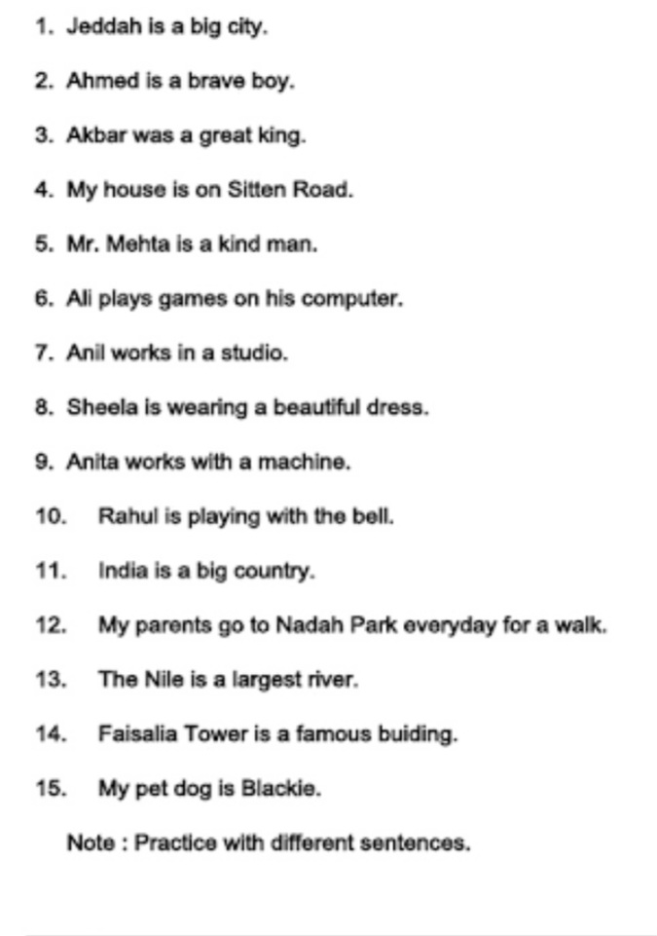**QIII. Write the feminine gender for the given words from the clue box.**

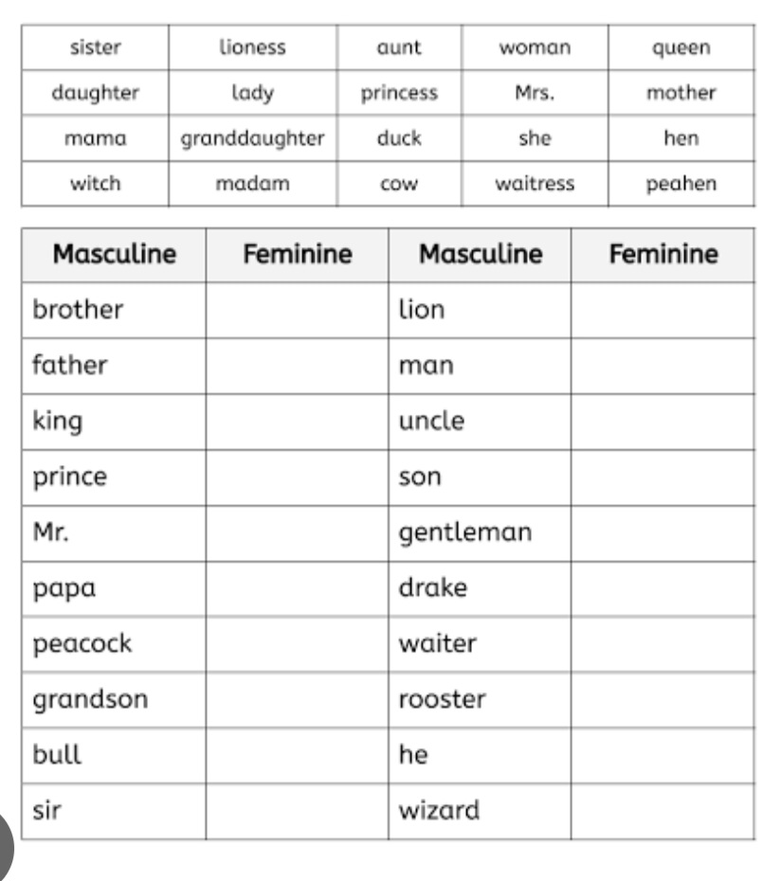**QI A. Write your name and address**

**B. Draw a picture below where you live.**

**Please practice the dictation words and practice writhing question and answer.**