**Grade: V**

**I. Answer in one sentences.**

1. Define the globe.
2. What are the lines of latitude called?
3. How many major directions are there?
4. Which of the mountain peak in Asia?
5. Which is the longest latitude?
6. What is the 23 ½ N latitude called?
7. What is the 66 ½ S latitude called?
8. What is the natural features on the Earth called?
9. How many latitudes are there in the Southern Hemisphere?

10.What shows a physical map?

**II. Answer in Three-Four sentences**

1. Write few disadvantages of globe.
2. What is rotation? What does it cause.
3. What is revolution? What does it cause.
4. Why do very few people live in the mountain?
5. Write the names of five parallels on a globe?
6. Write few disadvantages of globe?
7. Write a note on the three stages of a river.
8. Why do we draw latitudes and longitudes?
9. What are the main features of a desert?
10. Explain how days and nights are caused.
11. What is the difference between map distance and ground distance?



Suresh Angadi Education Foundation’s

Angadi International School

(

Affiliated CBSE, New Delhi

)

**SOCIAL STUDIES WORKSHHET**

**(2024**

**-**

**25**

**)**

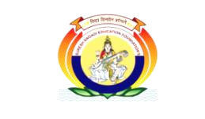

1. What are parallels? List their features.
2. Why do we not feel the movements of the Earth?
3. Write the names of five oceans and seven continents.
4. Why do the different colours used in a map show?

|  |
| --- |
|  |