Veda International School

Kusugal Road, Hubballi Ph: 0836-2002275 (Proposed ICSE Board )

Chapter-7

Topic: North America

GRADE:6

Subject: SST (Geography)

1. New words:

1. Boundaries
2. Cordilleras
3. Appalachians
4. Lumbering
5. Canadian Shield
6. Plateaus.
7. Territories
8. Isthmus.
9. Caribbean
10. Continents

Exercise

A. Fill in the blanks.

1. 23

2. Greenland, Aleutian Islands

3. 95

4. Laurentian

5. Lumber

B. Match the following.

1. (c) Kingston. 2. (a) Ottawa. 3. (d) Havana 4. E. Nuuk. 5. (b) Port-au-Prince

C. State whether True or False.

1. False. 2. False. 3. False 4. True. 5. True

D. Tick the correct answer.

1. 579 million

2. Isthmus of Panama

3. Eastern Highlands

4. Great Basin

5. USA

E. Answer in a paragraph or two.

Q1. Explain the location of North America.

Ans: North America lies entirely in the northern and western hemispheres. The Arctic Circle and the Tropic of Cancer run across its northern and middle parts, respectively. It is surrounded by the Arctic, Atlantic and Pacific Oceans in the north, east and west, respectively.

Q2. Describe the characteristics of the Western Cordilleras.

Ans:The continent stretches from Greenland in the east to Aleutian Islands in the west. The Bering Strait narrowly separates it from Asia. In the south, the continent narrows drastically along the Isthmus of Panama, which connects it to South America. It separates from South America at the Darién watershed along the Colombia- Panama border, placing Panama within North America.Most Caribbean islands are part of North America, except Aruba, Bonaire, Curacao, Trinidad and Tobago, which lie on the continental shelf of South America.

Q3. Describe the characteristics of the. Western Cordilleras.

Ans: These are young fold mountains along the west coast, which are around 80 million years ago. These run parallel to the Pacific coast, starting from the Alaskan range in the north, for a length of about 6,400 km through Canada, United States and Mexico.

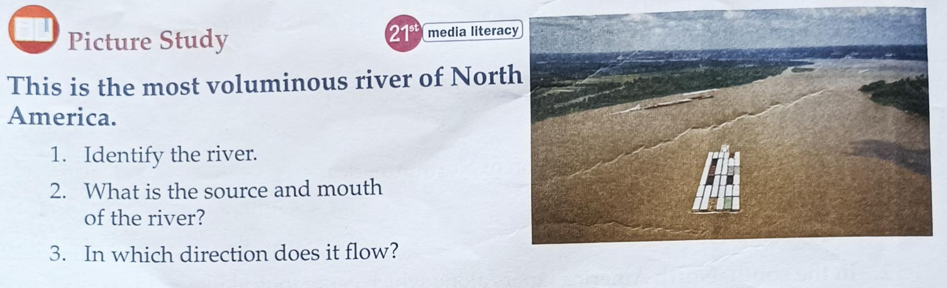

Solution

1. River Mississippi
2. The source of the river is Lake Itasca and the mouth is at Gulf of Mexico
3. It flows southwards.

Teacher Signature Principal Signature

Name: Mrs. Rupa P L