Veda International School

Kusugal Road, Hubballi Ph: 0836-2002275 (Proposed ICSE Board )

Chapter-

Topic: Minerals

GRADE:6

Subject: SST (Geography)

1. New words:

1. Minerals
2. Metallic.
3. Non-metallictem
4. Excavation.
5. Conservation
6. Occurrence
7. Distribution
8. Reduce
9. Reuse
10. Recycle.

Exercise

A. Fill in the blanks.

1. Reduce, Reuse, Recycle

2. ore

3. 2,800

4. Zawara

5. Deep Shaft

B. Choose the correct answer.

1. Karnataka

2. Mumbai High complex

3. Bihar

4. Australia

5. Mexico

C. Name the following.

1. Africa

2. Iron ore

3. Bauxite

D. State whether True or False.

1. False

2. False

3. False

E. Answer in one or two sentences.

Q1. Give examples of non-metallic minerals.

Ans: Limestone, mica, gypsum

Q2. Which types of rocks contain metallic minerals?

Ans: Igneous and metamorphic rocks

Q3. Which countries are the leading producers of tin?

Ans: Brazil, Bolivia and Australia

Q4. Where are petroleum belts located in India?

Ans: Assam belt, Gujarat-Cambay belt and Mumbai High.

Q5. What is the use of uranium?

5. Uranium is used as fuel in nuclear reactors.

E. Answer in a paragraph or two.

Q1. Write a note metallic minerals.

Ans: Metallic minerals contain metal in raw form. They conduct heat and electricity and have a lustre or shine. Iron ore, copper, silver, gold and manganese ore are some examples.

Q2. List the important features of minerals.

Ans: Minerals are naturally occurring substances. They are generally inorganic in nature. They are also stable and solid at room temperature and have a definite chemical formula. Minerals are found in various forms, ranging from the hardest diamond and gold to the softest talc and salt. Some common examples of minerals are gold, silver, copper, limestone and mica. Minerals are found in various forms, ranging from the hardest naturally occurring substance, diamond, to the softest talc and salt. Some common examples of minerals are gold, silver, copper, limestone and mica.

Q3. List the uses of minerals.

Ans:

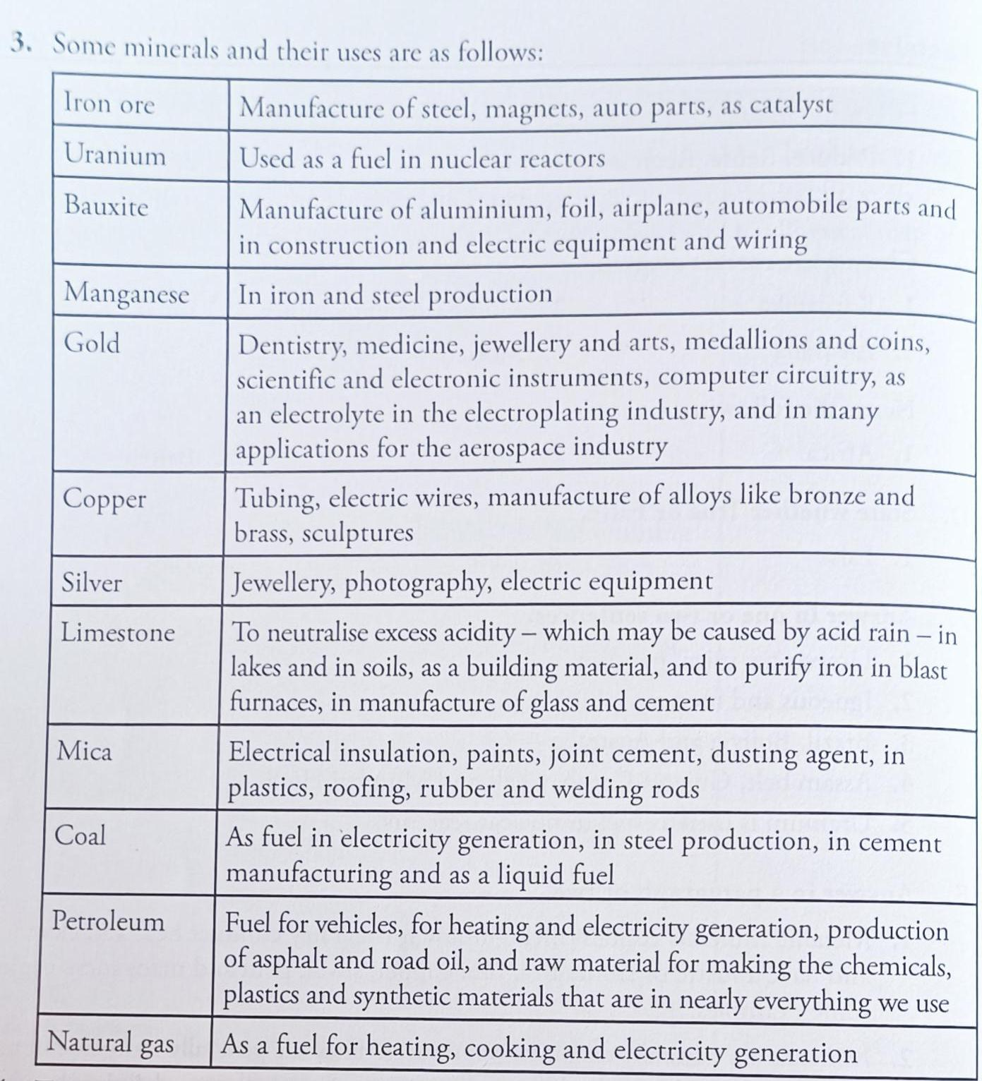

Teacher Signature Principal Signature

Name: Mrs. Rupa P L