Veda International School

Kusugal Road, Hubballi Ph: 0836-2002275 (Proposed ICSE Board )

Chapter-5

Topic: Major Crops

GRADE:6

Subject: SST (Geography)

1. New words:

1. Millets

2. Grains

3. Rice

4. Coffee

5. Cotton

6. Rubber

7. Maize

8. Sugarcane

9. Jute

10. Wheat

Exercise

1. Fill in the blanks.
   1. Food
   2. Cash
   3. 24°C
   4. India
   5. Agriculture
2. Match the following.
   1. Wheat. B Low humidity, moderate temperature of 20°C-24°C and moderate rainfall of 50-70 cm
   2. Rice. E High humidity and rainfall in the range of 100-200 cm, and fertile, clayey soil that can hold water
   3. Cotton. A Black and alluvial soil and high temperature
   4. Tea. C Warm and wet climate with moderate temperature (25°C-28°C)
   5. Coffee. D Well-distributed high rainfall and deep, light, well-drained loamy soil
3. State whether true or false.
   1. False
   2. True
   3. Falsc
   4. True
   5. True
4. Tick the correct answer.
   1. China
   2. Dry tropical and subtropical region
   3. China
   4. Sugarcane
   5. Maize
5. Answer in one or two sentences.

Q1 .Which country is the largest producer of coffee?

Ans: Brazil is the largest producer of coffee.

Q2. How much rainfall do rubber plantations require?

Ans: It needs around 150-300 cm of rainfall.

Q3. How did the Green Revolution lead to regional inequality?

Ans:Middle and higher-income farmers have often benefited much more than the majority on low incomes, thus widening the income gap in rural communities. Increased rural-to-urban migration has often been the result.

Q4.Name the jute producing countries of the world.

Ans: India, China and Bangladesh are the three major jute-producing countries in the world. Jute is also cultivated in Thailand, Myanmar, Brazil and Uzbekistan.

Q5. What are the uses of maize?

Ans: Maize, also known as corn, is grown as a food and fodder crop. It is also used in the manufacturing of ethanol, beer, cornflakes and animal feed.

Q6. Explain the difference between a food crop and a cash crop.

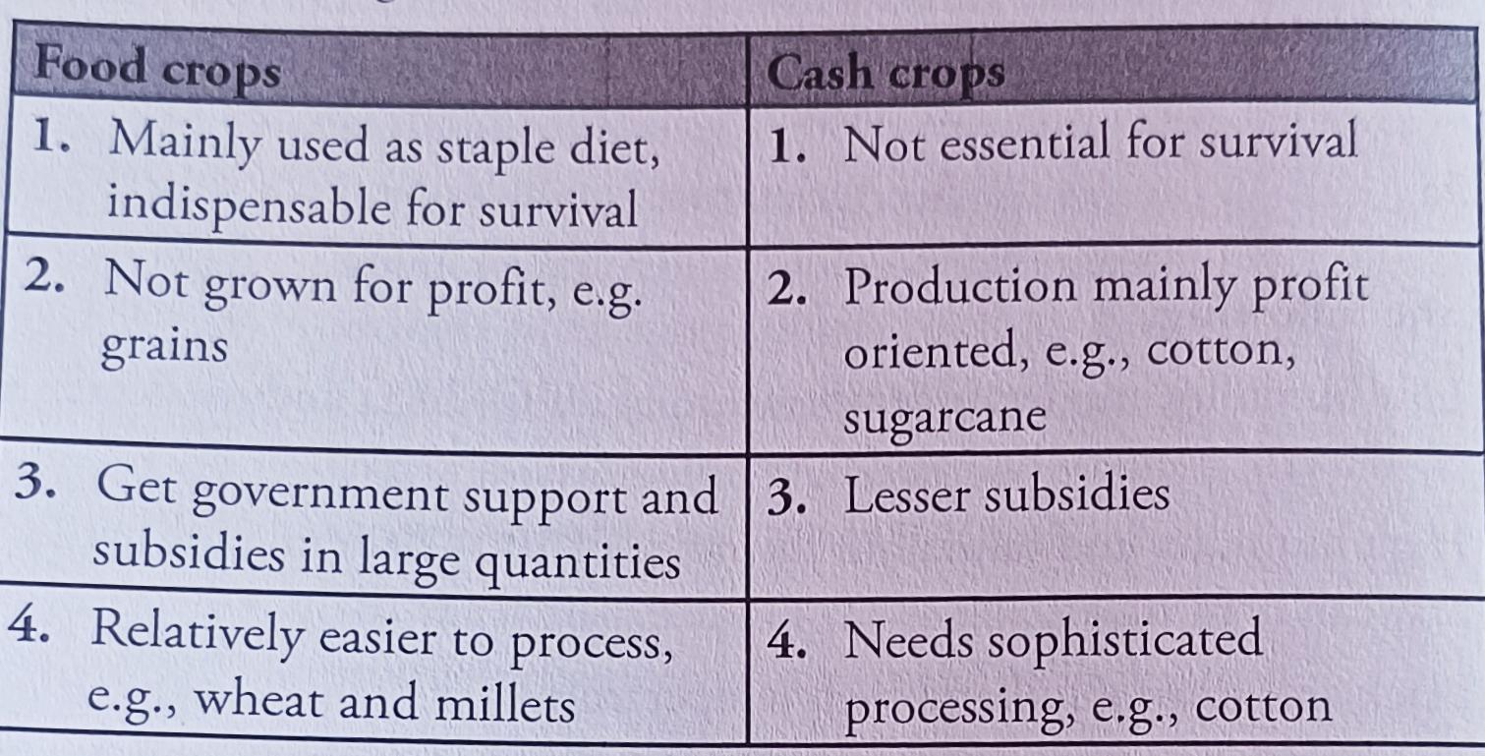

Teacher Signature Principal Signature

Name: Mrs. Rupa P L