Veda International School

Kusugal Road, Hubballi Ph: 0836-2002275 (Proposed ICSE Board )

Chapter-8

Topic: South America

GRADE:6

Subject: SST (Geography)

1. New words:

1. Indigenous
2. Sovereign
3. Tectonic
4. Amazon
5. River basin:
6. Lake Titicaca.
7. Ecuador
8. Quito
9. Atacama.
10. Cape columbia.

Exercise

A.Fill in the blanks.

1. 423. 2.Panama. 3.Brazil. 4. Andes. 5.Amazon River Basin

B.Tick the correct answer.

1. Cape Horn. 2.Quito. 3. 4,000 m. 4.Atacama 5.Lake Titicaca

C.Match the following.

1. © Asuncion. 2.(b) Paramaribo. 3.(E)Caracus. 4.(a) Buenos Aires. 5.(d) Sucre

D.State whether true or false.

1. False. 2.True. 3.False. 4. False. 5.True

II Answer the following in one or two sentences :

What is the extent of the Andes Mountains?

Ans It extends for about 7,200 km along the west coast, from the Caribbean Coast in the north to cape Horn in the south.

Q2. What is the highest peak of the Andes?

Ans: Mt. Aconcagua 16,962m

Q3. Name the three major rivers of the Central Lowlands.

Ans River Amazon, River Orinoco and River Paraguay.

Q4. What is Llanos?

Ans- It is a vast Savannah or Grassland region.

Q5 What is Tierra del Fuego?

Ans: Tierra del Fuego is an archipelago that lies off the south-east coast of the South American mainland. It consists of a group of islands including Cape Horn and Diego Ramírez Islands.

Answer in a paragraph or two.

Q1. Discuss the boundaries of South America?

Ans The Isthmus of Panama connects South America to North America in the northeast . The continent is bordered by the Caribbean sea, Atlantic Ocean in its north, east, west and South, respectively.

Q2. Write a note on the important rivers of South America.

Ans:

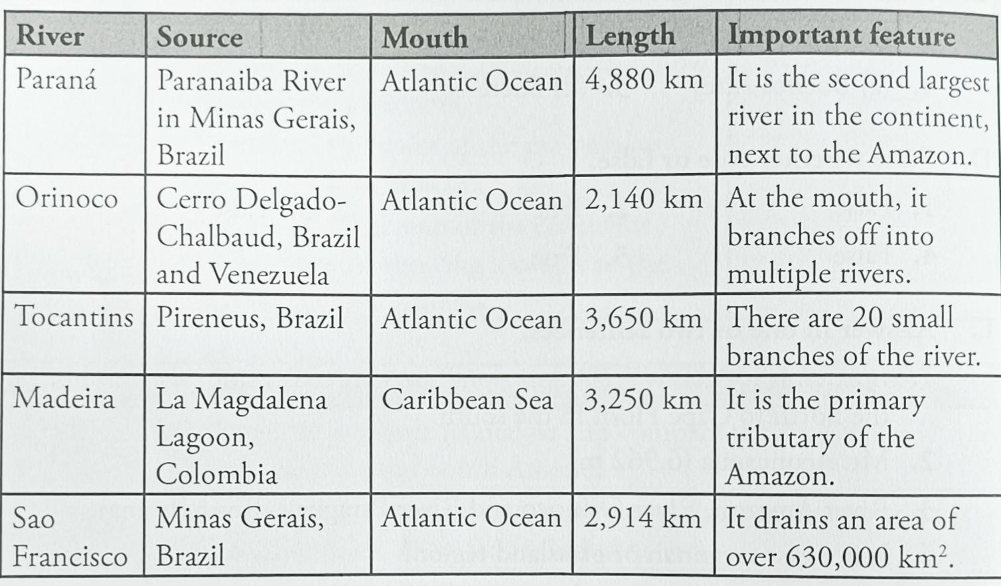

Q3. Write a note on the Atacama Desert.

Ans: Atacama Desert (the driest desert of the world) lies in the coastal plains. The Atacama receives less than 1 mm of rainfall in a year.

The Atacama Desert is located over high altitudes, 2,500 m above sea level. It is also situated in the ‘rain shadow’ of two mountain ranges-the Andes and the Chilean Coast Range. The Andes acts as a natural barrier to the moisture of the Amazon. The Humboldt Current carries cold water northward along the western coast, which prevents the formation of high rain-bearing clouds.

A mix of mountains, winds and ocean currents make the air in the Atacama Desert extremely dry, leading to minimal precipitation.

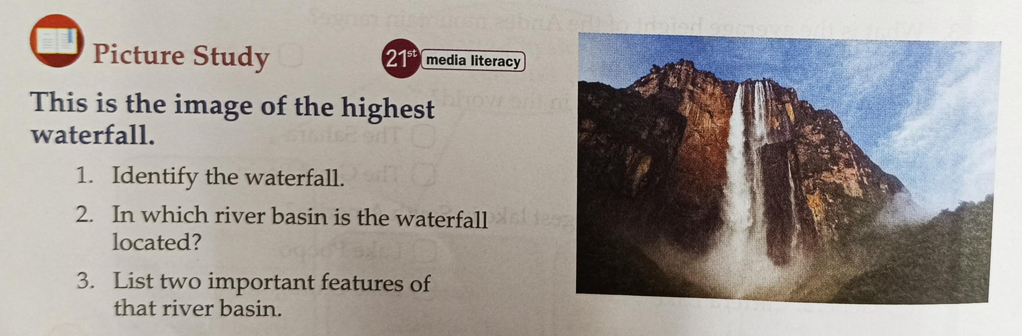

Solution:

1. The Angel Falls
2. Orinoco River Basin
3. It is a vast basin spread across an area of 948,000 km².

It occupies the northern part of the Central Lowlands.

Teacher Signature Principal Signature

Name: Mrs. Rupa P L