 **Veda International School**

**Kusugal Road, Hubballi Ph: 0836-2002275**

(Proposed ICSE Board)

WORKSHEET

**Name: _________________________ Subject: Hindi**

**Grade : 1 Roll No : ________ Date:________________**

**Teacher Sign : _____________ Total marks: 10**

**प्र 1. फलो को पहचानकर उसके नाम लिखो. (5x2=10)**

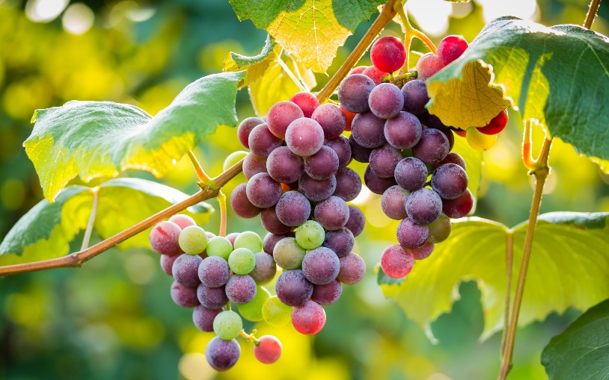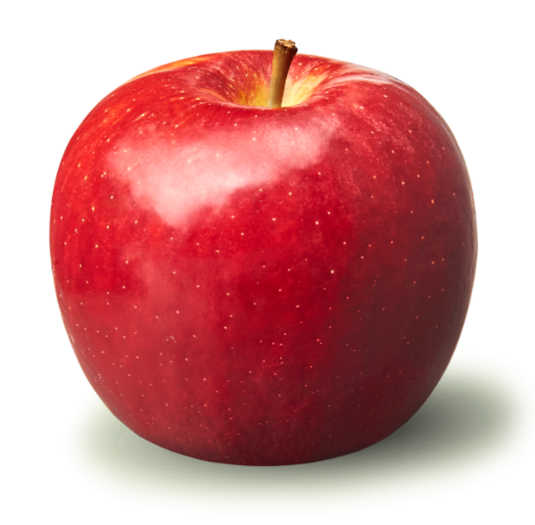 **1.---------------------**

**2.------------------------**

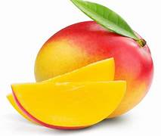 **3.-------------------------**

** 4.---------------------**

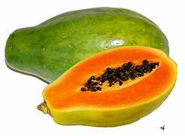 **5.-------------------------**