Veda International School

**Kusugal Road, Hubballi Ph: 0836-2002275**

**(ICSE Board )**

Chapter-4

GRADE:4 Topic:Parts of a plant and their uses Month:July/Aug

Subject: Science

Q.I New words:

1. **Plants**
2. **Taproot**
3. **Fibrous root**
4. **Stomata**
5. **Chlorophyll**
6. **Photosynthesis**
7. **Minerals**
8. **Glucose**
9. **Starch**
10. **Germination**

Inbuilt Questions Textbook Exercises

Activity Page No. 28

Identify the plants and name them. Also, write whether they are herbs, shrubs or trees.

1. Rose plant It is a shrub. 2. Banyan tree It is a tree.

3. Tomato plant It is a herb. 4. Neem tree It is a tree.

5. Mint It is a herb. 6. Cotton plant It is a shrub.

Exercise For Revision Page No. 31-32

A. Fill in the blanks.

1. root 2. Shoot 3. Stem 4. stem

B. Tick() the correct answers.

1. (c) 2. (d) 3. (a) 4. (d) 5. (d) 6. (c)

Exercise For Revision page no 36

A. Write 'T' for true and 'F' for false sentences.

1. T 2. F 3. F

B. Tick() the correct answers.

1. (b) 2. (d) 3. (d) 4. (b)

Exercise For Revision Page No. 40

A. Match the following.

B 1. (d) 2. (c) 3. (b) 4. (e) 5. (a)

B. Tick (✔) the correct answers.

1. (d) 2. (d) 3. (a) 4. (c) 5. (c)

A. Short Answer Questions:

Q1. What are stomata?

Ans: The under surface of a leaf has many tiny pores. These tiny pores are called stomata.

Q2. What do you mean by transpiration?

Ans: The loss of excess water from plants mainly through leaves as water vapour is called transpiration.

Q3. How is a tap root different from a fibrous root?

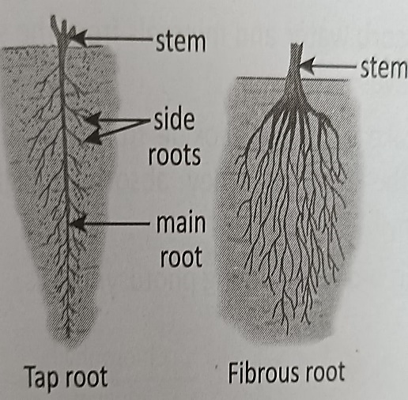Ans: Tap Root: The main root that grows from the base of the stem is called a tap root. Many small side roots grow from the main root. Pea, sunflower, mustard and carrot have tap roots.

Fibrous Root: A bunch of thin and small roots that grows from the base of the stem is called a fibrous root. Grass, onion, rice and wheat have fibrous roots.

Q4. Which part of a plant is called the kitchen of the plant? Give a reason.

Ans:The leaves of a plant are called kitchen or food factory of the plant because they prepare food for the plant.

Q5. What would happen when a plant did not get sunlight?

Ans: Sunlight is essential for a plant's overall health and growth. Without it, plants may exhibit a range of negative effects, impacting their ability to thrive and survive.

B. Long Answer Questions:

Q1. Describe the structure of a leaf.

1. Leaves grow on the stem and its branches. They are of different shapes and sizes. They are generally green in colour. They are green due to the presence of a green substance called chlorophyll.

Structure of a leaf

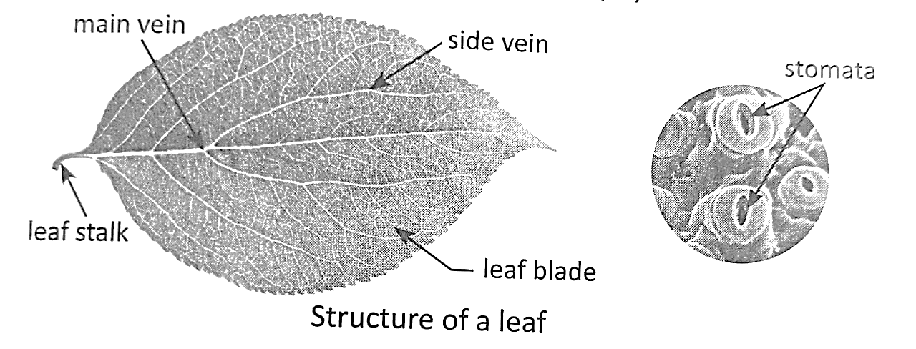

While observing a leaf closely, the green and flat part of the leaf that we see is called the leaf blade. Each leaf has a tube in the middle. It is called the main vein. Many side tubes arise from the main vein. They are called the side veins. A leaf is attached to the branch through a leaf stalk. The under surface of the leaf has many tiny pores called stomata. They help the plant to breathe.

Q2. What is photosynthesis? What does a plant need to make food?

2. Green plants make their own food with the help of carbon dioxide and water in the presence of sunlight and chlorophyll. This process is called photosynthesis. It takes place in the green leaves.

In the presence of sunlight, leaves use water and carbon dioxide to make food (glucose).

Roots absorb water and minerals from the soil. The stem carries in to the leaves.

Leaves take in carbon dioxide from the air through the stomata during the daytime. They absorb sunlight with the help of chlorophyll.

Oxygen is produced during photosynthesis.

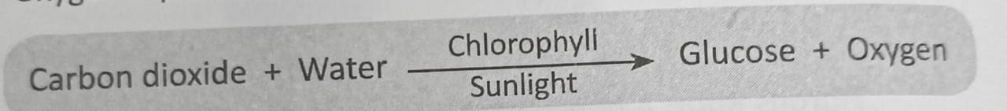

Q3. How does a plant use its food?

Ans: A plant uses its food in following ways:

(i) It uses food to get energy to carry out different activities.

(ii) It uses food to grow.

(iii) It stores extra food in the form of starch in their different parts (roots, stem, leaves and fruits).

Q4. Write about any five products we get from plants.

Ans: The things that we get from plants are:

(i) Cereals: We get cereals like wheat, rice, maize and barley from plants.

(ii) Pulses: We get pulses like rajma, moong, arhar, and masoor from plants.

(iii) Fruits and vegetables: We get fruits like apples, oranges, guavas and mangoes, and vegetables like potatoes, carrots, radishes and spinach from plants.

(iv) Oil: We get oils like mustard oil, sunflower oil, groundnut oil and coconut oil from plants.

(v) Medicines: We get various medicines from plants. The neem, amla, tulsi and ginger are some examples of medicinal plants.

Q5. We should promote the local food sources. Analyse the statement and list any four benefits of it.

Ans: Promoting local food sources has multiple benefits, including environmental sustainability, economic support for local communities, improved freshness and nutritional quality, and the preservation of biodiversity. Choosing locally sourced foods is a holistic approach that positively impacts both communities and the environment.

Read the hints and identify the parts of a plant. Draw a picture of plant and label these parts in the picture:

1. Kitchen of the plant- Leaves

2. The part that holds the plant firmly in soil- Roots

3. The part that has pleasant smell and attracts butterflies- Flower

4. The main part of the shoot that bears branches, buds, leaves, flowers and fruits- Stem

5. The part of a plant that is formed from flowers- Fruit

Teacher Signature: Mrs. Rupa P Principal Signature