**Veda International School**

**Kusugal Road, Hubballi Ph: 0836-2002275**

(ICSE Board)

WORKSHEET

**Name: _______________________________ Date: _____________**

**Roll No : __________________ Subject: Computer Grade : IV _________**

**Teacher Sign : _____________ Total Marks: 10M**

1. **Look the following pictures and find the names in puzzle. (5 Marks)**

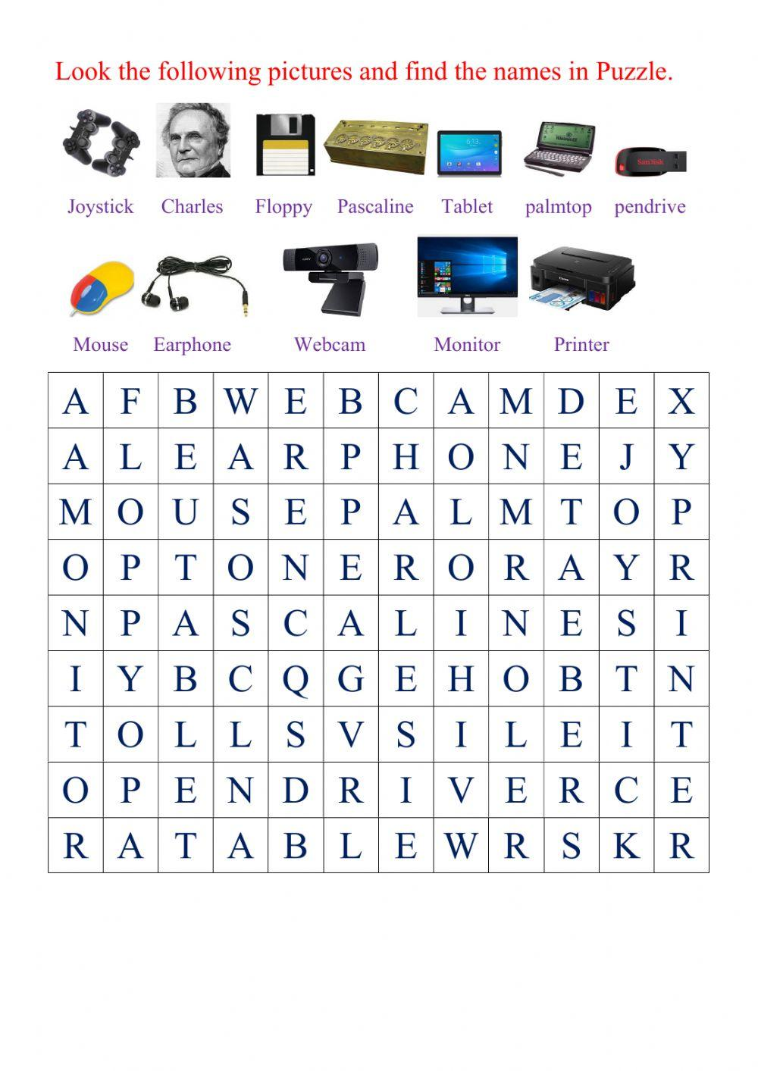

**2. Write the Computer parts on the correct place. (2 Marks)**

**Monitor Keyboard Speaker Printer CPU Mouse**

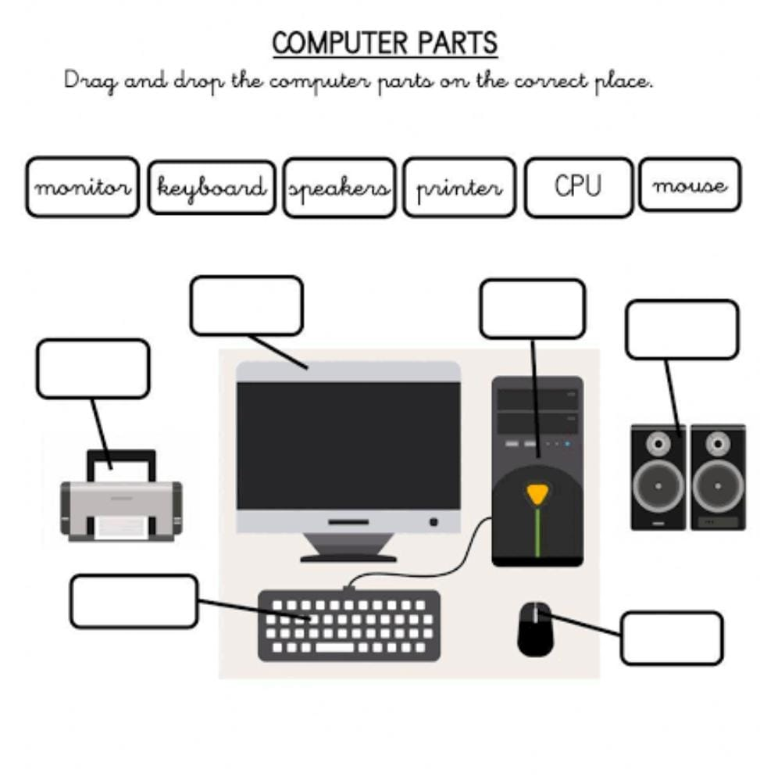

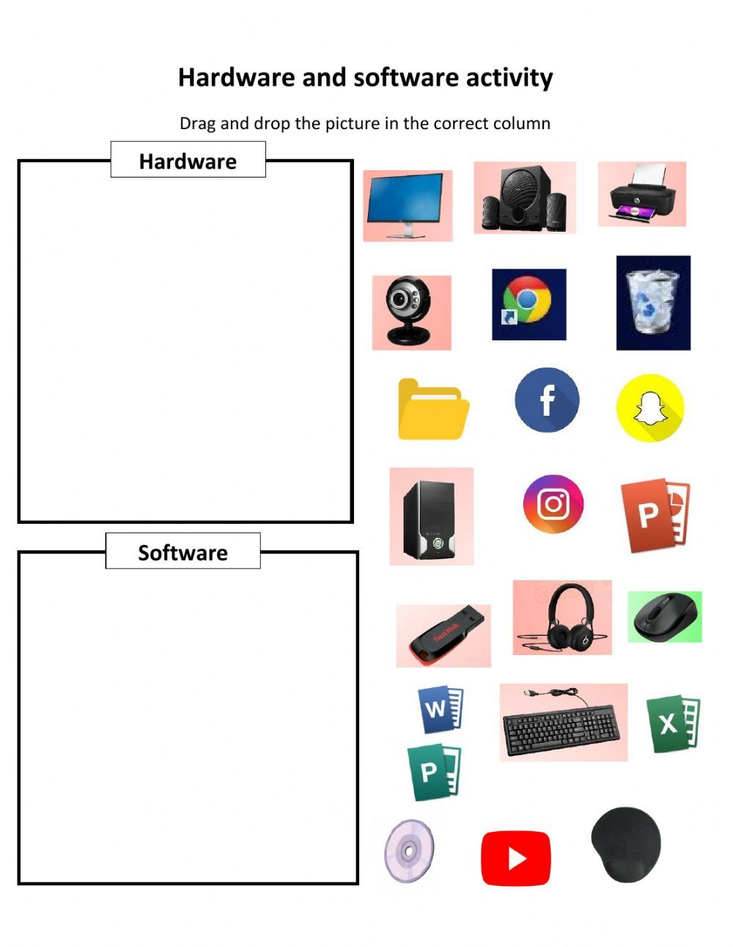**3. Software and Hardware Activity, Cut and Paste in given place. (3 Marks)**

