 **Veda International School**

**Kusugal Road, Hubballi Ph: 0836-2002275**

(ICSE Board)

WORKSHEET

**Name: _____________________________ Subject: English - 1 Date: _____________**

**Roll No : __________________ Grade : II**

**Teacher Sign : _____________ Total Marks: 10 M**

1. **Nouns : Underline or circle the nouns in each sentence : 2 ½ marks**
2. 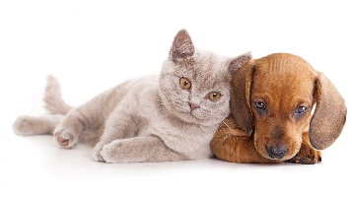The cat ran after the dog .

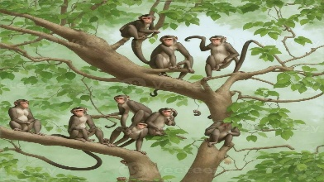

1. Five little monkeys climbed the tree .

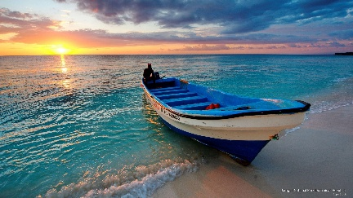

1. An old man jumped off his boat .



1. She read her book for five hours .



1. His dog ran around the park .
2. **Rearrange the letters in the correct order to make a word : 5 marks**
3. BAVOE = __________________ 2. PROERT = _________________
4. EBUCASE = ________________ 4. BDIRS = ___________________
5. HCIDLERN = _______________ 6. RANIBWO = _______________
6. BIRGN = ___________________ 8. DKARSNES = ______________
7. EWARHTE = ________________ 10. HCAGNE = ________________

1. **Make a word cloud . Write a word that being with the last letter of the word before it : 2 ½ marks**

Cloud

Blue

Water

Earth

Boy

